The objectives
- Be able to differentiate among connective tissue classes
- Be able to know the different between Mucous and Mesenchymal tissue
- Classify the adult (proper) C.T?
- The main different between loose and dense c.T
- Classify the specialized C.T.?
- What are the different between the two types of adipose tissue? Functions?
- Define cartilage?
- Be able to classify the cartilages types with examples
- What are the components of hyaline cartilages?
- The main different between chondroblasts and chondrocyte?
Types of connective tissue
A. Embryonic connective tissue
1. Mucous tissue is a loose connective tissue that is the main constituent of the umbilical cord. It consists of a jellylike matrix with some collagen fibers in which large stellate fibroblasts are embedded.
2. Mesenchymal tissue is found only in embryos. It consists of a gel-like amorphous matrix containing only a few scattered reticular fibers, in which star-shaped, pale-staining mesenchymal cells are embedded.

b- Adult connective tissue (proper): this type includes
a - Loose (areolar) connective tissue
b- Dense connective tissue (regular & irregular)
- Specialized connective tissue: it consist of from different types of connective tissue such as adipose tissue, cartilage, bone, reticular tissue and blood.
** Adult connective tissue(proper)
1- Loose connective tissue: is a very common type of connective tissue that supports many structures which are normally under some pressure and low friction. It usually supports epithelial tissue, forms a layer around small blood and lymphatic vessels, and fills the spaces between muscle and nerve fibers. Loose connective tissue is also found in the papillary layer of the dermis, in the hypodermis, in the linings of the peritoneal and pleural cavities, in glands, and in the mucous membranes (wet membranes that line the hollow organs) supporting the epithelial cells.
Loose connective tissue, sometimes called areolar tissue, has all the main components of connective tissue (cells, fibers, and ground substance) in roughly equal parts. The most numerous cells are fibroblasts and macrophages, but other types of connective tissue cells are also present. Collagen, elastic, and reticular fibers also appear in this tissue. With a moderate amount of ground substance, loose connective tissue has a delicate consistency; it is flexible, well vascularized, and not very resistant to stress.
2- Dense connective tissue: is adapted to offer resistance and protection. It has the same components found in loose connective tissue, but there are fewer cells and a clear predominance of collagen fibers over ground substance. Dense connective tissue is less flexible and far more resistant to stress than is loose connective tissue. It is known as dense irregular connective tissue when the collagen fibers are arranged in bundles without a definite orientation. The collagen fibers form a 3-dimensional network in dense irregular tissue, providing resistance to stress from all directions. Dense irregular connective tissue is often found closely associated with loose connective tissue. The two types frequently grade into one another and distinctions between them are often arbitrary.
The collagen bundles of dense regular connective tissue are arranged with collagen fibers aligned with the linear orientation of fibroblasts in response to prolonged stresses exerted in the same direction.
3- Specialized connective tissue:
1-Adipose Tissue: Adipose tissue is a specialized type of connective tissue in which adipocytes or fat cells predominate. These cells can be found isolated or in groups within loose or irregular connective tissue, often in large aggregates where they are the major component of adipose tissue. Located in many areas throughout the body, adipose tissue represents 15–20% of the body weight in men of normal weight; in women of normal weight, 20–25% of body weight.
Adipose tissue is the largest repository of energy (in the form of triglycerides, the neutral fats) in the body. Adipocytes themselves release hormones and a number of important factors, and adipose tissue is now recognized as a major endocrine and signaling organ. Adipose tissue also fills up spaces between other tissues and helps to keep some organs in place.
There are two types of adipose tissue with different locations, structures, colors, and pathologic characteristics. White adipose tissue, the more common type, is composed of cells that, when completely developed, contain one large central droplet of whitish-yellow fat in their cytoplasm. Brown adipose tissue contains cells with multiple lipid droplets interspersed among abundant mitochondria, which give these cells the darker appearance. Both types of adipose tissue have a rich blood supply.
a. White adipose tissue is composed of unilocular adipose cells.
(1) This tissue constitutes nearly all of the adult adipose tissue throughout the body.
(2) It stores and releases lipids.
b. Brown adipose tissue is composed of multilocular adipose cells, which contain many large mitochondria.
(1) This tissue is capable of generating heat by uncoupling oxidative phosphorylation. Thermogenin, a transmembrane protein in mitochondria, causes the release of protons away from adenosine triphosphate (ATP) synthesis, resulting in heat production.
(2) This tissue is found in infants (also in hibernating animals) and is much reduced in adults.
2-Cartilage: is an a vascular specialized fibrous connective tissue. It has a firm extracellular matrix that is less pliable than that of connective tissue proper, and it contains chondrocytes embedded in the matrix. Cartilage functions primarily to support soft tissues and assist in the development and growth of long bones. The three types of cartilage hyaline cartilage, elastic cartilage, and fibro cartilage vary in certain matrix components.
A. Hyaline cartilage: is the most abundant cartilage in the body and it also serves as a temporary skeleton in the fetus until it is replaced by bone (nose, larynx, trachea, bronchi) .The main structure is:
a. Matrix : The matrix is composed of an amorphous ground substance containing proteoglycan aggregates and chondronectin, in which type II collagen is embedded .
b. Perichondrium is a layer of dense, irregular connective tissue that surrounds hyaline cartilage except at articular surfaces. (1) It consists of an outer fibrous layer containing type I collagen, fibroblasts, and blood vessels and an inner cellular layer containing chondrogenic cells and chondroblasts.
(2) It provides the nearest blood supply to the a vascular cartilaginous tissue.
C. Chondroblasts manufacture the cartilage matrix through which nutrients and waste materials pass to and from the cells, respectively. These cells contain an extensive Golgi complex, abundant rough endoplasmic reticulum (RER), lipid droplets, and glycogen. Mesenchymal cells can be induced to become secreting chondroblasts in the proper environment, but if removed and grown as a monolayer in a low-density substrate, they will discontinue secreting cartilage matrix, become fibroblast like, and secrete type I rather than type II collagen.
d. Chondrocytes are mature cartilage cells that are embedded within lacunae in the matrix. (1) They arise by differentiation of mesenchymal chondrogenic cells and from chondrogenic cells within the inner layer of the perichondrium into chondroblasts, which are the earliest cells to produce cartilage matrix. Once these cells become totally enveloped by matrix, they are referred to as chondrocytes .
(2) Chondrocytes located superficially are ovoid and positioned with their longitudinal axis parallel to the cartilage surface. Those located deeper are more nearly spherical and may occur in groups of four to eight cells (isogenous groups).
B. Elastic cartilage ex. (external ear as well as certain structures of the middle ear and larynx): possesses a perichondrium and is nearly identical to hyaline cartilage except for a network of elastic fibers, which impart a yellowish color. Although it contains type II collagen, it is less prone to degeneration than hyaline cartilage and is located in areas where flexible support is required.
C. Fibrocartilag (intervertebral discs, in attachments of certain ligaments): lacks an identifiable perichondrium. It is characterized by alternating rows of fibroblast-derived chondrocytes surrounded by scant matrix and thick parallel bundles of type I collagen fibers. Fibrocartilage is located in areas where support and tensile strength are required. Table 7-1 p 137
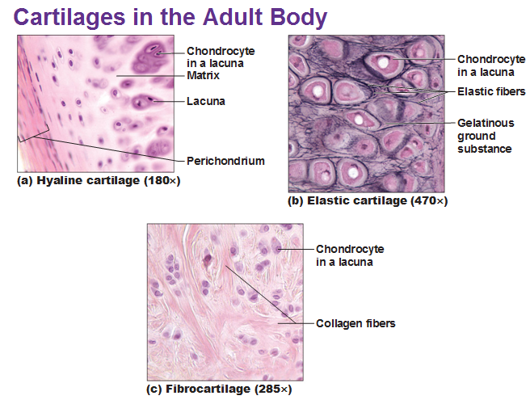
MEDICAL APPICATION
- Increased vascular permeability is caused by the action of vasoactive substances such as histamine released from mast cells during inflammation. Increased blood flow and vascular permeability produce local swelling (edema), redness, and heat. Pain is due mainly to the action of the chemical mediators on nerve endings. All these activities help protect and repair the inflamed tissue. Chemotaxis (Gr. chemeia, alchemy + taxis, orderly arrangement), the phenomenon by which specific cell types are attracted by specific molecules, draws much larger numbers of leukocytes into inflamed tissues.
- Fibrillins comprise a family of proteins involved in making the scaffolding necessary for the deposition of elastin. Mutations in the fibrillin genes result in Marfan syndrome, a disease characterized by a lack of resistance in tissues rich in elastic fibers. Because the walls of large arteries are rich in elastic components and because the blood pressure is high in the aorta, patients with this disease often experience aortic swellings called aneurysms, which are life-threatening conditions.

