## The Objectives

## When you have finished this course you should be able to:

## 1-Give the defining characteristics of each of the four major tissue types.

## 2-Describe the differences among the types of epithelial tissues you will study and identify them.

## 3-Describe the differences among the types of connective tissues and identify them.

## 4-Identify the three types of muscular tissue and describe the differences among them.

## 5-Identify the parts of neurons and supporting cells

## 6- State where each of these tissues is found and what its function is.

## The objectives of this lecture 1:

## Numerate the main functions of epithelial tissues

## Classify the epithelial cells?

## Define lamina propria? What is the function of its?

## What is a papillae?

## What is basal lamina? Numerate the layers of it?

## What are the main functions of basal lamina?

## How is tissues associated with each other?

## Classify the junctions types?

## Explain the apical cells?

## Classify the epithelial tissue according to the number of layers?

## Classify the epithelial tissue according to the cells shape?

## What are the functions of each type? Where it’s found give an example?

**TISSUES**

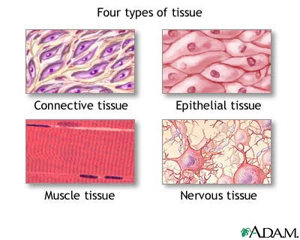In this lecture we will provides an introduction to the concept of how cells, the fundamental building blocks of the body, are assembled into tissues and how tissues assemble into organs in order to perform complex functions necessary for the operation of the body. There are four basic tissue types in the body: 1-***Epithelial tissue 2-Connective tissue 3- Muscle tissue 4- Nervous tissue***. They are represented in most organs.

**Epithelial Tissue**

Epithelial tissues are composed of closely aggregated polyhedral cells with very little extracellular substance. These cells have strong adhesion and form cellular sheets that cover the surface of the body and line its cavities. The principal functions of epithelial tissues are: 1- Covering, lining, and protecting surfaces (eg, skin)

2-Absorption (eg, the intestines)

3- Secretion (eg, the epithelial cells of glands)

4-Contractility (eg, myoepithelial cells)

## Because epithelial cells line all external and internal surfaces of the body, everything that enters or leaves the body must cross an epithelial sheet. Epithelial cells line the free external and internal surfaces of the body.

**Characteristic Features of Epithelial Cells**

The forms and dimensions of epithelial cells range from high **columnar** to **cuboidal** to low **squamous** cells. Epithelial cell nuclei have a distinctive shape, varying from spherical to elongated or elliptic. The nuclear form often corresponds roughly to the cell shape; thus, cuboidal cells have spherical nuclei, and squamous cells have flattened nuclei. The long axis of the nucleus is always parallel to the main axis of the cell.

Because the lipid-rich membranes between cells are frequently indistinguishable with the light microscope, the stained cell nucleus is a clue to the shape and number of cells. Nuclear form is also useful to determine whether the cells are arranged in layers, a primary morphologic criterion for classifying epithelia.

Most epithelia rest on connective tissue. In the case of epithelia lining the cavity of internal organs (especially in the digestive, respiratory, and urinary systems) this layer of connective tissue is often called the **lamina propria**. The lamina propria not only serves to support the epithelium but also provides nutrition and binds it to underlying structures. The area of contact between epithelium and lamina propria is increased by irregularities in the connective tissue surface in the form of small evaginatons called **papillae**. Papillae occur most frequently in epithelial tissues subject to friction, such as the covering of the skin or tongue.

**Basal Laminae & Basement Membranes**

All epithelial cells in contact with subjacent connective tissue have at their basal surfaces a felt-like sheet of extracellular material called the **basal lamina**. This structure is visible only with the electron microscope, where it appears as an electron-dense layer, 20–100 nm thick, consisting of a network of fine fibrils, the **dense layer** or **lamina densa** .In addition, basal laminae may have electron-lucent layers on one or both sides of the dense layer, called **clear layers** or **laminae lucida.** Basal laminae are found not only in epithelial tissues but also where other cell types come into contact with connective tissue. ***Basal laminae have many functions. Such as regulate cell proliferation and*** ***differentiation by binding and concentrating growth factors; influence cell metabolism and survival; organize the proteins in the adjacent plasma membrane (affecting signal transduction); and serve as pathways for cell migration.*** An extracellular **basal lamina** always lies at the interface of epithelial cells and connective tissue. Nutrients for epithelial cells must diffuse across the basal lamina. Nerve fibers normally penetrate this structure, but small blood capillaries (being epithelial themselves) never enter an epithelium across a basal lamina. When components of a basal lamina are resolved with the light microscope, the structure is often called a **basement membrane**.

Figure 1- Basement membranes



**Intercellular Adhesion & Other Junctions**

Several membrane-associated structures provide adhesion and communication between cells. Some are present in other tissues but all are particularly numerous and prominent in epithelia. Epithelial cells adhere strongly to neighboring cells and basal laminae, particularly in epithelia subject to friction or other mechanical forces.

Lateral surfaces of epithelial cells exhibit several specialized intercellular junctions, which serve different functions: (Fig4-4 P:76)

■■ Tight or occluding junctions: the closely associated areas between two adjacent cells.

■■ Adherent or anchoring junctions share the characteristic of anchoring cells through their cytoplasmic actin filaments.

■■ Gap junctions are channels for communication between adjacent cells.

* Desmosome also known as a macula adherents (plural: maculae adherents) is a cell structure specialized for cell-to-cell adhesion. A type of junctional complex, they are localized spot-like adhesions randomly arranged on the lateral sides of plasma membranes.

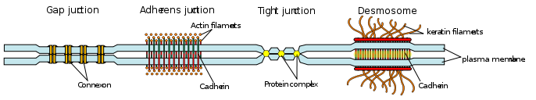

Fig.2 Types of Junctions in Epithelial cells

**Specializations of the Apical cell Surface**

**Cilia** : hair-like appendages attached to the apical surface of cells that act as sensory structures or to produce movement.

**Goblet cells**: specialized cells that produce mucus to lubricate and protect the surface of an organ

**Villi** : finger-like projections that arise from the epithelial layer in some organs. They help to increase surface area allowing for faster and more efficient adsorption.

**Microvilli**: smaller projections that arise from the cell's surface that also increase surface area. Due to the bushy appearance that they sometimes produce, they are sometimes referred to as the **brush border** of an organ.

Epithelial tissue can be divided into ***two groups depending on the number of layers of which it is composes.*** Epithelial tissue which is only one cell thick (one layer) is known as **simple epithelium**. If it is two or more cells thick (more than two layers)  it is known as **stratified epithelium** .

***http://staff.uobabylon.edu.iq/site.aspx?id=604***