The objectives
By the end of lecture, the student should be able to
. 1-Define bones, and its functions
2- Be able to distinguish between the different bone cells
3- Classify the bones.
4- Describe the endochondral and intramembranous ossification.
3- Bone
Bone is the primary constituent of the adult skeleton. Bone tissue supports fleshy structures, protects vital organs such as those in the cranial and thoracic cavities, and harbors the bone marrow, where blood cells are formed. Bone also serves as a reservoir of calcium, phosphate, and other ions that can be released or stored in a controlled fashion to maintain constant concentrations of these important ions in body fluids.
In addition, bones form a system of levers that multiply the forces generated during skeletal muscle contraction and transform them into bodily movements. This mineralized tissue therefore confers mechanical and metabolic functions to the skeleton.
Bone is a specialized connective tissue composed of calcified intercellular material, the bone matrix, and three cell types:
§ Osteocytes : which are found in cavities (lacunae) between layers (lamellae) of bone matrix .
§ Osteoblasts: which synthesize the organic components of the matrix
§ Osteoclasts: which are multi-nucleated giant cells involved in the resorption and remodeling
Bone Cells
1-Osteoblasts
Osteoblasts are responsible for the synthesis of the organic components of bone matrix, consisting of type I collagen fibers, proteoglycans, and several glycoproteins including osteonectin. Osteoblasts are located exclusively at the surfaces of bone matrix, usually side by side in a layer somewhat resembling a simple epithelium. When they are actively engaged in matrix synthesis, osteoblasts have a cuboidal to columnar shape and basophilic cytoplasm. When their synthesizing activity declines, they flatten and cytoplasmic basophilia is reduced. Osteoblast activity is stimulated by parathyroid hormone (PTH).
During matrix synthesis, osteoblasts have the ultrastructure of cells actively synthesizing proteins for secretion. Osteoblasts are polarized cells: matrix components are secreted at the cell surface in contact with older bone matrix, producing a layer of new (but not yet calcified) material called osteoid between the osteoblast layer and the bone formed earlier (Figure 1). This process of bone appositional growth is completed by subsequent deposition of calcium salts into the newly formed matrix.
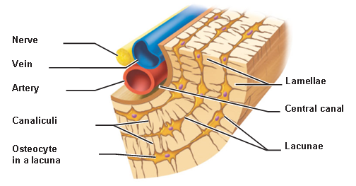
Fig. 1 The osteon structure

2- Osteocytes:
a.Osteocytes are mature bone cells housed in their own lacunae .
b. They have narrow cytoplasmic processes that extend through canaliculi in the calcified matrix .
c. They maintain communication with each other via gap junctions between their processes.
d. They contain abundant heterochromatin, a paucity of RER, and a small Golgi complex.
3- Osteoclasts : are large, motile, multinucleated cells . The large size and multinucleated condition of osteoclasts is due to their origin from the fusion of bone marrow-derived cells. In areas of bone undergoing resorption, osteoclasts lie within enzymatically etched depressions or crypts in the matrix known as resorption bays (formerly called Howship lacunae).
In active osteoclasts, the surface against the bone matrix is folded into irregular projections, which form a ruffled border. Formation of the ruffled borders is related to the activity of osteoclasts. Surrounding the ruffled border is a clear cytoplasmic zone rich in actin filaments which is the site of adhesion to the bone matrix. This circumferential adhesion zone creates a microenvironment between the osteoclast and the matrix in which bone resorption occurs. Figure 2 shows the main structure of the bone

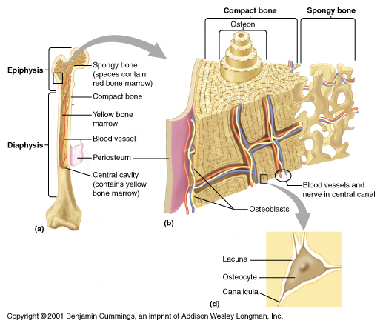
Fig. 2 The structure of the bone
Types of Bone
Classification of bone is based on both gross and microscopic properties. 1. Gross observation of cross-sections of bone reveals two types:
a. Spongy (cancellous) bone, which is composed of interconnected trabeculae. Bony trabeculae surround cavities filled with bone marrow. The trabeculae contain osteocytes and are lined on both surfaces by a single layer of osteoblasts. Spongy bone is always surrounded by compact bone.
b. Compact (dense) bone has no trabeculae or bone marrow cavities.
2. Microscopic observation of bone reveals two types:
a. Primary bone, also known as immature or woven bone. The main characteristics are :
(1) Primary bone contains many osteocytes and large, irregularly arranged type I collagen bundles.
(2) It has a low mineral content.
(3) It is the first compact bone produced during fetal development and bone repair.
(4) It is remodeled and replaced by secondary bone except in a few places (e.g., tooth sockets, near suture lines in skull bones, and at insertion sites of tendons).
b. Secondary bone, is also known as mature or lamellar bone. The main features are:
(1) Secondary bone is the compact bone of adults.
(2) It has a calcified matrix arranged in regular layers, or lamellae. Each lamella is 3 to 7 µm thick.(3) It contains osteocytes in lacunae between, and within, lamellae.
Osteogenesis
Bone can be formed initially by either of two ways:
§ Intramembranous ossification, in which osteoblasts differentiate directly from mesenchyme and begin secreting osteoid.
Endochondral ossification, in which the matrix of preexisting hyaline cartilage is eroded and replaced by osteoblasts producing osteoid.
In both processes, the bone tissue that appears first is primary or woven. Primary bone is a temporary and is soon replaced by the definitive secondary lamellar bone. During bone growth, areas of primary bone, areas of resorption, and areas of secondary bone all appear side by side.
MEDICAL APPLICATION
- Cancer originating directly from bone cells (a primary bone tumor) is fairly uncommon (0.5% of all cancer deaths), although a cancer called osteosarcoma can arise in osteoprogenitor cells. The skeleton is often the site of secondary, metastatic tumors, however, arising when cancer cells move into bones via small blood or lymphatic vessels from malignancies in other organs, most commonly the breast, lung, prostate gland, kidney, or thyroid gland.

- In the genetic disease osteopetrosis, which is characterized by dense, heavy bones (“marble bones”), the osteoclasts lack ruffled borders and bone resorption is defective. This disorder results in overgrowth and thickening of bones, often with obliteration of the marrow cavities, depressing blood cell formation and causing anemia and the loss of white blood cells. The defective osteoclasts in most patients with osteopetrosis have mutations in genes for the cells’ proton-ATPase pumps or chloride channels.

