Objectives: Upon completion of this lecture, the student should be able to State the main characteristics of each stage of mitosis
Cell Division
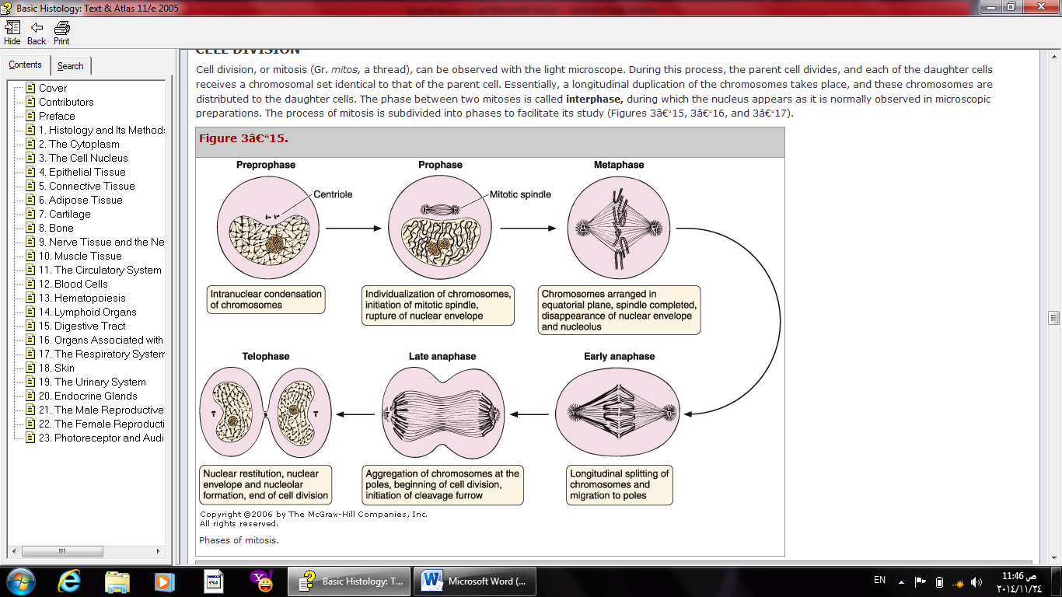
Cell division, or mitosis, is the division of somatic (body) cells and can be observed with the light microscope. During this process, the parent cell divides, and each of the daughter cells receives a chromosomal set identical to that of the parent cell. Essentially, a longitudinal duplication of the chromosomes takes place, and these chromosomes are distributed to the daughter cells. The period between mitoses is called interphase, during which the DNA is replicated and the nucleus appears as it is most commonly seen in histological preparations. The process of mitosis is subdivided into four phases (Figures 1).
Figure 1: Phases of mitosis

During interphase, Interesting things happen: Cell prepares to divide and Genetic material is doubled.
In prophase:
- The nuclear envelope begins to disaggregate
- The chromatin in the nucleus begins to condense and becomes visible by light microscopy as elongated, spindly chromosomes.
- The nucleolus disappears.
Centrosomes begin migrating to opposite poles of the cell, and microtubule fibers extend from centrosome to centrosome and from centrosome to the kinetochore (a large protein complex serves as a site for attachment to microtubules) of the centromere of each chromosome to form the mitotic spindle.
During metaphase,
- Chromosomes migrate to the equatorial plane of the cell.
- The chromatids attach to the microtubules of the mitotic spindle at the kinetochore, located close to the centromere.
- Spindle fibers line the chromosomes along the middle of the cell nucleus. This line is referred to as the metaphase plate. Polar microtubules extend from the pole to the equator, and typically overlap. Kinetochore microtubules extend from the pole to the kinetochores.
In anaphase,
- The sister chromatids separate from each other and migrate toward the opposite poles of the cell, pulled by microtubules. Throughout this process, the centromeres move away from the center, pulling the remainder of the chromosome along.
- The chromosomes are pulled by the kinetochore microtubules to the poles and form a "V" shape. Motion results from a combination of kinetochore movement along the spindle microtubules and through the physical interaction of polar microtubules.
Telophase is characterized by:
- The reappearance of nuclei in the daughter cells.
- The chromosomes revert to their semidispersed state, and the nucleoli, chromatin, and nuclear envelope reappear.
- A constriction develops at the equatorial plane of the parent cell and progresses until the cytoplasm and its organelles are divided in two, this called the cytokinesis. In animal cells, cytokinesis results when a fibre ring composed of a protein called actin around the centre of the cell contracts dividing the cell into two daughter cells, each with one nucleus.
Most tissues undergo constant cell turnover because of continuous cell division and the ongoing death of cells. Nerve tissue and cardiac muscle cells are exceptions. The turnover rate of cells varies greatly from one tissue to another, rapid in the epithelium of the digestive tract and the epidermis and slow in the pancreas and the thyroid gland.

