Electron Microscopy and Autoradiography

Objectives: Upon completion of this lecture, the student should be able to:

Explain the main components of SEM & TEM.

Discus the differences between light and electron microscopy.

Differentiate between SEM and TEM images.

Describe briefly how to use the Autoradiography method for macromolecules localization.
Transmission and scanning electron microscopes are based on the interaction of electrons and tissue components. The wavelength in the electron beam is much shorter than that of light, allowing a thousand-fold increase in resolution.
Transmission Electron Microscopy
The transmission electron microscope (TEM) is an imaging system that permits very high resolution (3 nm) (Figure 1a). This high resolution allows magnifications of up to 400,000 times to be viewed with details. Unfortunately, this level of magnification applies only to isolated molecules or particles. Very thin tissue sections can be observed with details at magnifications of up to about 120,000 times.
Figure 1: (a): Schematic view of a transmission electron microscope (TEM) with its lenses and the pathway of the electrons. (b): Schematic view of a scanning electron microscope (SEM) with many similarities to a TEM

The TEM functions on the principle that a beam of electrons can be deflected by electromagnetic fields in a manner similar to light deflection in glass lenses. The beam is produced by a cathode at the top of the instrument and passes down through the chamber in a vacuum. Because electrons change their path when submitted to electromagnetic fields, the beam can be focused by passing through electric coils which can be considered as electromagnetic lenses.
The first lens is a condenser focusing the beam of electrons on the specimen section. Some electrons interact with atoms in the section and their course is modified, while others simply cross the specimen without interacting. Electrons passing through the specimen reach the objective lens, which forms a focused, magnified image that is then magnified further through other lenses and captured on a viewing screen. The image of the specimen shows areas of white, black, and shades of gray corresponding to areas through which electrons readily passed (appearing brighter or electron lucent) and areas where electrons were absorbed or deflected (appearing darker or more electron dense). To improve contrast and resolution in TEM, compounds with heavy metal ions (like osmium tetroxide, lead citrate) are often added to the fixative or dehydrating solutions used to prepare the tissue. This will bind cellular macromolecules, increasing their electron density and visibility.
To provide a useful interaction between the specimen and the electrons, TEM requires very thin sections (40–90 nm); therefore, embedding is performed with a hard epoxy and sectioning is done with a glass or diamond knife. The extremely thin sections are collected on small metal grids and transferred to the interior of the microscope to be analyzed.
Cryofracture and freeze etching are techniques that allow TEM study of cells without fixation or embedding. Cryofracture has been particularly useful in the study of membrane structure. In these methods very small tissue specimens are rapidly frozen in liquid nitrogen and either fractured or cut with a knife. A replica (mask) of the frozen exposed surface is produced in a vacuum by applying thin coats of vaporized platinum or other metal atoms. After removal of the organic material, the replica of the cut surface can be examined by EM. With membranes the random fracture planes often split the lipid bilayers, exposing protein components whose size, shape, and distribution are difficult to study by other methods.
Scanning Electron Microscopy
Scanning electron microscopy (SEM) permits pseudo–three-dimensional views of the surfaces of cells, tissues, and organs. Like the TEM this microscope produces and focuses a very narrow beam of electrons, but in this instrument the beam does not pass through the specimen (Figure 1b). Instead the surface of the specimen is first dried and coated with a very thin layer of metal atoms through which electrons do not pass readily. When the beam is scanned from point to point across the specimen it interacts with the metal atoms and produces reflected electrons or secondary electrons emitted from the metal. These are captured by a detector and the resulting signal is processed to produce a black-and-white image on a monitor. SEM images are usually easy to interpret because they present a 3D view that appears to be illuminated from above, in the same way that large objects are seen with highlights and shadows caused by light from above.
Autoradiography
Autoradiography is a method for localizing newly synthesized macromolecules (DNA, RNA, protein, glycoproteins, and polysaccharides) in cells or tissue sections. Radioactively labeled metabolites (nucleotides, amino acids) incorporated into the macromolecules emit weak radiation that is restricted to the cellular regions where the molecules are located. Radiolabeled cells or mounted tissue sections are coated in a darkroom with photographic emulsion containing silver bromide crystals, which act as microdetectors of this radiation in the same way that they respond to light in common photographic film. After an adequate exposure time in lightproof boxes the slides are developed photographically. The silver bromide crystals reduced by the radiation are reduced to small black grains of metallic silver, indicating locations of radiolabeled macromolecules in the tissue. This general procedure can be used in preparations for both light microscopy and TEM (Figure 2). Much information becomes available by autoradiography of cells or tissues.
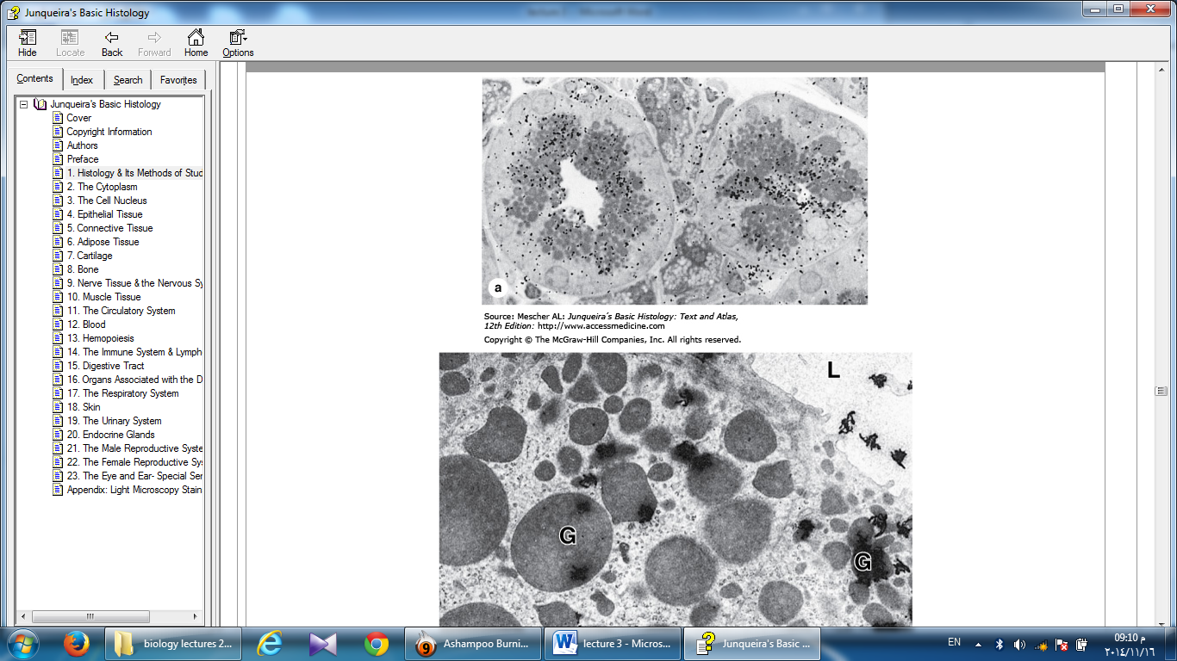
Figure 2: Autoradiography, (a): Black "silver grains" are visible over regions with secretory granules and the duct indicating glycoprotein locations. X1500. (b): The same tissue prepared for TEM autoradiography shows silver grains with a coiled or amorphous appearance again localized mainly over the granules (G) and in the gland lumen (L). X7500.

Thus, if a radioactive amino acid is used, it is possible to know which cells in a tissue produce more protein and which cells produce less, because the number of silver grains formed over the cells is proportional to the intensity of protein synthesis. If a radioactive precursor of DNA (such as tritium-labeled thymidine) is used, it is possible to know which cells in a tissue (and how many) are preparing to divide. Dynamic events may also be analyzed. For example, if one wishes to know where in the cell protein is produced, if it is secreted, and which path it follows in the cell before being secreted, several animals are injected with a radioactive amino acid and tissues collected at different times after the injections. Autoradiography of the tissues representing the various times throughout the experiment will indicate the migration of the radioactive proteins. If one wishes to know where new cells are produced in an organ and where they migrate, several animals are injected with radioactive thymidine and tissues collected at different times after the injection. Autoradiographs of the sections will show the location of the dividing cells and where they migrate.

