Histology & Its Methods of Study
Introduction
Histology: is the study of the microscopic anatomy of cells and tissues of the body and how these tissues are arranged to constitute organs. Histology involves all aspects of tissue biology, with the focus on how cells' structure and arrangement optimize functions specific to each organ.
Tissues are made of two interacting components: cells and extracellular matrix. The extracellular matrix consists of many kinds of molecules, most of which are highly organized and form complex structures, such as collagen fibrils and basement membranes. The main functions are:
1- Provide a mechanical support for the cells,
2- Transport nutrients to the cells,
3- Carry away catabolites and secretory products.
Although the cells produce the extracellular matrix, they are also influenced and sometimes controlled by molecules of the matrix. There is, thus, an intense interaction between cells and matrix, with many components of the matrix recognized by and attaching to receptors present on cell surfaces. Most of these receptors are molecules that cross the cell membranes and connect to structural components of the intracellular cytoplasm. Thus, cells and extracellular matrix form a continuum that functions together and reacts to stimuli and inhibitors together.
Each of the fundamental tissues (except the central nervous system) is formed by several types of cells and typically by specific associations of cells and extracellular matrix.
The small size of cells and matrix components makes histology dependent on the use of microscopes. Advances in chemistry, molecular biology, physiology, immunology, and pathology—and the interactions among these fields—are essential for a better knowledge of tissue biology.

Preparation of Tissues for Study
The first step to study the tissues is the preparation of histological sections or tissue slices that can be studied with the aid of the light microscope. Under the light microscope, tissues are examined via a light beam that is transmitted through the tissue. Because tissues and organs are usually too thick for light to pass through them, they must be sectioned to obtain thin, translucent sections and then attached to glass slides before they can be examined.
The ideal microscope tissue preparation should be preserved so that the tissue on the slide has the same structure and molecular composition as it had in the body. However, as a practical matter this is seldom feasible and artifacts, distortions, and loss of components due to the preparation process are almost always present.
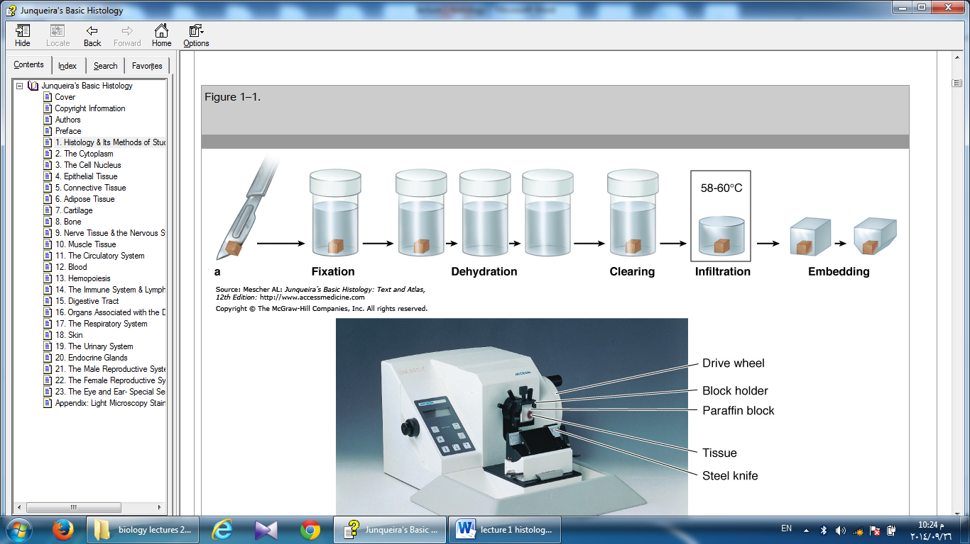
The basic steps used in tissue preparation for histology are shown in Figure 1-1

Figure 1-1: steps of tissue preparation

1- Fixation
If a permanent section is desired, tissues must be fixed. Fixation is used to:
- Terminate cell metabolism,
- Prevent enzymatic degradation of cells and tissues by autolysis (self-digestion).
- Kill pathogenic microorganisms such as bacteria, fungi, and viruses.
- Harden the tissue as a result of either cross-linking or denaturing protein molecules.
Pieces of organs should be quickly and adequately treated before, or as soon as possible after, removal from the animal's body. This treatment (fixation) can be done by chemical or, less frequently, physical methods. In chemical fixation, the tissues are usually immersed in solutions of stabilizing or cross-linking agents called fixatives. Because the fixative needs some time to fully diffuse into the tissues, the tissues are usually cut into small fragments before fixation to facilitate the penetration of the fixative and to guarantee preservation of the tissue. Intravascular perfusion of fixatives can be used. Because the fixative in this case rapidly reaches the tissues through the blood vessels, fixation is greatly improved.
One of the best fixatives for routine light microscopy is formalin, a buffered isotonic solution of 37% formaldehyde. The chemistry of the process involved in fixation is complex and not always well understood. Formaldehyde and glutaraldehyde, another widely used fixative, are known to react with the amine groups (NH₂) of tissue proteins. In the case of glutaraldehyde, the fixing action is reinforced by virtue of its being a dialdehyde, which can cross-link proteins.
In view of the high resolution afforded by the electron microscope, greater care in fixation is necessary to preserve ultrastructural detail. Toward that end, a double fixation procedure, using a buffered glutaraldehyde solution followed by a second fixation in buffered osmium tetroxide, is a standard procedure in preparations for fine structural studies. The effect of osmium tetroxide is to preserve and stain lipids and proteins.
Fixation by freezing
An alternate way to prepare tissue sections is to submit the tissues to rapid freezing. In this process, the tissues are fixed by freezing (physical, not chemical fixation) and at the same time become hard and thus ready to be sectioned. A freezing microtome- the cryostat-is then used to section the frozen block with tissue. Because this method allows the rapid preparation of sections without going through the long embedding procedure described above, it is routinely used in hospitals to study specimens during surgical procedures. Freezing of tissues is also effective in the histochemical study of very sensitive enzymes or small molecules, since freezing, unlike fixation, does not inactivate most enzymes. Finally, because immersion in solvents such as xylene dissolves cell lipids in fixed tissues, frozen sections are also useful when structures containing lipids are to be studied.
2- Embedding & Sectioning
Tissues are usually embedded in a solid medium to facilitate sectioning. To obtain thin sections with the microtome, tissues must be infiltrated after fixation with embedding substances that impart a rigid consistency to the tissue. Embedding materials include paraffin and plastic resins. Paraffin is used routinely for light microscopy; resins are used for both light and electron microscopy.
The process of paraffin embedding, or tissue impregnation, is ordinarily preceded by two main steps: dehydration and clearing. The water is first extracted from the fragments to be embedded by bathing them successively in a graded series of mixtures of ethanol and water, usually from 70% to 100% ethanol (dehydration). The ethanol is then replaced with a solvent mixture of both alcohol and the embedding medium. As the tissues are infiltrated with this solvent, they generally become transparent (clearing). Once the tissue is impregnated with the solvent, it is placed in melted paraffin in an oven, typically at 52–60°C. The heat causes the solvent to evaporate, and the spaces within the tissues become filled with paraffin. The tissue together with its impregnating paraffin hardens after removal from the oven.
Tissues to be embedded with plastic resin are also dehydrated in ethanol and-depending on the kind of resin used-subsequently infiltrated with plastic solvents. The ethanol or the solvents are later replaced by plastic solutions that are hardened by means of cross-linking polymerizers. Plastic embedding prevents the shrinking effect of the high temperatures needed for paraffin embedding and gives little or no distortion to the cells.
The hard blocks containing the tissues are then placed in an instrument called a microtome (Figure 1–2) and are sliced by the microtome's steel or glass blade into sections 1 to10 micrometers thick, (micrometer (1um) = 1/1,000 of a millimeter (mm) = 10^{–6} m). The sections are floated on water and then transferred to glass slides to be stained.
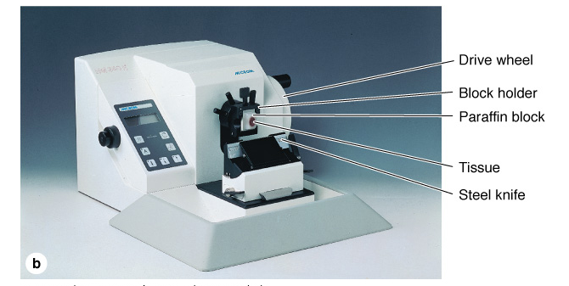
Figure 1-2: The microtome
3- Staining
To be studied microscopically, sections must typically be stained or dyed because most tissues are colorless. Methods of staining tissues have therefore been devised that not only make the various tissue components visible but also permit distinctions to be made between them. The dyes stain tissue components more or less selectively. Most of these dyes behave like acidic or basic compounds and have a tendency to form electrostatic (salt) linkages with ionizable radicals of the tissues. Tissue components with a net negative charge (anionic) stain more readily with basic dyes and are termed basophilic; cationic components, such as proteins with many ionized amino groups, have affinity for acidic dyes and are termed acidophilic.
Examples of basic dyes are toluidine blue, alcian blue, and methylene blue. Hematoxylin behaves like a basic dye, that is, it stains the basophilic tissue components. The main tissue components that ionize and react with basic dyes do so because of acids in their composition (nucleic acids, glycosaminoglycans, and acid glycoproteins). Acid dyes (eg, orange G, eosin, acid fuchsin) stain the acidophilic components of tissues such as mitochondria, secretory granules, and collagen.
Of all dyes, the simple combination of hematoxylin and eosin (H&E) is used most commonly. Hematoxylin stains DNA of the cell nucleus and other acidic structures (such as RNA-rich portions of the cytoplasm and the matrix of cartilage) blue. In contrast, eosin stains other cytoplasmic components and collagen pink (Figure 1–2). Many other dyes, such as the trichromes (eg, Mallory stain, Masson stain), are used in different histologic procedures. The trichromes, besides showing the nuclei and cytoplasm very well, help to distinguish extracellular tissue components better than H&E.
The chemical basis of other staining procedures is more complicated than the electrostatic interactions underlying basophilia and acidophilia. DNA can be specifically identified and quantified in nuclei using the Feulgen reaction, in which deoxyribose sugars are hydrolyzed by mild hydrochloric acid, followed by treatment with periodic acid and Schiff reagent (PAS). The PAS technique is based on the transformation of 1,2-glycol groups present in the sugars into aldehyde residues, which then react with Schiff reagent to produce a purple or magenta color.
Polysaccharides constitute an extremely heterogeneous group in tissues and occur either in a free state or combined with proteins and lipids. Because of their hexose sugar content, many polysaccharides can also be demonstrated by the PAS reaction. An abundant free polysaccharide in animal cells is glycogen, which can be demonstrated by PAS in liver, striated muscle, and other tissues where it accumulates.

