Lipoproteins metabolism
A lipoprotein is a complex spherical structure which has a hydrophobic core wrapped in a hydrophilic coating. The core contains triglyceride and cholesterol esters , while the surface contains phospholipid, free cholesterol and proteins (the apolipo-proteins).
Classification of lipoproteins

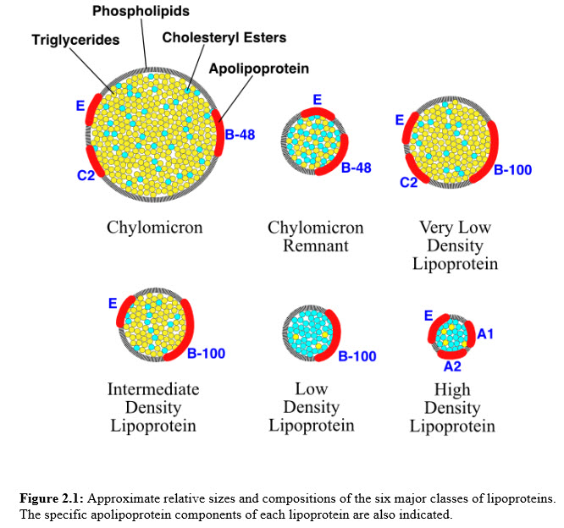

High-Density Lipoproteins (HDL)
HDL has a density greater than 1.063 g/mL and ranges in diameter from 5 to 15 nm. In a young and otherwise healthy individual, it is composed of approximately 33% protein, 30% cholesterol, 29% phospholipid and 4% triacylglycerol.
The role of HDL is to collect hat molecules such as phospholipids, cholesterol and triglycerides in the cells of the body and transport it to the liver to be broken down. HDL is sometimes known as “good” cholesterol because high concentrations of this lipoprotein usually correspond to healthier blood vessels and lower risk of atherosclerosis.

Low-Density Lipoproteins (LDL)
The density of LDL is between 1.019 and 1.063 g/mL and ranges in diameter from 18 to 28 nm. In a young and otherwise healthy individual, it is composed of approximately 50% cholesterol, 25% protein, 21% phospholipid and 8% triacylglycerol. LDL is important for the transport of fat molecules such as phospholipids, cholesterol and triglycerides around the body. It is sometimes known as “bad” cholesterol because raised concentrations tend to be associated with progression of atherosclerosis.
There are further subtypes of LDL, including large buoyant LDL (lb LDL) and small dense LDL (sd-LDL).

Intermediate Density Lipoproteins (IDL)
The density of IDL is between 1.006 and 1.019 g/mL and ranges in diameter from 25 to 50 nm. In a young and otherwise healthy individual, it is composed of approximately 31% triacylglycerol. 29% cholesterol, 22% phospholipid and 18% protein. This type of lipoprotein is not usually present in the blood when fasting.

Very Low-Density Lipoproteins (VLDL)
VLDL has a density between 0.950 and 1.006 g/mL and ranges in diameter from 30 to 80 nm. In a young and otherwise healthy individual, it is composed of approximately 50% triacylglycerol. 22% cholesterol, 18% phospholipid and 10% protein.
This lipoprotein is responsible for the transportation of synthesized triglyceride from the liver to the adipose tissue where it can be stored.

Chylomicrons
The density of chylomicrons is less than 0.95 g/mL and ranges in diameter from 100 to 1000 nm. In a young and otherwise healthy individual, it is composed of approximately 84% triacylglycerol. 8% cholesterol, 7% phospholipid and less than 2% protein.
These lipoproteins are responsible for the transportation of triglycerides in the gastrointestinal tract throughout the body, such as to the liver, skeletal tissue and adipose tissue.
Metabolism
Lipoprotein metabolism can be thought of as two cycles, one exogenous and one endogenous ,both centered on the liver. These cycles are interconnected.

The Exogenous lipid cycle
Dietary lipid is absorbed in the small intestine and incorporated into chylomicrons which are secreted into the lymphatics and reach the bloodstream via the thoracic duct
Formation of chylomicron remnants: As the chylomicron circulates and more than ninety percent of the triacylglycerol in its core is degraded by lipoprotein lipase, the particle decreases in size and increases in density. In addition, the C apoproteins (but not apo E) are returned to HDLs. The remaining particle, called a "remnant," is rapidly removed from the circulation by the liver, whose cell membranes contain lipoprotein receptors that recognize apo E. Chylomicron remnants bind to these receptors and are taken into the hepatocytes by endocytosis. These remnants are removed by the liver to form cell membrane components or bile acids, or may be excreted in the bile . The liver provides the only route by which cholesterol leaves the body in significant amounts. The receptor is recycled.
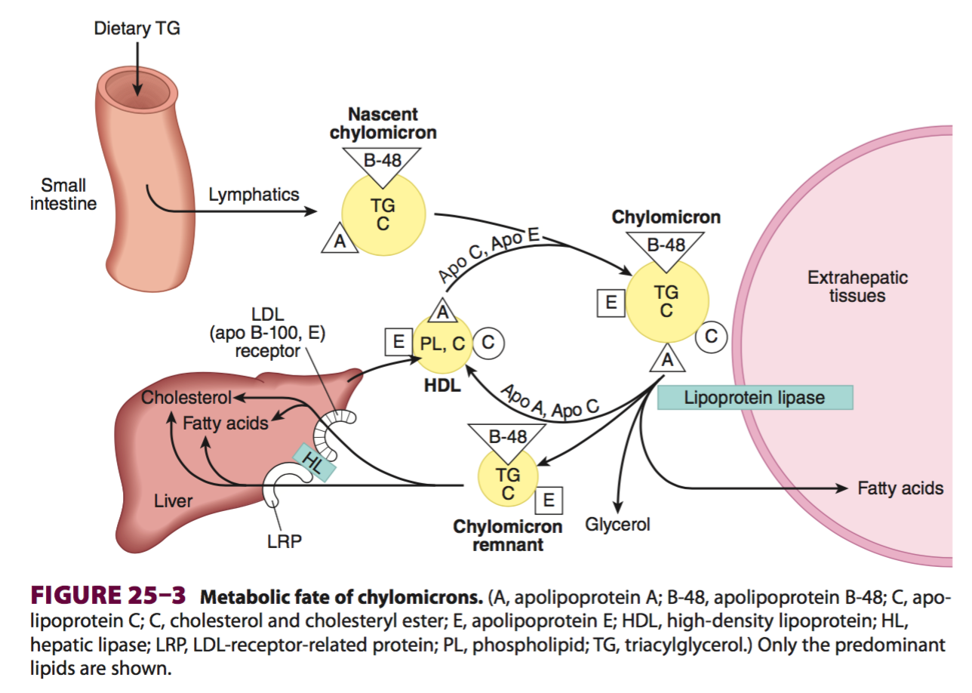
The endogenous lipid cycle
The liver synthesizes VLDL particles which undergo the same form of delipidation as chylomicrons by the action of lipoprotein lipase.
Metabolism of very low density lipoproteins:
VLDLs are produced in the liver. They are composed predominantly of triacylglycerol, and their function is to carry this lipid from the liver to the peripheral tissues. There, the triacylglycerol is degraded by lipoprotein lipase .
1. Release of VLDLs: VLDLs are secreted directly into the blood by
the liver as nascent VLDL particles containing apolipoprotein B-100.They must obtain apo C-ll and apo E from circulating HDL . As with chylomicrons, apo C-ll is required for activation of lipoprotein lipase.
2. Modification of circulating VLDL: As VLDLs pass through the circulation, triacylglycerol is degraded by lipoprotein lipase, causing the VLDL to decrease in size and become denser. Surface components, including the C apoproteins , is returned to HDL, but the particles retain apo B-100 Finally, triacylglycerols are transferred from VLDL to HDL in an exchange reaction that concomitantly transfers cholesteryl esters from HDL to VLDL. This exchange is accomplished by cholesteryl ester transfer protein.
3. Production of LDL from VLDL in the plasma: With these modifications, the VLDL is converted in the plasma to LDL. An intermediate-sized particle, the intermediate-density lipoprotein (IDL) or VLDL remnant, is observed during this transition. IDLs can also be taken up by cells through receptor-mediated endocytosis that uses apo E as the ligand.

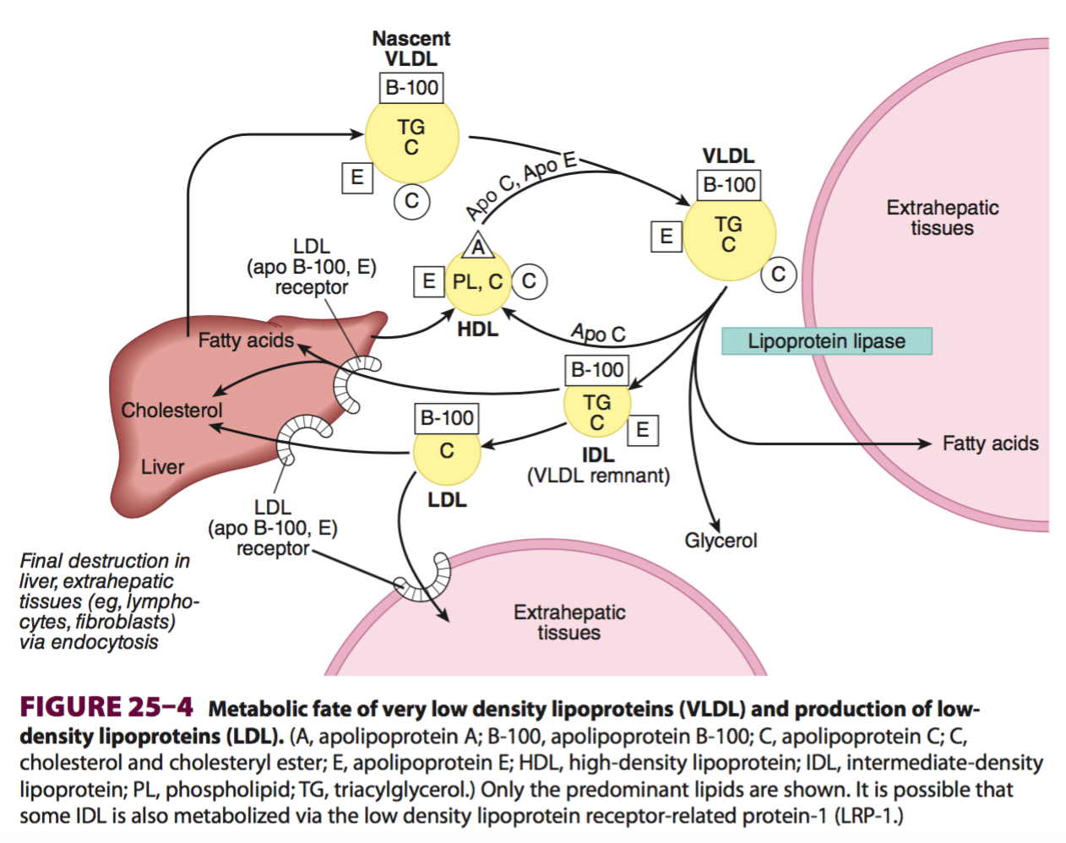
HDL particles are derived from both liver and gut. They act as cholesteryl ester shuttles, removing the sterol from the peripheral tissues and returning it to the liver. The HDL is taken up either directly by the liver, or indirectly by being transferred to other circulating lipoproteins, which then return it to the liver. This process is thought to be anti-atherogenic, and an elevated HDL-cholesterol level has been shown to confer a decreased risk of coronary heart disease on an individual.
***Over supply of cholesterol (from LDL, HDL, chylomicron remnants) decrease by:

- (-) HMG CoA reductase → decrease cholesterol synthesis

- (+) ACAT (Acyl-CoA cholesterol acyl transferase) which transfer FA form fatty acyl CoA to cholesterol → cholesterol Ester
- (-) synthesis of new LDL receptors → decrease further entry of LDL into cell.
Function of LDL:
Carry cholesterol from liver to extra hepatic tissue

Functions of HDL:
- Act as a source for apo C and apo E that are required in the metabolism of chylomicrons & VLDL
- Removing free cholesterol from extra hepatic tissues and esterifying it using LCAT The apo A1 of HDL activates LCAT. Cholesterol ester transferred to HDL, carry cholesterol ester to liver a process known as reverse cholesterol transport
- Transport phospholipids from liver to tissues

Hyperlipoproteinemias
A group of disorders characterized by increased plasma lipoproteins. According to fredrickson: They can be classified into 5 types Each of which may be familial or acquired .

1- Type I, Hyperlipoproteinemias:
- The familial type is due to deficiency of lipoprotein lipase enzyme
- Characterized by increased plasma chylomicrons and somewhat VLDL, but LDL and HDL are reduced
- There is marked increase in plasma triacylglycerol's & some increase in plasma cholesterol may occur
- The plasma is turbid

2-TypeII, Hyperbetalipoproteinemia:
- Characterized by increased plasma LDL
- The familial type is caused by reduced LDL metabolism due to defective LDL receptors
- There is marked increase in plasma cholesterol (familial hypercholesterolemia)
- Plasma is clear
- The acquired type occurs in hypothyroidism
3-Type III, Dysbetalipoproteinemia
- Characterized by increased VLDL, (IDL) & chylomicrons remnants
- The plasma is turbid
- There is hypercholesterolemia & hypertriacylglycerodemia
- The familial type is caused by defective apo E necessary for uptake and metabolism of VLDL and chylomicron remnants by liver
4- Type IV, Hyperprebetalipoproteinemia
- Characterized by increased plasma VLDL , triacylglycerol's & some increase in plasma cholesterol
- The plasma is turbid
- The familial type is due to increased formation of triacylglycerol's from carbohydrates
- The acquired type occurs in severe type II DM, obesity & alcoholism
5- TypeV: Hyperchylomicronemia & Hyperprebetalipoproteinemia
- Characterized by increased chylomicrons and VLDL increase triacylglycerol's & somewhat cholesterol
- The plasma is turbid
- The cause of disease is unknown, but may be due to increase formation of apo- B.
- it is usually associated with obesity and glucose hypotolerance
6-Type VI, hyperalphalipoproteinemia
- Characterized by increased HDL & hypercholesterolemia
- It occurs during estrogen therapy
Hypolipoproteinemias
1. Abetalipoproteinemia
- Familial disease.
- Caused by failure of liver & intestine to synthesize apo B that lead to absence of chylomicrons, VLDL & LDL from blood
- Marked decrease in plasma lipids
- The intestine fails to absorb triacylglycerol which may cause fatty diarrhea
- The liver fails to mobilize fats to the blood that lead to fatty liver
2. Hypobetalipoproteinemia
- Familial disease
- Caused by decreased formation of the apo-B100 by the liver which may cause decreased formation of VLDL & LDL
- Decreased plasma lipids
3. Alphalipoprotein deficiency
- Familial disease
- Caused by failure of the liver to synthesis apo-A
- Cholesterol esters accumulate in tissues (Tangiers disease)
- Plasma triacylglycerol's are increased due to deficiency of apo C-II the activator of lipoproteins lipase
- HDL is absent in Tangier disease

**There is an important relationship between atherosclerosis and HDL: Decreased HDL is associated with atherosclerosis Increased HDL represents protection against atherosclerosis Increased LDL/HDL ratio is a predispose to atherosclerosis. Decreased LDL/ HDL ratio is a good sign

4- Lecithin-cholesterol acyl transferase deficiency:

- Familial disease
- Abnormal plasma HDL, LDL and VLDL are present
Enzymes Involved in Lipid Transport
(1) LCAT:
- Transfer acyl group from lecithin (HDL) to cholesterol forming cholesterol ester & lysolecithin
- Site: plasma
- Activated by apo A1 (HDL)

(2) Lipoprotein Lipase:
- Site: wall of blood capillaries in all tissues except liver and brain.
- Attached to endothelial cells by heparin sulphate
- It hydrolyses triglycerides present in chylomicrons & VLDL
(3) Hepatic Lipase:

- Site: endothelial cells of the liver,
- Similar action to lipoprotein lipase but it is more specific in hydrolyzing TG in smaller particles as VLDL remnants (IDL) & chylomicrons remnants.

(4) Mobilizing Lipase (Hormone sensitive triglyceride lipase):

- Site: adipose tissue cells,
- controls the release of FA from adipose tissue to plasma.
(5) (HMG COA) reductase enzyme
Control cholesterol biosynthesis (Key enzyme). Activity is controlled by amount of cholesterol cells , which in turn largely depends on cholesterol uptake from the blood.

