Permutations and Combinations
Permutations and combinations give us quick, algebraic methods of counting.
They are used in probability problems for two purposes:
- to count the number of equally likely possible results for the classical approach to probability, and
- to count the number of different arrangements of the same items to give a multiplying factor.
FACT 1: The number of distinct Permutations of n objects is “n factorial”, denoted by $n !=n( n- 1 )…(2)(1)$

= n × (n − 1) × (n − 2) × ... × 2 × 1

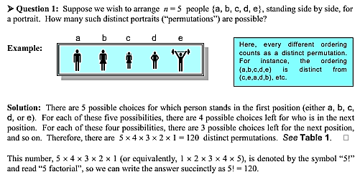

For example : $5!=5\left(4\right)\left(3\right)\left(2\right)\left(1\right)=120, 0!=1, 1!=1$

FACT 2: The number of distinct Permutations of n objects, taken k at a time, is given by the ratio
$P_{r}^{n}=\frac{n !}{(n-k)!}=\frac{n( n- 1 )…(2)(1)}{\left(n-k\right)\left(n-k-1\right)…1}=n( n- 1 )…\left(n-k+1\right)$

n!
(n − k)! = n × (n − 1) × (n − 2) × ... × (n − k + 1) .

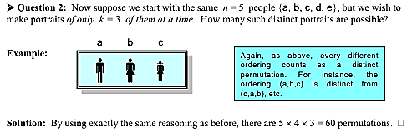

FACT 3: The number of distinct Combinations of n objects, taken k at a time, is given by the ratio
$C_{r}^{n}=\frac{n !}{k!(n-k)!}=\frac{n( n- 1 )…\left(n-k+1\right)}{k!}$
This quantity is usually written as $C_{r}^{n}$ or $\left({n \atop k}\right)$ and read "n choose k"

n!
(n − k)! = n × (n − 1) × (n − 2) × ... × (n − k + 1) .

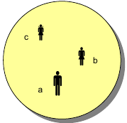
Question 3: Finally suppose that instead of portraits (“permutations”), we wish to form committees (“combinations”) of k = 3 people from the original n = 5. How many such distinct committees are possible?

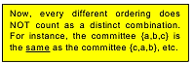

Solution: This time the reasoning is a little subtler. From the previous calculation, we know that # of permutations of k = 3 from n = 5 is equal to $\frac{5!}{2!}=60$
But now, all the ordered permutations of any three people (and there are 3! = 6 of them, by FACT 1), will “collapse” into one single unordered combination, e.g., {a, b, c}, as illustrated. So...
# of combinations of k = 3 from n = 5 is equal to $\frac{5!}{(3!)2!}=10$
See Table 3 for the explicit list!
number of ways of selecting 3 objects from 5 objects, regardless of their order.
Examples: Find $C_{3}^{5},C_{2}^{8},C_{5}^{5}$
$$C_{3}^{5}=\frac{5 !}{3!(5-3)!}=\frac{5( 4)(3)(2)( 1 )}{(3)(2)( 1 )(2)( 1 )}=10, C_{3}^{8}=\frac{8 !}{2!(8-2)!}=\frac{(8)(7)(6)(5)( 4)(3)(2)( 1 )}{(6)(5)( 4)(3)(2)( 1 )(2)}=28, C_{5}^{5}=1????$$
