Mathematical Statistics / Fourth Stage/ Dr. Kareema Abed AL-Kadim
-------------------------------------------------------------------------((1))-----------------------------------------

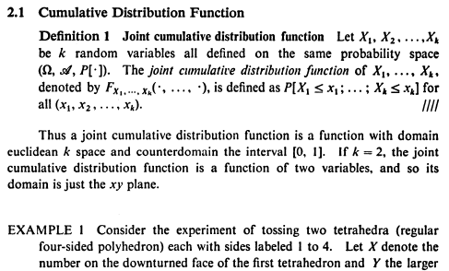

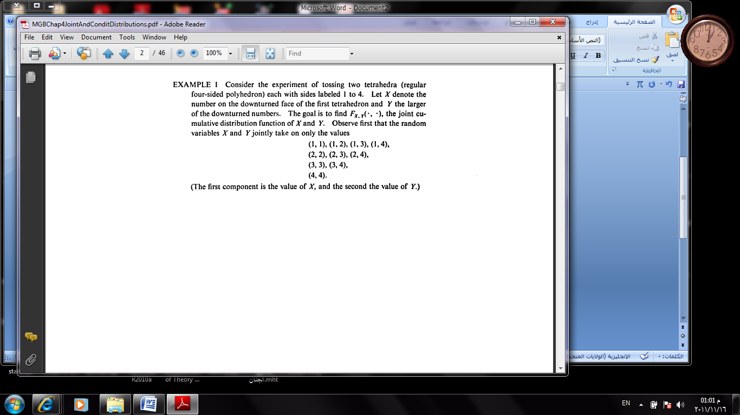

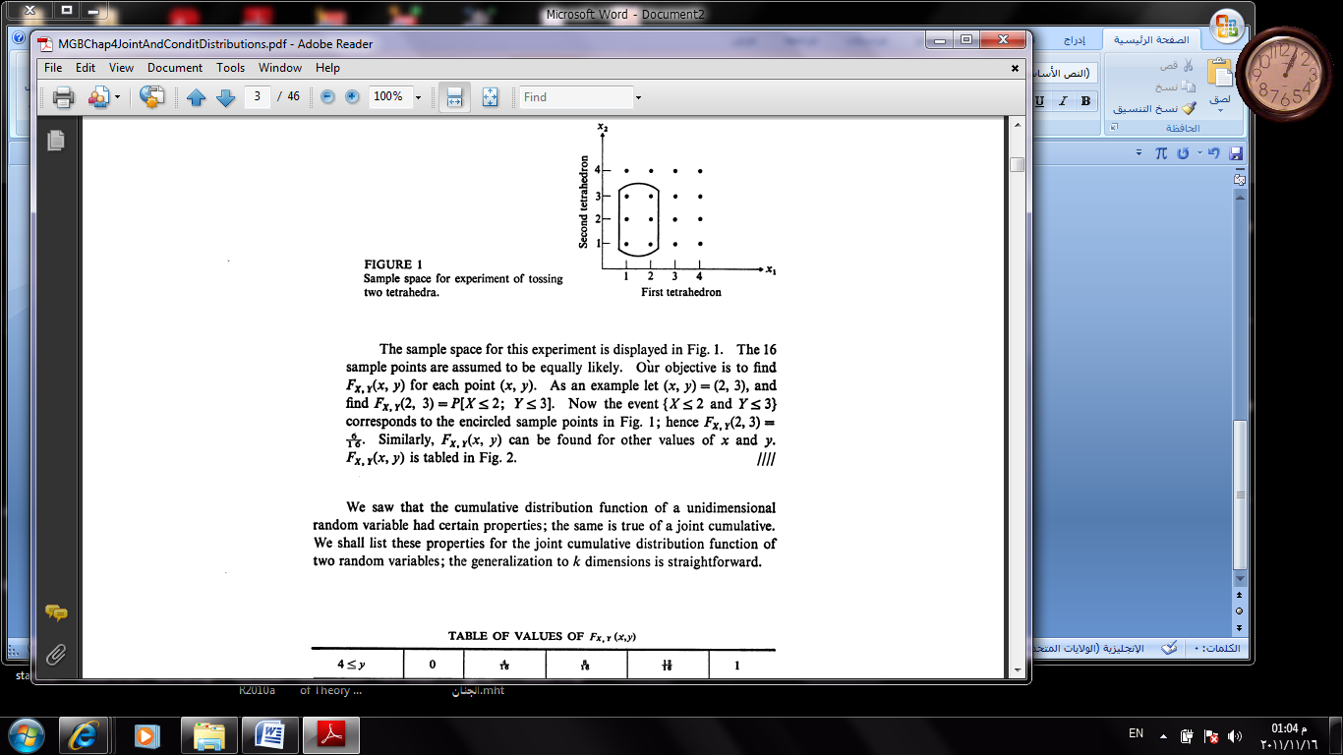

Mathematical Statistics / Fourth Stage/ Dr. Kareema Abed AL-Kadim
-------------------------------------------------------------------------((2))-----------------------------------------
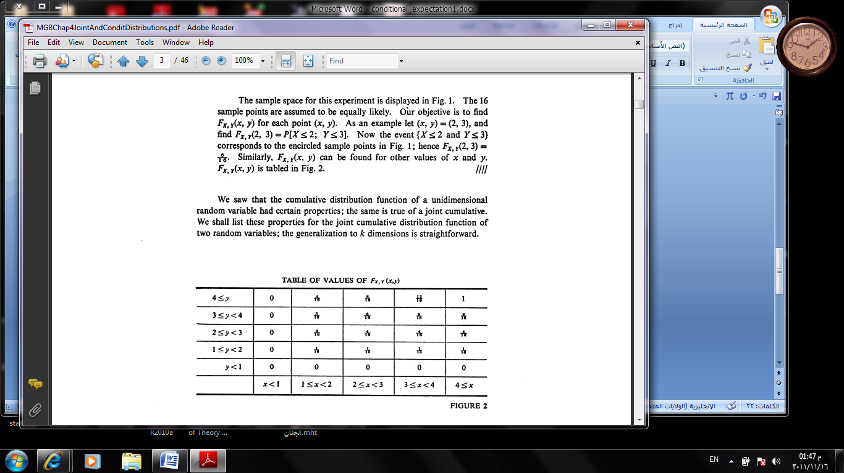

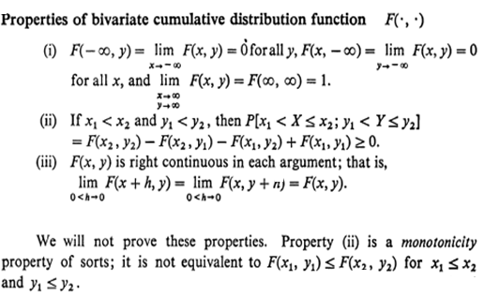

Mathematical Statistics / Fourth Stage/ Dr. Kareema Abed AL-Kadim
-------------------------------------------------------------------------((3))-----------------------------------------

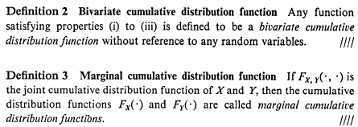

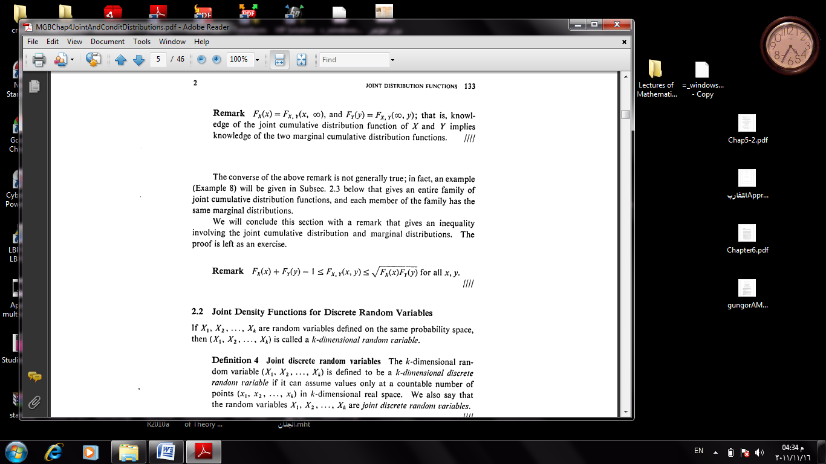

Mathematical Statistics / Fourth Stage/ Dr. Kareema Abed AL-Kadim
-------------------------------------------------------------------------((4))-----------------------------------------

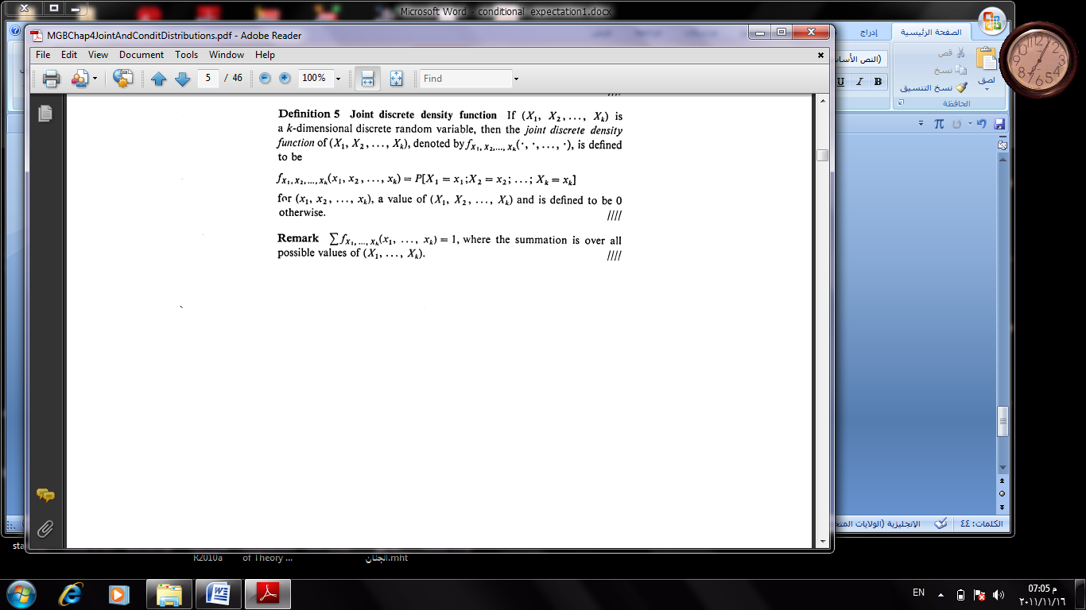

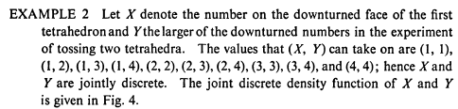

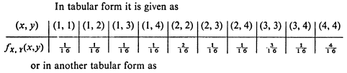

Mathematical Statistics / Fourth Stage/ Dr. Kareema Abed AL-Kadim
-------------------------------------------------------------------------((5))-----------------------------------------

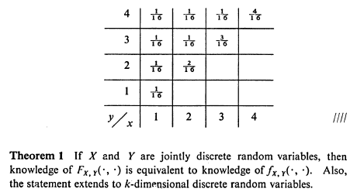

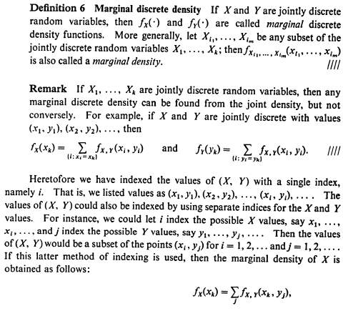

Mathematical Statistics / Fourth Stage/ Dr. Kareema Abed AL-Kadim
-------------------------------------------------------------------------((6))-----------------------------------------
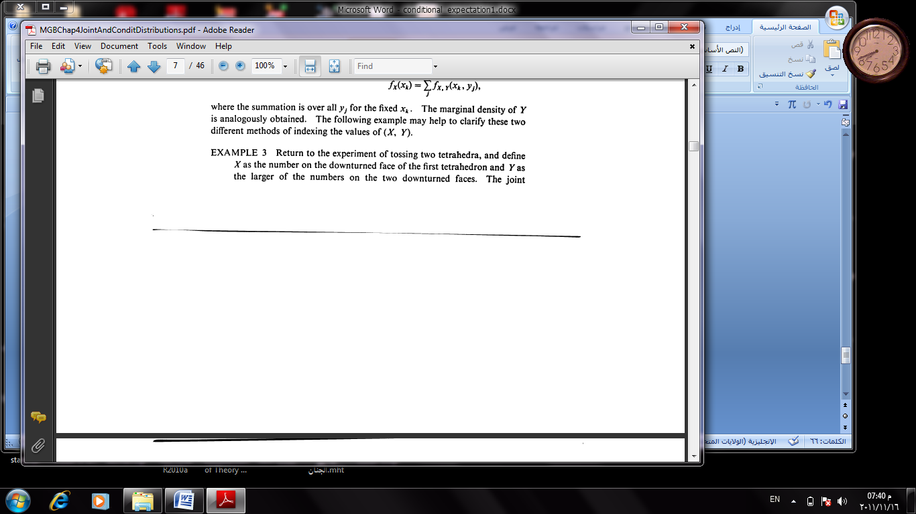

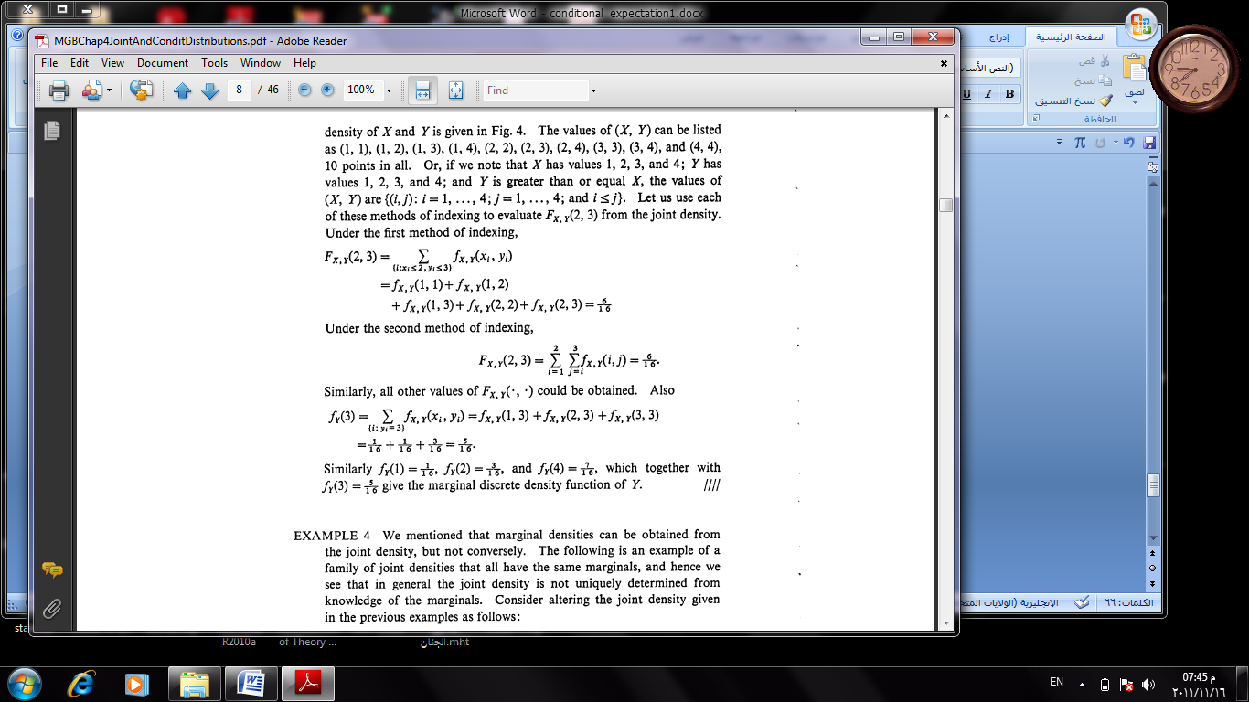

Mathematical Statistics / Fourth Stage/ Dr. Kareema Abed AL-Kadim
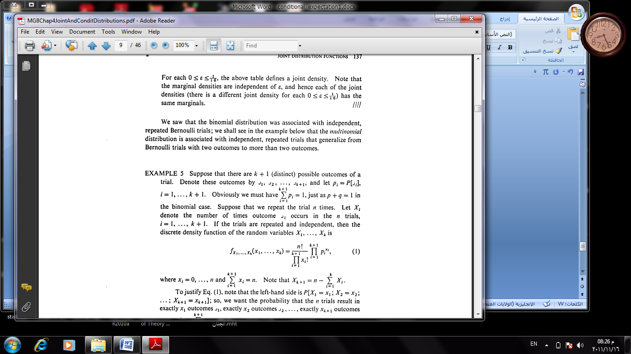
-------------------------------------------------------------------------((7))-----------------------------------------

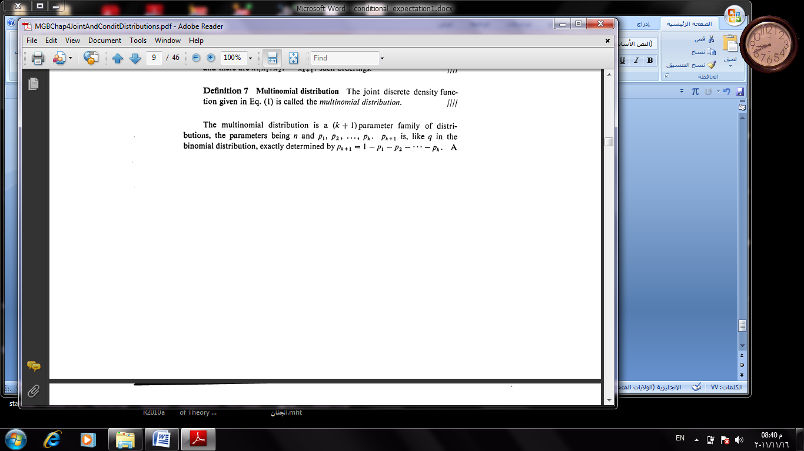

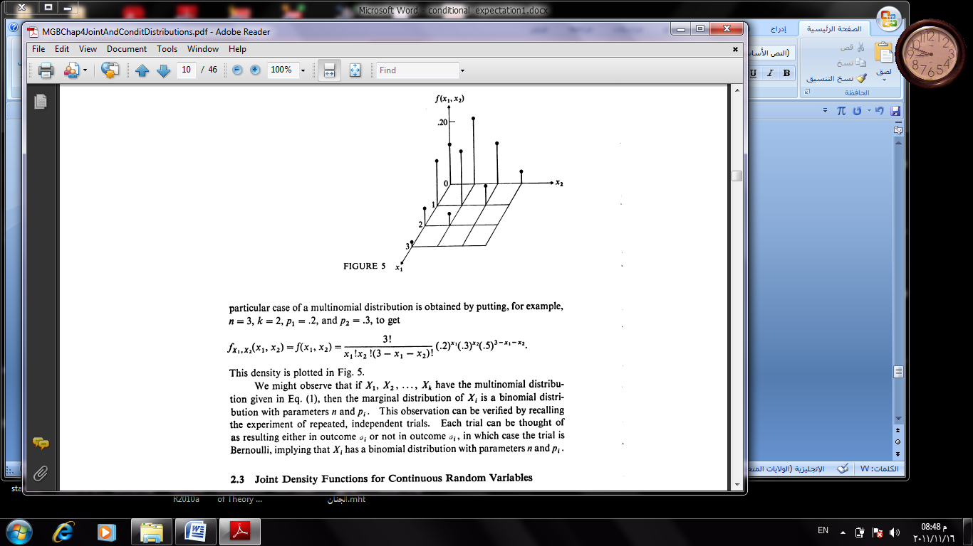

Mathematical Statistics / Fourth Stage/ Dr. Kareema Abed AL-Kadim
-------------------------------------------------------------------------((8))-----------------------------------------
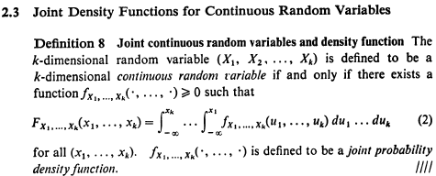

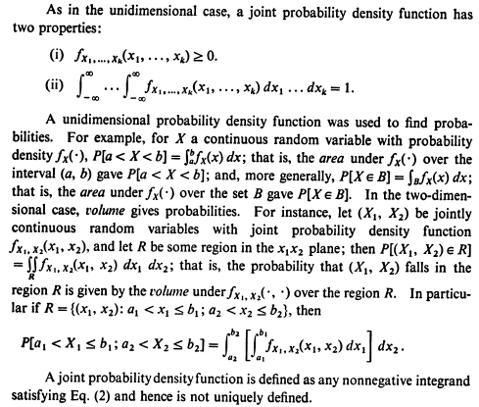

Mathematical Statistics / Fourth Stage/ Dr. Kareema Abed AL-Kadim
-------------------------------------------------------------------------((9))-----------------------------------------
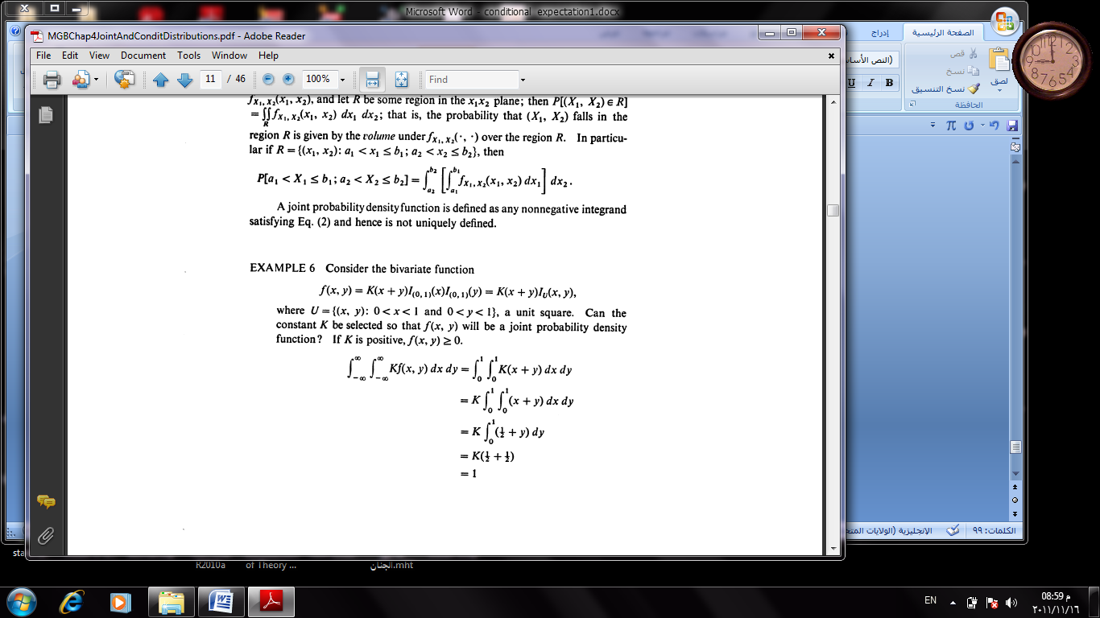

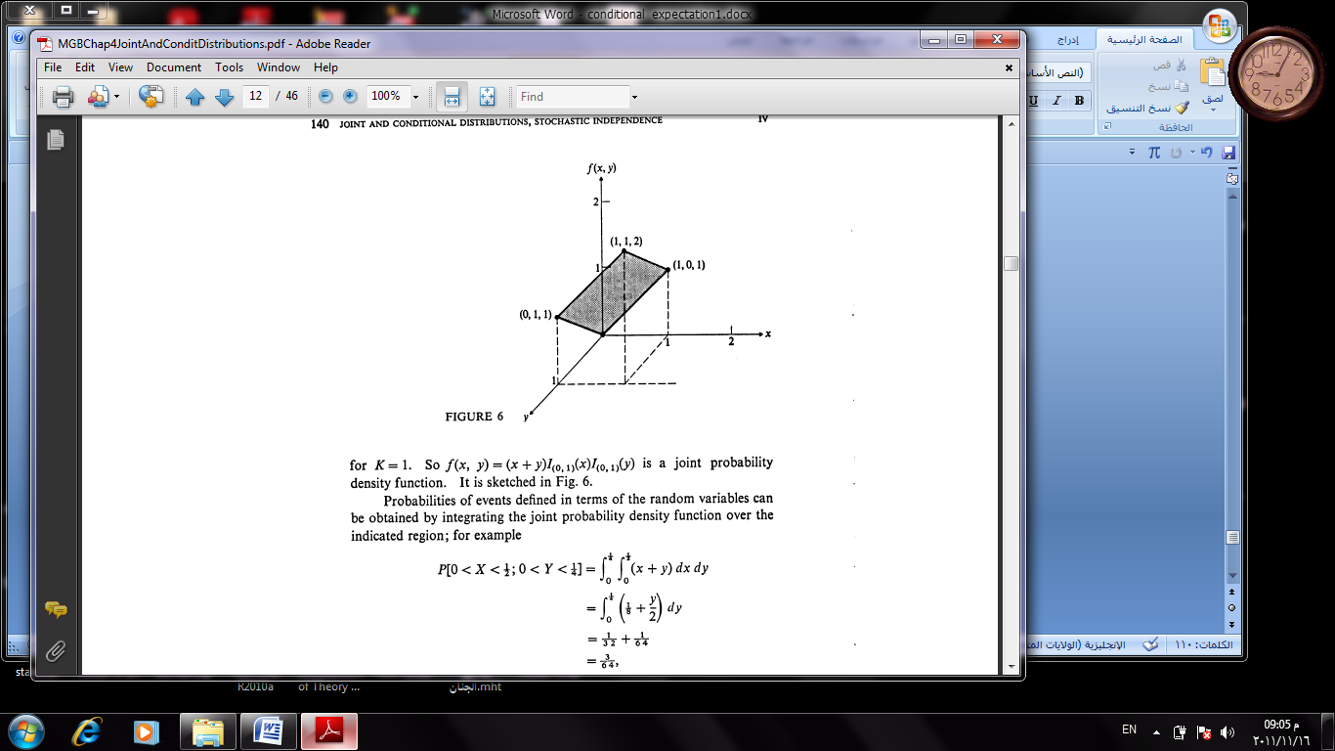

Mathematical Statistics / Fourth Stage/ Dr. Kareema Abed AL-Kadim
-------------------------------------------------------------------------((10))-----------------------------------------
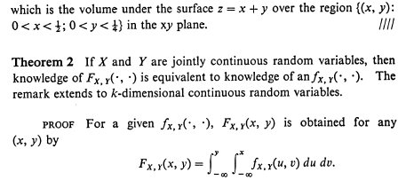

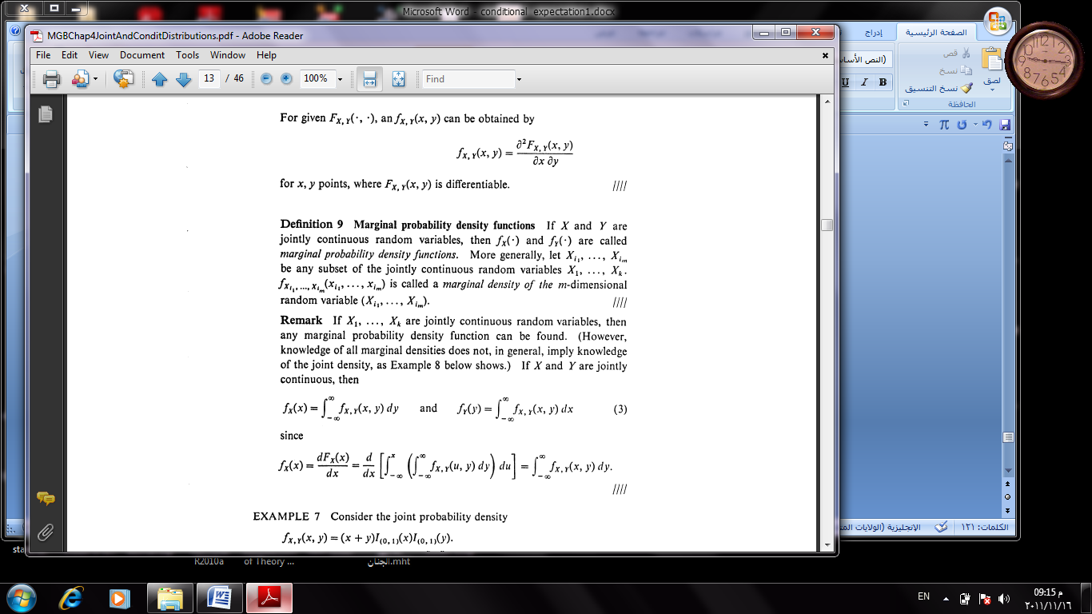

Mathematical Statistics / Fourth Stage/ Dr. Kareema Abed AL-Kadim
-------------------------------------------------------------------------((11))-----------------------------------------
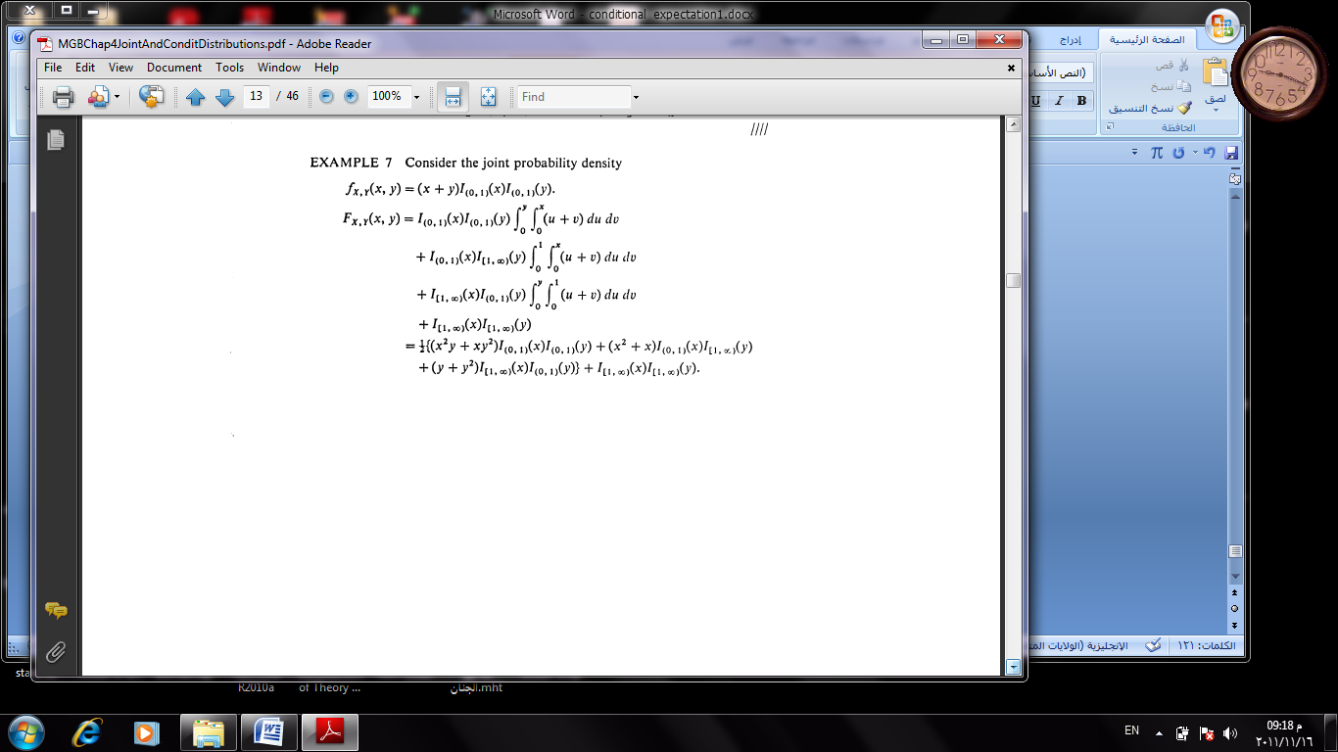

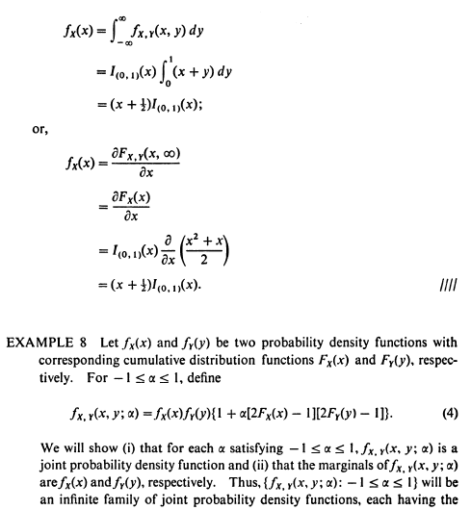

Mathematical Statistics / Fourth Stage/ Dr. Kareema Abed AL-Kadim
-------------------------------------------------------------------------((12))-----------------------------------------
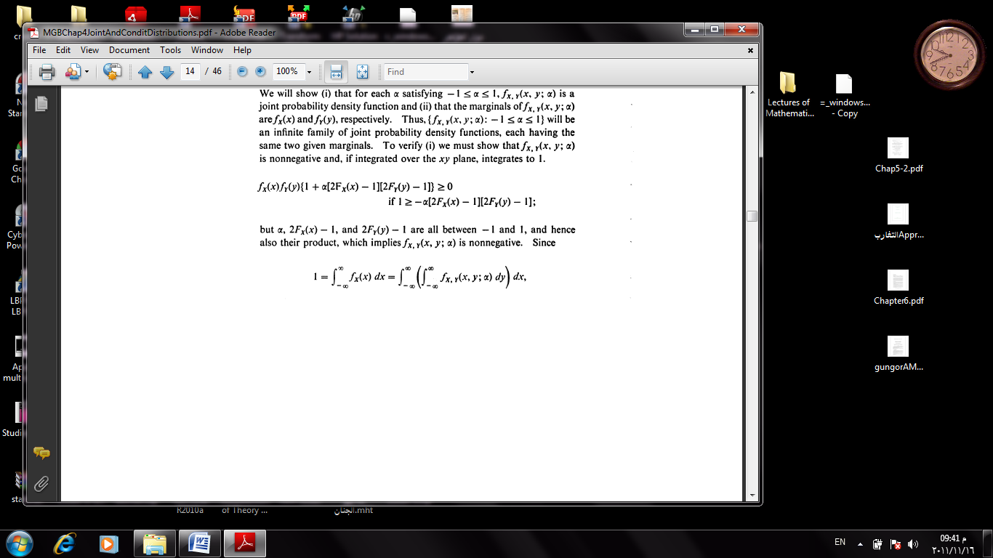

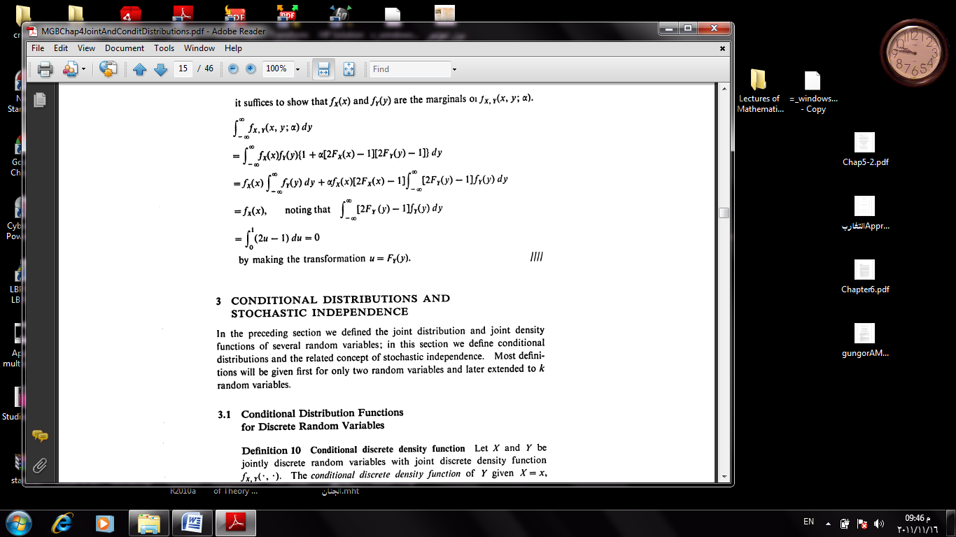

Mathematical Statistics / Fourth Stage/ Dr. Kareema Abed AL-Kadim
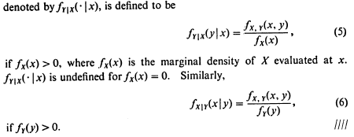
-------------------------------------------------------------------------((13))-----------------------------------------

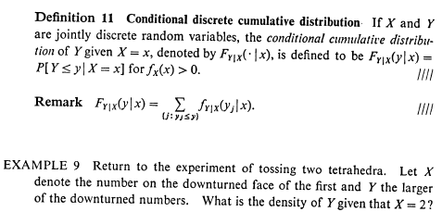

Mathematical Statistics / Fourth Stage/ Dr. Kareema Abed AL-Kadim
-------------------------------------------------------------------------((14))-----------------------------------------
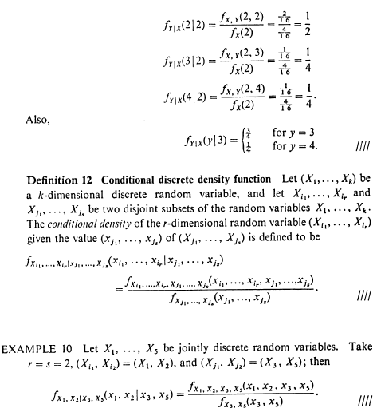

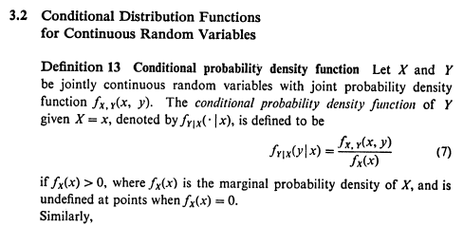

Mathematical Statistics / Fourth Stage/ Dr. Kareema Abed AL-Kadim
-------------------------------------------------------------------------((15))-----------------------------------------
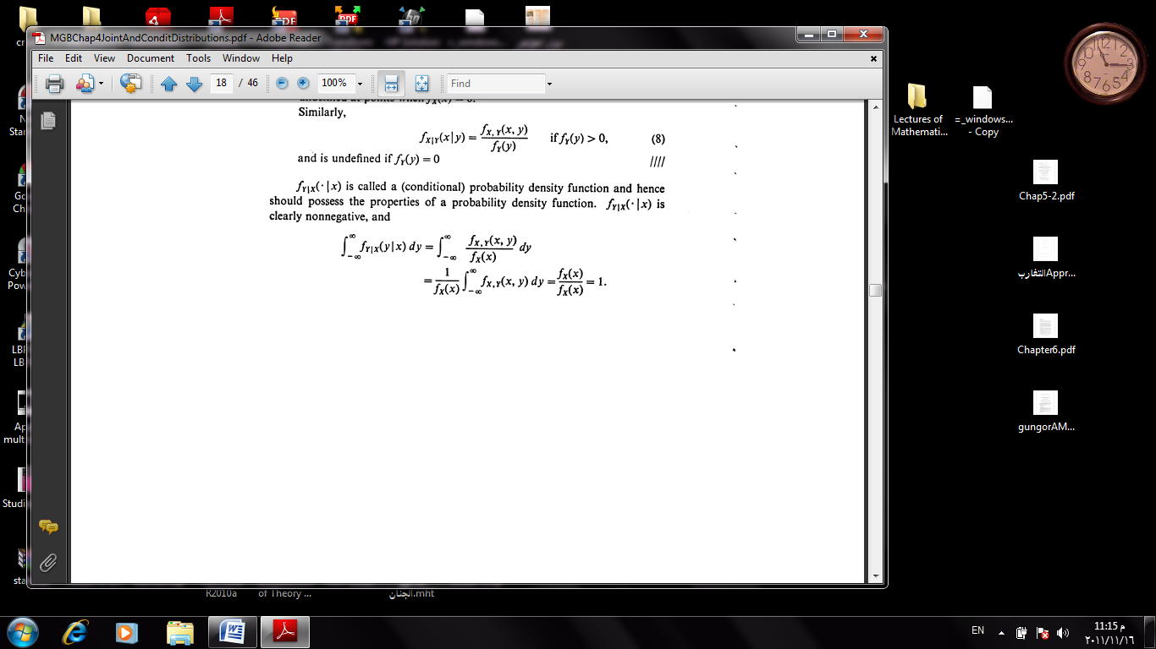

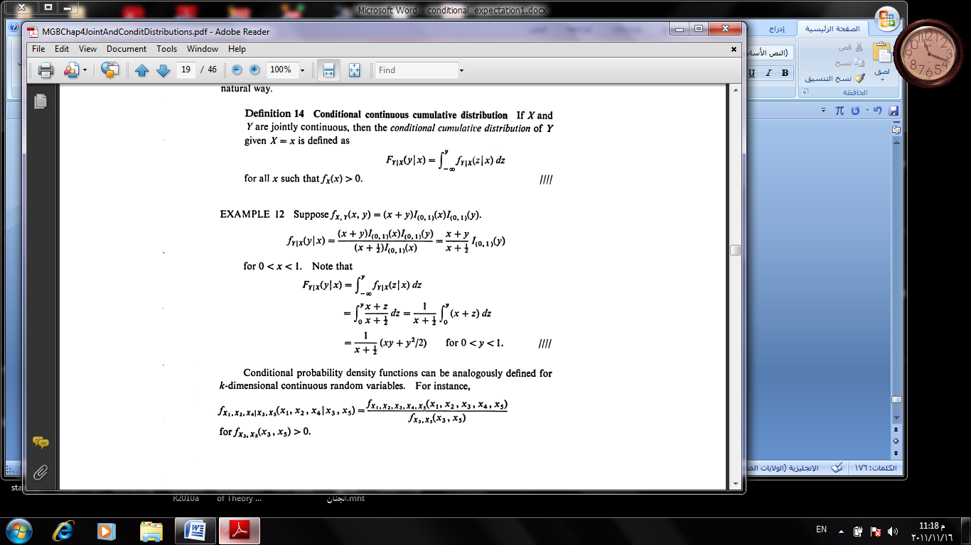

Mathematical Statistics / Fourth Stage/ Dr. Kareema Abed AL-Kadim
-------------------------------------------------------------------------((16))-----------------------------------------
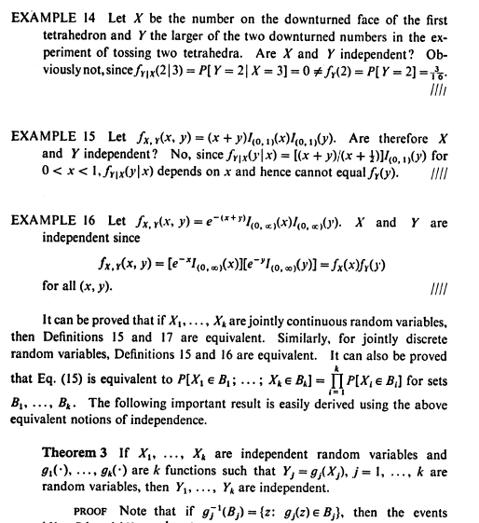

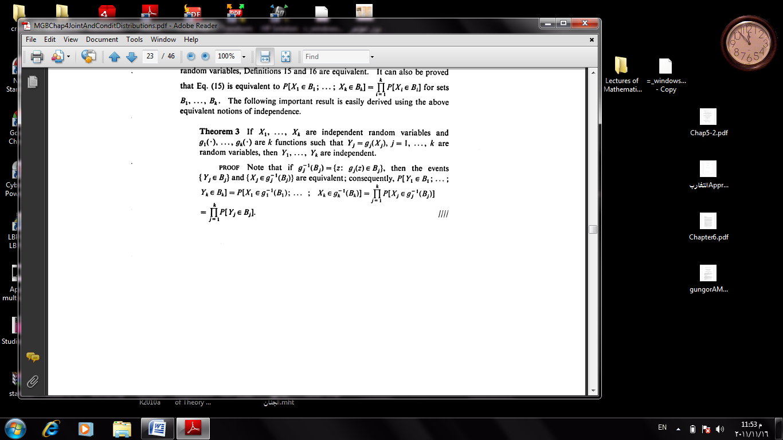

Mathematical Statistics / Fourth Stage/ Dr. Kareema Abed AL-Kadim
-------------------------------------------------------------------------((17))-----------------------------------------
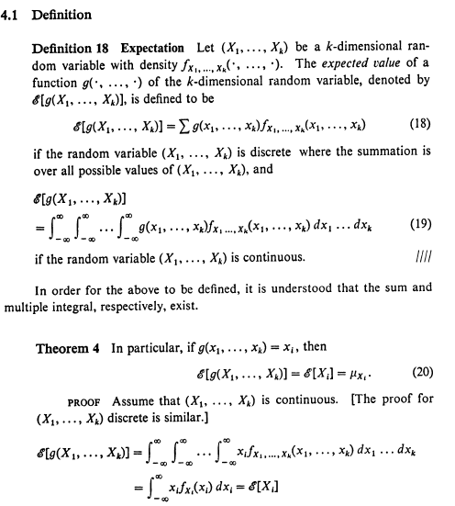

Mathematical Statistics / Fourth Stage/ Dr. Kareema Abed AL-Kadim
-------------------------------------------------------------------------((18))-----------------------------------------
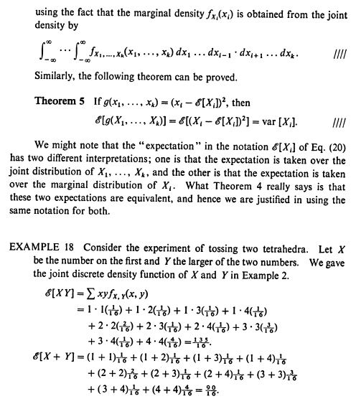

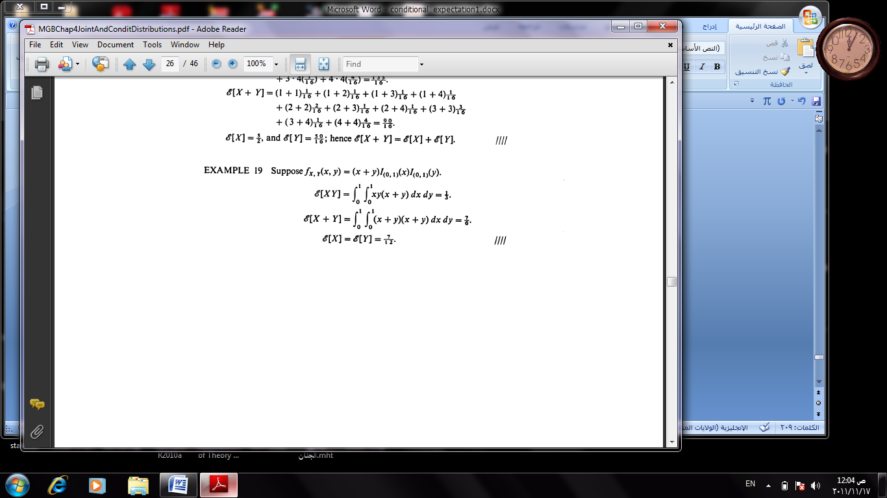

Mathematical Statistics / Fourth Stage/ Dr. Kareema Abed AL-Kadim
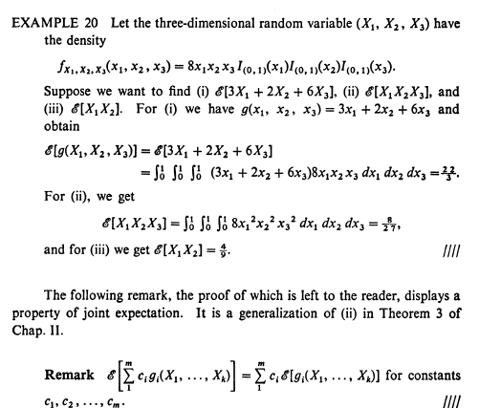
-------------------------------------------------------------------------((19))-----------------------------------------

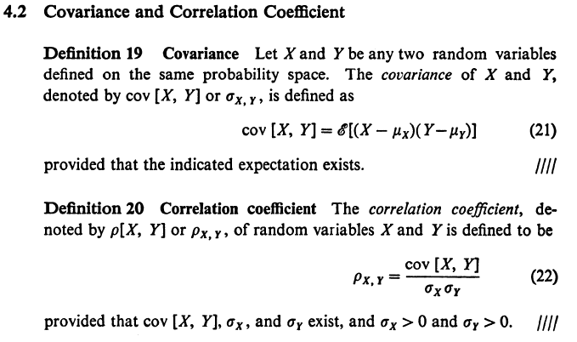

Mathematical Statistics / Fourth Stage/ Dr. Kareema Abed AL-Kadim
-------------------------------------------------------------------------((20))-----------------------------------------

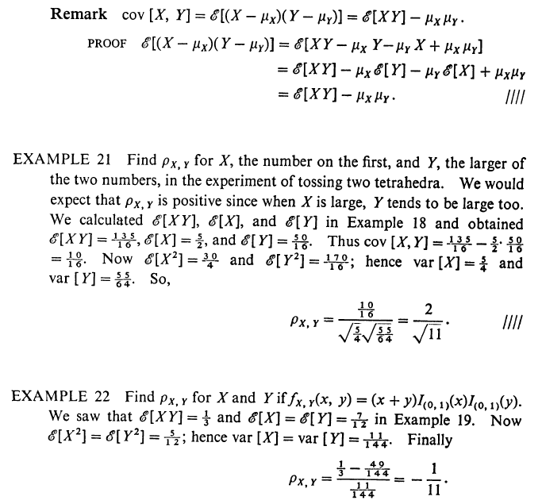

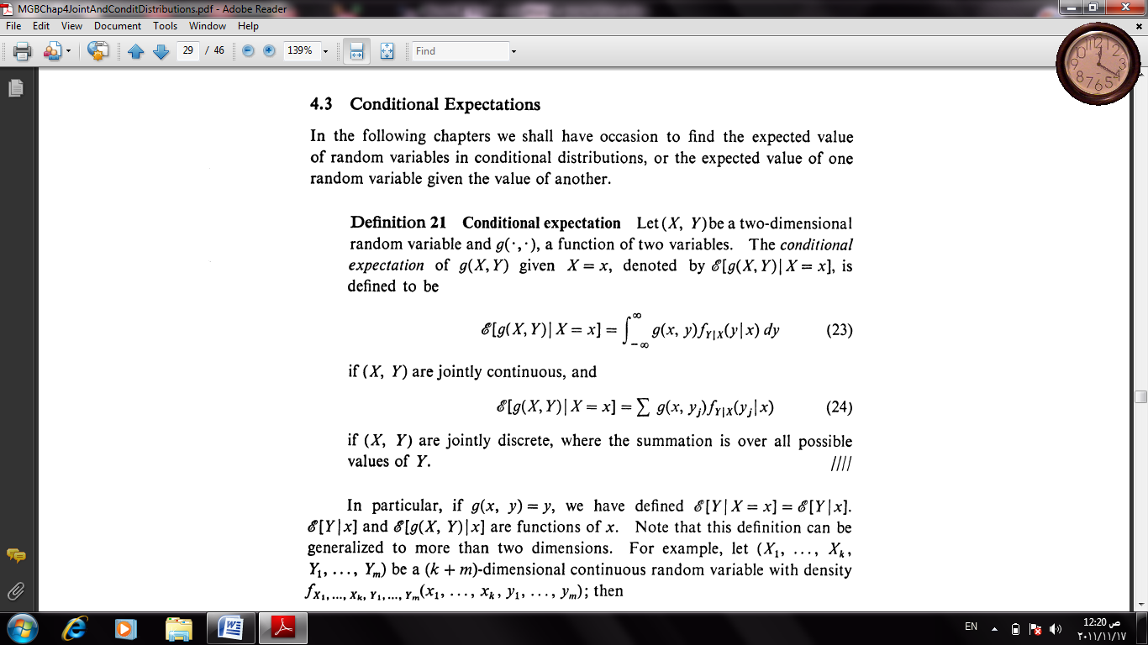

Mathematical Statistics / Fourth Stage/ Dr. Kareema Abed AL-Kadim
-------------------------------------------------------------------------((21))-----------------------------------------

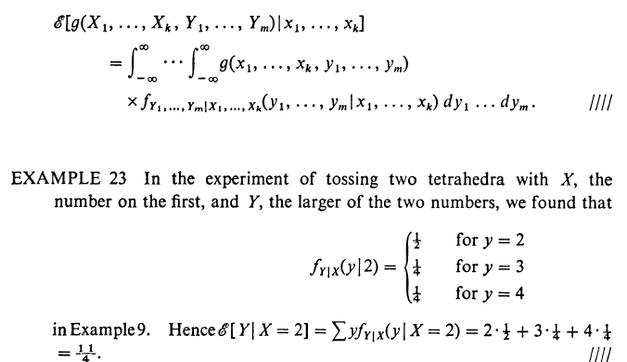

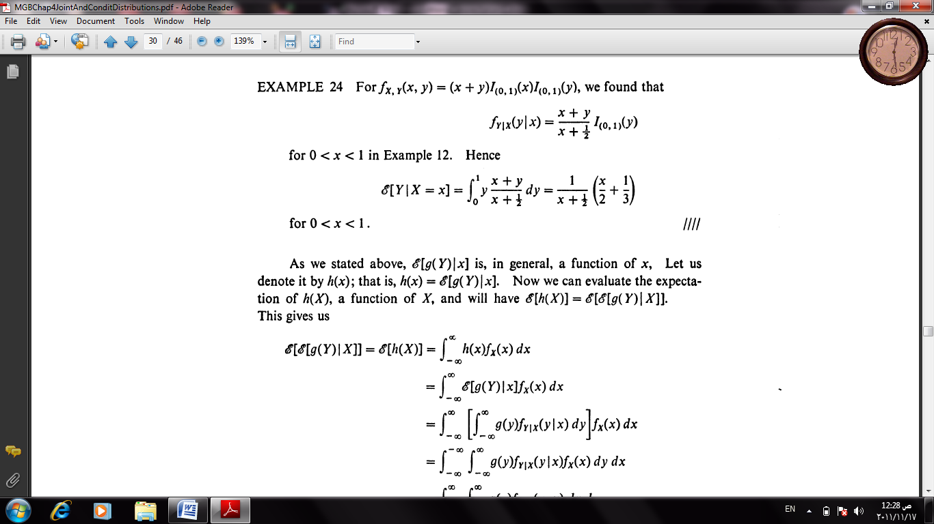

Mathematical Statistics / Fourth Stage/ Dr. Kareema Abed AL-Kadim
-------------------------------------------------------------------------((22))-----------------------------------------

