Lec2:microbial genetics Ass.Prof.Dr.Lamees A.Razzaq

Conjugation
- A second mechanism by which genetic transfer takes place is conjugation.
- This mechanism requires the presence of a special plasmid called the F plasmid.
  - The F plasmid, for example, facilities conjugation.
    - This can give a bacterium new genes that may help it survive in a changing environment.
    - An integrated plasmid is called an episome.
- Bacteria that have a F plasmid are referred to as F+ or male.
  - Those that do not have an F plasmid are F- of female.
- The F plasmid consists of 25 genes that mostly code for production of sex pilli.
- A conjugation event occurs when the male cell extends his sex pili and one attaches to the female.
  - This attached pilus is a temporary cytoplasmic bridge through which a replicating F plasmid is transferred from the male to the female.
  - When transfer is complete, the result is two male cells.
- The F plasmid can behave as an episome.
  - When the F+ plasmid is integrated within the bacterial chromosome, the cell is called an Hfr cell (high frequency of recombination cell).
- The Hfr cell still behaves as a F+ cell, transferring F genes to a F-cell, but now it can take some of the bacterial chromosome with it.
- Replication of the Hfr chromosome begins at a fixed point within the F episome and the chromosome is transferred to the female as it replicates.
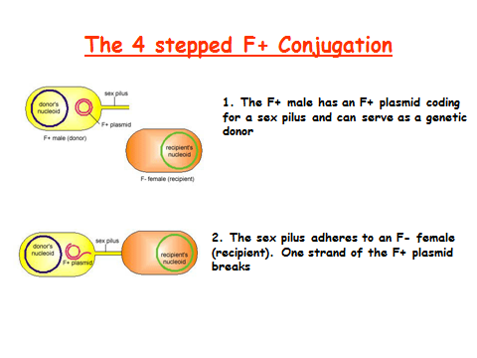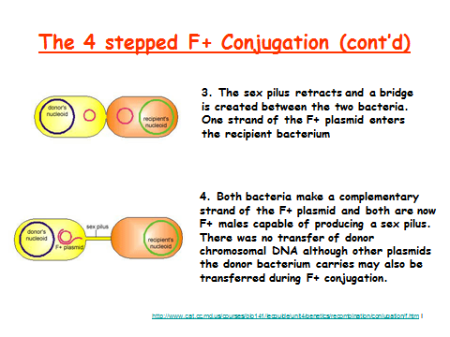

Transduction
- Another method of genetic transfer and recombination is transduction.
- This method involves the transfer of DNA from one bacterium to another with the use of a bacteriophage (phage).
  - A phage is a virus that infects bacteria.
  - The phage T4 and the phage lambda, for example, both infect E. coli.
- Phages are obligatory intracellular parasites and must invade a host cell in order to reproduce.
  - T4 multiplies by the lytic cycle which kills the host and lamba multiplies by the lysogenic cycle which does not cause the death of the host cell.
  - In lysogeny, the phage DNA remains latent in the host until it breaks out in a lytic cycle.
- General Steps Of The Lytic Cycle:
  - Attachment of T4 to receptors on E. coli cell wall.
  - Penetration of the cell wall by tail core. Inject DNA into host.
  - E. coli DNA is hydrolyzed. Phage DNA directs biosynthesis of viral parts using the host cell's machinery.
  - The phages mature as the parts are assembled.
  - Lyses of E. coli and release of the new phages.
- General Steps Of The Lysogenic Cycle:
  - Phage attaches to E. coli and injects DNA.
  - In the lysogenic cycle the circular phage DNA recombines with E. coli DNA and the phage DNA is now called prophage.
  - E. coli undergoes cell division, copying prophage and passing to daughter.
    - With more divisions there are more cells with the prophage.
  - The prophage may exit the chromosome and start a lytic cycle at any time.

Transduction can be generalized or specialized.
- The Steps Of General Transduction:
  - A phage attaches to cell wall of bacterium and injects DNA.
  - The bacterial chromosome is broken down and biosynthesis of phage DNA and protein occurs.
  - Sometimes bacterial DNA can be packaged into the virus instead of phage DNA.
    - This phage is defective (can't destroy another host cell) because it does not carry its own genetic material.
  - The cell lyses, releasing viruses.
  - The phage carrying bacterial DNA infects another cell.
  - Crossing over between donor and recipient DNA can occur producing a recombinant cell.
- In generalized transduction, any bacterial genes can be transferred because the host's chromosome is broken down into fragments.
  - Whatever piece of bacterial DNA happens to get packaged within the phage is the genetic material that will be transferred between cells.
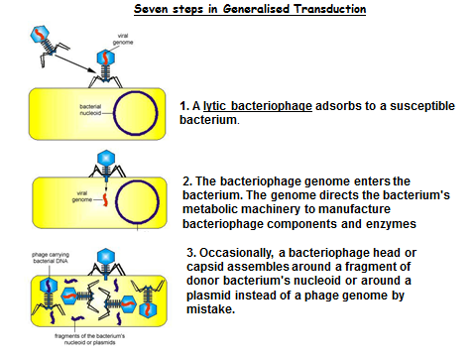
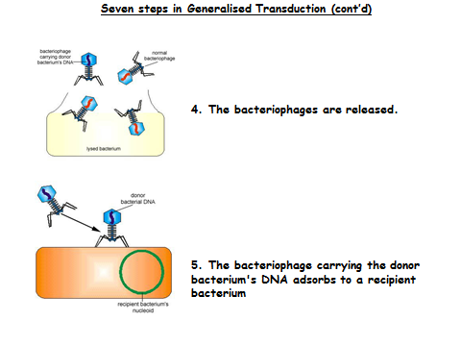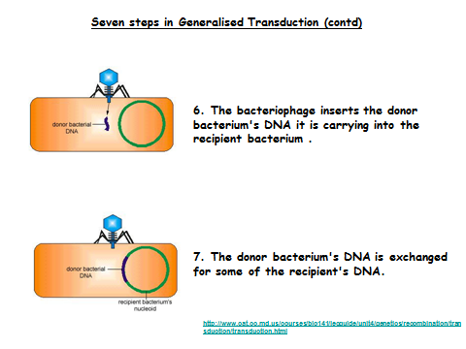
- In specialized transduction, on the other hand, only certain bacterial genes can be transferred.
  - Specialized transduction requires a phage that uses the lysogenic cycle for reproduction.
  - The Steps In Specialized Transduction:
    - Remember that in the lysogenic cycle, phage DNA can exist as a prophage integrated in the bacterial chromosome)
    - Occasionally when the prophage exits it can take adjacent bacterial genes with it.
    - The phage DNA directs synthesis of new phages.
      - The phage particles carry phage DNA and bacterial DNA.
    - The cell lyses, releasing the phages.
    - A phage carrying bacterial DNA infects another cell.
    - The joined phage and bacterial DNA circularize.
    - Along with the prophage, bacterial DNA integrates with the recipient chromosome by a cross over event.
      - This forms a recombinant cell.

