**INTRODUCTION**

**Economics** is the science that deals with the production and consumption of goods and services and the distribution and rendering of these for human welfare.

**Law of Supply and Demand**

From Fig. 1.2 it is clear that when there is a decrease in the price of a product, the demand for the product increases and its supply decreases. Also, the product is more in demand and hence the demand of the product increases. At the same time, lowering of the price of the product makes the producers restrain from releasing more quantities of the product in the market. Hence, the supply of the product is decreased. The point of intersection of the supply curve and the demand curve is known as the *equilibrium point*. At the price corresponding to this point, the quantity of supply is equal to the quantity of demand. Hence, this point is called the *equilibrium point*.

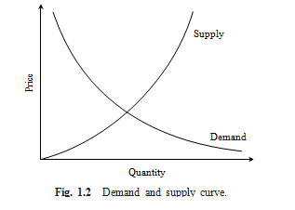

**Fig.** Demand and supply curve

**Types of Efficiency**

Efficiency of a system is generally defined as the ratio of its output to input. The efficiency can be classified into *technical efficiency* and *economic efficiency*.

**Technical efficiency**

It is the ratio of the output to input of a physical system. The physical system may be a diesel engine, a machine working in a shop floor, a furnace, etc.

Technical efficiency (%) = Output × 100

Input

The technical efficiency of a diesel engine is as follows:

Technical efficiency (%) =

Heat equivalent of mechanical energy produced

Heat equivalent of fuel used

× 100

In practice, technical efficiency can never be more than 100%. This is mainly due to frictional loss and incomplete combustion of fuel, which are considered to be unavoidable phenomena in the working of a diesel engine.

**Economic efficiency**

Economic efficiency is the ratio of output to input of a business system.



**Engineering Economics**

Engineering economics deals with the methods that enable one to take economic decisions towards minimizing costs and/or maximizing benefits to business organizations.

**BREAK-EVEN ANALYSIS**

Linear programming is called a normative procedure because it prescribes the optimal solution to a problem. Breakeven analysis is a *descriptive procedure* because it simply describes relationships among variables; it then is up to the manager to make decisions.

The main objective of break-even analysis is to find the cut-off production volume from where a firm will make profit. Let

*s* = selling price per unit

*v* = variable cost per unit

*FC* = fixed cost per period

*Q* = volume of production

The total sales revenue (*S*) of the firm is given by the following formula:

*S* = *s*  × *Q*

The total cost of the firm for a given production volume is given as

*TC* = Total variable cost + Fixed cost

= *v*  × *Q* + *FC*

The linear plots of the above two equations are shown in Fig. 1.3. The intersection point of the total sales revenue line and the total cost line is called

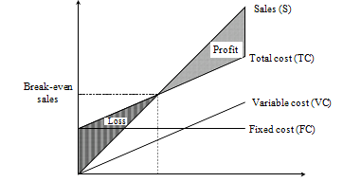

BEP (Q*) Production quantity

**Fig.**  Break-even chart.

the break-even point. The corresponding volume of production on the *X*-axis is known as the break-even sales quantity. At the intersection point, the total cost is equal to the total revenue. This point is also called the no-loss or no-gain situation. For any production quantity which is less than the break-even quantity, the total cost is more than the total revenue. Hence, the firm will be making loss.

For any production quantity which is more than the break-even quantity, the total revenue will be more than the total cost. Hence, the firm will be making profit.

Profit = Sales – (Fixed cost + Variable costs)

= *s*  × *Q* – (*FC* + *v*  × *Q*)

The formulae to find the break-even quantity and break-even sales quantity



The contribution is the difference between the sales and the variable costs. The margin of safety (M.S.) is the sales over and above the break-even sales. The formulae to compute these values are

Contribution = Sales – Variable costs

Contribution/unit = Selling price/unit – Variable cost/unit

M.S. = Actual sales – Break-even sales

= Profit

Contribution

M.S. as a per cent of sales = (M.S./Sales) ×100

× sales