Dr. MOHAMMED AL-DUJAILI
DEPARTMENT OF NON-METALLIC MATERIALS ENGINEERING
FACULTY OF MATERIALS ENGINEERING
UNIVERSITY OF BABYLON
ACADEMICYEAR 2014-2015
CHAPTER 5: DEPARTMENT OF MECHANICAL ENGINEERING
CHAPTER 6: DEPARTMENT OF NON-METALLIC MATERIALS ENGINEERING
STAGE: FORTH
SUBJECT:INDUSTRIALENGINEERIG
Linear Programming, Transportation Models and Maintenance Engineering
Operation Research Engineering (ORE)
ORE: is designed to provide a techniques and modeling concepts needed to analyze and design complex systems. That's mean, it is a discipline that deals with the application of advanced analytical methods to help make better decisions. It is often considered to be a sub-field of mathematics.
Steps of Operation Research Engineering
- Problem Definition
- Data Collection.
- Model Formulation
- Model Solution
- Validation and Analysis
- Implementation and Monitoring
The following diagram explaining the steps of operation research.
Model Formulation

Model Solution
- mathematical method
- Probability method
-Simulation

the model validation & the solution extracted
Data Collection
Problem Definition

- objective Function
- constraints

solutions classification
Implementation of solutions
Diagram to the Operation Research Steps
- Linear Programming
Linear programming (LP), or linear optimization) is a method to achieve the best outcome (such as maximum process or lowest cost) in a mathematical model whose requirements are represented by linear relationships. LP is a special case of mathematical programming (mathematical optimization).
More formally, LP is a technique for the optimization of a linear objective function, subject to linear equality and linear inequality constraints. It's feasible region is a convex polyhedron, which is a set defined as the intersection of finitely many half spaces, each of which is defined by a linear inequality. Its objective function is a real-valued affine function defined on this polyhedron. A LP algorithm finds a point in the polyhedron where this function has the smallest (or largest) value if such a point exists.
- Linear programs are problems that can be expressed in canonical form:
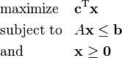
where x represents the vector of variables (to be determined), c and b are vectors of (known) coefficients, A is a (known) matrix of coefficients, and is the matrix transpose. The expression to be maximized or minimized is called the objective function (c^{T}x in this case). The inequalities Ax ≤ b and x ≥ 0 are the constraints which specify a convex polytope over which the objective function is to be optimized. In this context, two vectors are comparable when they have the same dimensions. If every entry in the first is less-than or equal-to the corresponding entry in the second then we can say the first vector is less-than or equal-to the second vector. Linear programming can be applied to various fields of study. It is used in processes, but can also be utilized for some engineering problems. Industries that use linear programming models include transportation, energy, telecommunications, and manufacturing. It has proved useful in modeling diverse types of problems in planning, routing, scheduling, assignment, and design.
- Standard form
Standard form is the usual and most intuitive form of describing a linear programming problem. It consists of the following three parts:
- A linear function to be maximized
e.g.
- Problem constraints of the following form
e.g.
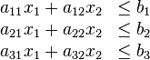
- Non-negative variables
e.g.
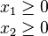
The problem is usually expressed in matrix form, and then becomes:
- Augmented form (slack form)
Linear programming problems must be converted into augmented form before being solved by the simplex algorithm. This form introduces non-negative slack variables to replace inequalities with equalities in the constraints. The problems can then be written in the following block matrix form:
Maximize Z:
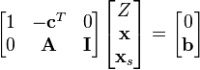
x, x_{s} ≥ 0
where x_{s} are the newly introduced slack variables, and Z is the variable to be maximized.
Assumptions of linear programming
  - There are restrictions on the freedom of the use of resources and facilities available at the company as working hours or quantities of raw materials or semi-processed the plant or machinery.
  - Available several alternatives to a combination of resources and capabilities down to the goal sought by the involved company.
  - The relationships among the linear variables.
  - Provide the accuracy and reliability of the information and planning data, which will make the optimization decision in its light.
Methods and techniques the linear programming
- Graphical Method
- Algebraic method
- Simplex method
- Transportation method
- Assignment method
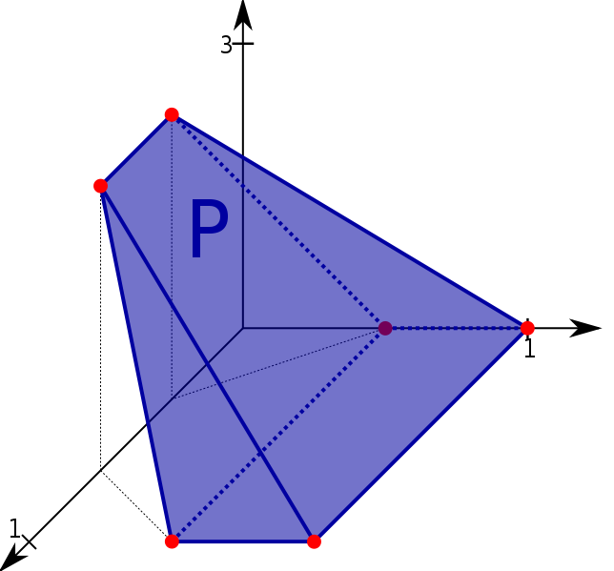

Transportation method
Is simplified meaner helps of determining the best transportation programs which reduce of the costs to the lowest possible. Represents the problem basically in the case of a multiple sources, and places of destination required transport between them, where the multiplicity of means of access from the supply centers for demand centers. Using linear programming according to the iterative solutions in the search for a possible solution.

Start
Is the problem written in format of equations (standard form)
Enter the additional variables
No
Find the feasible primary basic solution
Yes
Is this optimal solution
Stop
Yes
Select on the basis of cell values (cj-zj) for the variables which will enter to the basis
Determine the variables which will go out of the basis
Make the process of replacing the variables outside with inside with it in accordance with the requirements of the necessary
No
Flowchart for the Solution Process According to Simplex Method

