Session 6
Lecture 11: Electricity within the body
Dr. Amjed H. Abbas
Lecture Objectives:
- Definition electrical potential of nerves.
- The application of electrical within various body parts like brain (EEG), heart (ECG) and (EMG) methods about the muscle.
- Current research involves electricity in the body.
- Electrical potential of nerves.
A cross membrane of neuron an electrical potential (voltage) is present due to presence of more negative ions in the inside of the membrane than outside.
The neuron is polarized; there are typical concentrations (moles/liter) of K⁺. Na⁺, Cl⁺ and A⁻ (proteins ions) inside and outsides a cell.
The rest potential, which is the potential difference across the membrane of the neuron at the rest, is about (60-90mV).

Figure 1: Resting membrane potential
The action potential is the change in the resting potential when the neuron is stimulated (heat, cold, light, sound), a large momentary change at the point of stimulation propagates along the axon of the neuron.
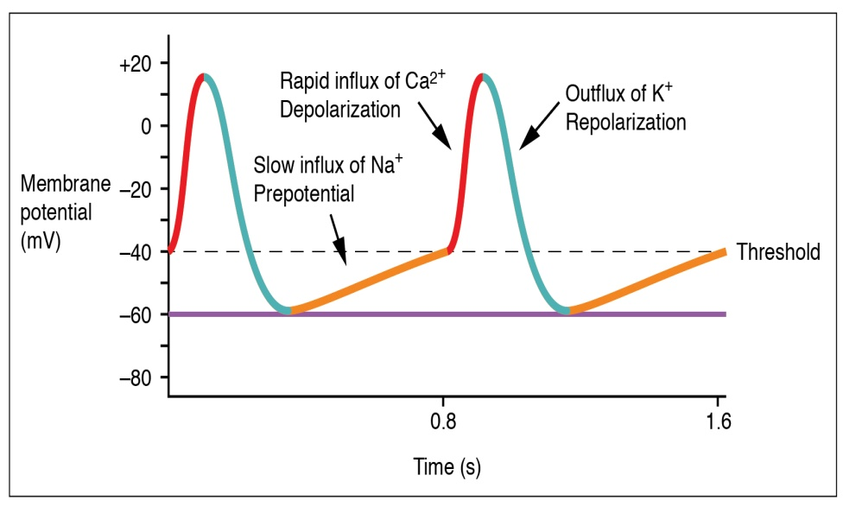
Figure 2: Action Potential
The membrane of some axons is covered with fatty insulating layer called myelin, has small non-insulating gabs called nodes of Ranvier.
The action potential decreases in the amplitude as it travels through myelinated segment just an electrical signal is attenuated when it passes through a cable. The reduced signal then acts as stimulatus at the next node of Ranvier (gab) to restore the action to its original size and shape.This process repeat along the axon.
The applications of electricity in medicine:
- Electrical signal from muscle Electromyogram (EMG):
The record of potentials from muscles during movement is called Electromyogram.

Two factors affect the speed of the propagation of the action potential.
- Resistance within the core of the membrane.
- Capacitance (change stored) across the membrane.
- Electrical signal from the heart Electrocardiogram (ECG):
The electrical signals from SA node or pacemaker initiates the depolarization of the nerve and muscles of both atri, causing atria to contract and pump blood into ventricles. The electrical signals then passes through atrioventricular (AV) node, which initiate depolarization of right and left ventricles, causing them to contract and force blood to pulmonary and general circulation. The ventricle nerves and muscles then depolarized and the sequence begins again.
The major electrical events of the normal heart cycle as:
- The atrial depolarization which produce ( P wave )
- The atrial depolarization which rarely seen and is un labeled
- The ventricular depolarization which produces ( QRS)
- The ventricular depolarization which produces ( T wave )

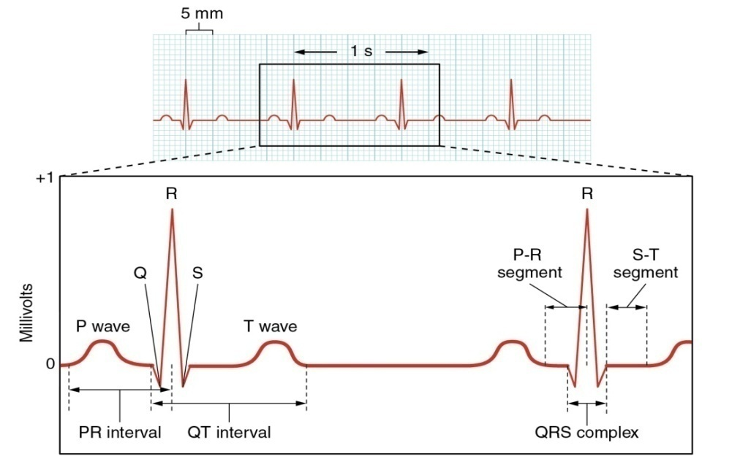
Figure 3: The potential distribution on the chest (ECG).
- Electrical signals from the brain electroencephalogram (EEG):
The recording of signals from the brain is called electroencephalogram (EEG). The frequencies of EEG signals depends on mental activity
Applications of EEG:
- In the diagnosis of epilepsy.
- In confirming brain tumor, since electrical activity is reduced in the region of tumor.
- EEG used as monitor in surgery in addition to ECG, also useful in surgery for indicating anesthesia level of the patient
Current research involves electricity in the body:
Bone contain collagen which is piezoelectric material, when force is applied to collagen, small electrical potential is generated collagen behaves like N-type semiconductor its current like negative charge.
Mineral crystal of bone (apatite) close to collagen behave like P-type semiconductor its current by positive charge.
At junction current flows from P to N type, the forces on the bones produces potential by piezoelectric and P N junction of collagen apatite produce currents that induce and control bone growth.
Another small direct current arises in injured zone called injury current, the electrical current at side of injury is higher than that in surrounding areas. This high potential associated with limb regeneration in animals like salamander, stimulation of fracture sites with direct current of 1-3 μA has been found to promote healing of bone fractures.

