**Lecture 12: Physics of the lung and breathing**

Lecture Objectives:

* To get information about anatomy of respiratory system.
* To get information about removal of inhaled particles.
* To get information about measurement of lung volumes.
* To get information about physics of alveoli.
* To get information about physics of common lung diseases

**Anatomy of respiratory system**

The respiratory system is divided into upper and airways

* + The upper airways consist from nose, pharynx, larynx and associated structures.
  + Lower Airways involve trachea, bronchi, and lungs.

There are two lungs: Right lung consists from three lobes while the left lung consists of two lobes.

Pulmonary interstitial tissues include elastin, collagen fibers, lymphocytes, plasma cells, and mast cells.

The air passes through windpipe (trachea), each bronchus divide multiple times (about 15 times) until it reach to a sac like structure called alveoli of 0.2mm diameter and 0.4 μm wall thickness, each alveolus surrounded by blood capillary. So O2 can diffuse from alveolus into RBC and CO2 diffuse from blood into air in the alveolus.

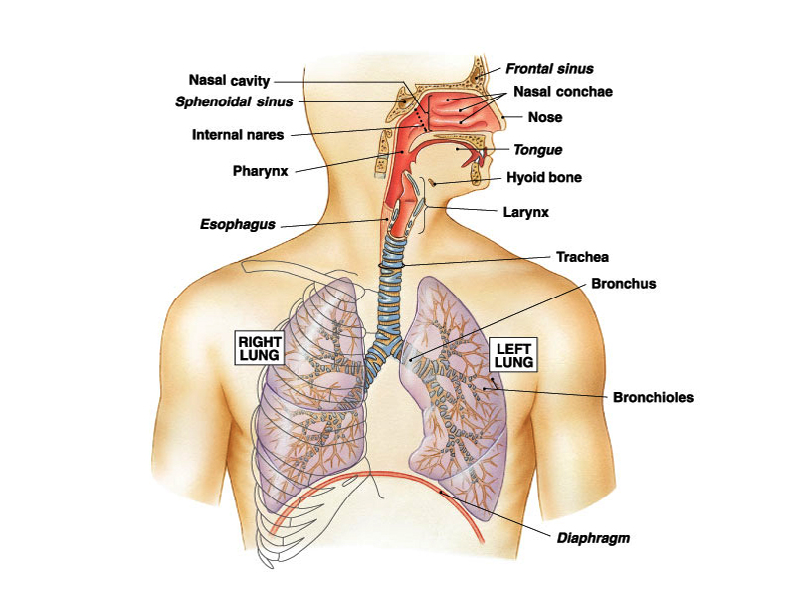

**Figure (1): Anatomy of respiratory system**

**Removal of Inhaled Particles:**

With its surface area of 50 to 100 square meters, the lung presents the largest

surface of the body to an increasingly hostile environment. Various mechanisms for dealing with inhaled particles have been developed.

Large particles are filtered out in the nose. Smaller particles that deposit in the conducting airways are removed by a moving staircase of mucus that continually sweeps debris up to the epiglottis, by the moving cilia, where it is swallowed or coughed up. Each cilia vibrates about 1000 times a minute. The mucus moves 1-2 cm/min (1 mile/week).Cilia as escalator system of trachea. It takes 30 min for particle of dust to be cleared out of the bronchi and trachea into throat where it is expelled or swallowed.

**Measurement of lungs volumes and pulmonary function tests:**

Pulmonary function tests (PFTs) are noninvasive diagnostic tests that provide measurable feedback about the function of the lungs. By assessing lung volumes, capacities, rates of flow, and gas exchange, PFTs provide information that, when evaluated by doctor, can help in diagnosis of certain lung disorders.

**Lung volumes and capacities:**

There are four different volumes and capacities, they are:

1- The tidal volume (TV),the inspiratory reserve volume (IRV),the expiratory reserve volume (ERV), the residual volume (RV), the inspiratory capacity (IC), the functional residual capacity (FRC),the vital capacity (VC), and the total lung capacity (TLC) as illustrated in figure ( 2 ).

**Pulmonary function tests** encompasses a wide variety of objective tests to assess lung function which provide objective and standardized measurements for assessing the presence and severity of respiratory dysfunction, they include:

**1. Forced vital capacity (FVC).**This is the amount of air exhaled forcefully and quickly after maximum inspiration.

**2. Forced expiratory volume in one second (FEV1).**This is the volume of air expired during the first second of the FVC test.

**3. FEV1/FVC:** the ratio of FEV1 to FVC X 100 (expressed as a percent); an important value because a reduction of this ratio from expected values is specific for obstructive rather than restrictive diseases.

*Spirometer* is a method of assessing lung function by measuring the volume of air the patient can expel from the lungs after a maximal expiration

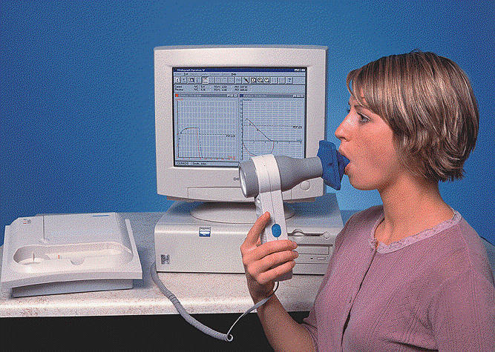

**Figure ( 2 ): Spirometer**

**Table (1): Lung volumes and capacities**



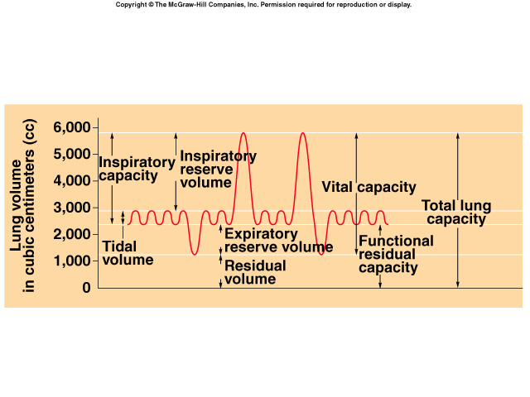

**Figure (3): Lung volumes**

**Physics of the alveoli:**

The alveoli like millions of small interconnected bubbles, have tendency to get smaller due to surface tension of unique fluid lining. This lining called *surfactant.* The absence of surfactant in the lungs of some new born infant is the cause of respiratory distress syndromes (RDS) called hyaline membrane disease which causes death.

To understand the physics of alveoli we have to understand physics of bubble. The pressure inside bubble is inversely proportional to the radius and directly to the surface tension.

$P=\frac{4γ}{R}$ Where: R radius, γ surface tension

**Two forces prevent lungs from collapsing:**

1. Surfactant that reduce the force of surface tension between lungs and chest wall.
2. Air pressure inside the lungs.

Since each lung has its own sealed compartment, it is possible to collapse one lung only. This is done by inserting a hollow needle between ribs and allowing air to flow into intrathoracic space, the air trapped in the space is gradually absorbed by tissue and lung expand to normal over few weeks, sometimes lung collapses spontaneously with no known cause.

The lungs returns to normal as the air are absorbed into surrounding tissues.

Since both lung and chest are elastic we can represent them with springs.

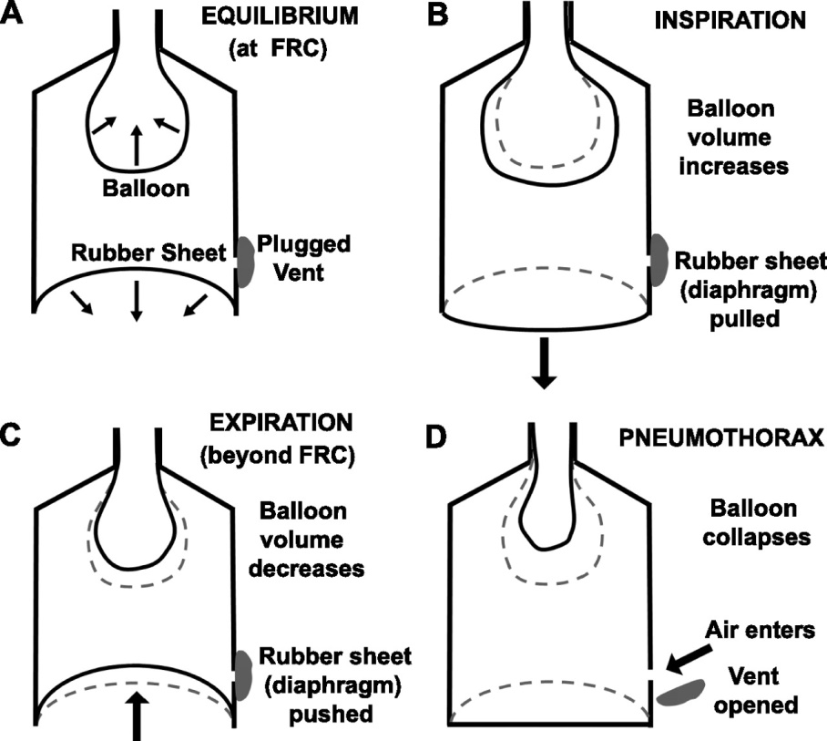

**Figure4:Simple model for mechanism of breathing during**

**(A) normal conditions, B inspiration, C expiration and D pneumothorax.**

**Air way resistance:**

During inspiration the forces on airways tend to open them further, during expiration the forces tend to close the airways and restrict flow.

Voltage replaced by pressure difference ∆P, Current replaced by rate of air flow or (V).

*Air way resistance*: $Rg=∆P/V$

Resistance is inversely proportional to the airway radius to the fourth power, small changes in diameter cause large changes in resistance.

The large airways offer little resistance to airflow. The small airways individually have high resistance, but their enormous number in parallel reduces their combined resistance to a small value. Therefore, the sites of highest resistance in the bronchial tree are normally in the medium airways.

**Physics of common lung diseases:**

**Emphysema** the division between alveoli breaks down produces large lung spaces; this destruction of lung tissue reduces the springiness of lungs. The lungs become more complaint, small change in pressure produces larger than normal change in volume.

**Emphysema** produces two changes:

1. The lungs become flabby and expands
2. The tissues do not pull very hard on the airways permitting the narrowed airways to collapse easily during expiration

In **asthma** due to increasing airway resistance, some of resistance is due to swelling (edema) and mucus in the smaller airways but much of it is due to contraction of smooth muscles round the large air ways.

**Fibrosis of lungs**, the membranes between alveoli thicken.

This has two effects

1. the compliance of the lungs decreases
2. The diffusion of O2 into capillary decreases

Fibrosis can occur if the lungs have been irradiated e.g. in treatment of cancer although this is not the only cause.

**Small Group Session Discussion:**

Q1/ Why we use differential amplifier in ECG machine.

Q2/ Which is QRS wave in ECG of normal heart represent.

Q3/ When patient must have pacemaker.

Q4/ Describe the activity of EMG.

Q5/ Explain how the EEG can be used to measure anesthesia level

Q6/ Can you test the pulmonary function and how?

Q7/ What are the suspected abnormalities that can be seen on a Spirogram of

asthmatic patient?

Q8/ In a patient with severe emphysema, which of the following are above the

normal:

i. Airway resistance.

ii. Inspiratory reverse volume.

iii. Functional residual capacity.

iv. Vital capacity.

v. Compliance.

Q9/ If the thickness of the alveolar walls doubled, by what factor would the diffusion time for O2 to reach the blood change?

Q10/A person inspired maximally and then began breathing from an expandable bag containing 2 liters of 40% helium gas. After a few breaths, the helium concentration in the bag was 10%. What was this person’s total lung capacity?