Session 7:
Lecture 13: Physics of Cardiovascular System (CVS)
Dr. Amjed H. Abbas
Lecture Objectives:
- The principle laws that govern the heart structure and function.
- Blood pressure and its measurement.
- Types of blood flow (laminar and turbulent) and application in diseases.

Cardiovascular physiology: Is the study of the circulatory system, specifically addressing the physiology of the heart ("cardio") and blood vessels (vascular).
The blood is pumped by contraction of the heart muscle, from left ventricle at pressure of 125 mmHg and finally into very fine meshwork or capillary bed for few seconds the blood supplies O₂ to cells and picks up CO₂. Adult has about 4.5 liters of blood, each section of heart pumps 80 ml with each contraction.
The combination of RBC and plasma causes blood to have flow properties different from those of fluid like water.
Starling law: fluid movement through capillary wall= the hydrostatic pressure (p) across the capillary wall+ osmotic pressure bringing fluid in.
Work done by the heart:
Left side of the heart systole pressure= 120 mmHg
Right side of the heart diastolic pressure= 80 mmHg

Above caused by following:
- The left side of the heart three times thicker than right side.
- The circular shape of left ventricle producing pressure larger than
elliptical shape of right ventricle. The work done = P∆V
Blood pressure and its measurement:
The instrument called sphygmomanometer, the sound heard with stethoscope called Kortokoff or K sounds. The onset of K indicate systolic pressure precision
± 2 mmHg. The fade of k indicates diastolic pressure precision ± 5 mmHg.
Pressure across blood vessel wall:
The pressure drops in the capillaries which have thin walls (1 μm) permit easy diffusion of O₂ and CO₂, the capillary do not burst according to Laplace law
Consider a tube of radius R
$$F= 2RP$$
P blood pressure T tension in the wall
2T = 2 R P T = R P
Bernoulli’s principle applied to cardiovascular system:
Bernoulli’s principle is based on the law of conservation of energy
Increasing KE (kinetic energy) obtained by reduction of PE, the pressure in the tube. Average K E of 1 gm (1 cm³) of blood as it leaves the heart
K.E= 1/2 mv² v= 30 cm/ sec
K.E = 1/2 x 1x (30) = 450 erg/ cm³

How fast does your blood flow:
Capillaries about 20 μm diameter, there total cross-sectional area 30 cm. The blood velocity V inversely related to the total cross-section area of the vessels carrying blood.
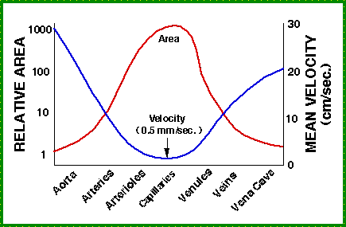
Figure 1: Relationship between cross sectional area of
vessel and velocity of blood flow.
Viscosity of blood = 3x10⁻³ to 4x10⁻³ Pas, depending on RBC in the blood or Hematocrit.
Hematocrit α Viscosity, Viscosity α Temperature

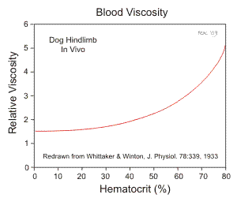
Figure 2: relationship between hematocrit and velocity of blood flow

Blood flow laminar and turbulent:
Laminar (silent) if all blood flow were laminar information could not be obtained from the heart with stethoscope
If increase the velocity of the fluid in the tube by reduction the radius it will reach the critical velocity Vc, when laminar flow change into turbulent flow. The critical velocity will be lower if there is restriction or obstruction in the tube.
Osborne Rynold studied the property in 1883
$Vc= kη/ρR$ R= radius of the tube
K= constant 1000 for many fluid
For aorta has radius= 1 cm in adults
$$Vc = (1000) (4x10-3pas)/(10³kg/cm³)(10̄-2m)= 0.4m/s.$$

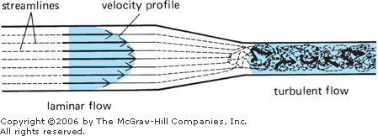
Figure 3: Effect of gradual tapering of tube on velocity

The physics of some cardiovascular diseases:
Work load of heart increases by;
      - Hypertension: Is high blood pressure. Blood pressure is the force of blood pushing against the walls of arteries as it flowsthrough them. Arteries are the blood vessels that carry oxygenated blood from the heart to the body's tissues.
      - Tachycardia, also called tachyarrhythmia.
Is a heart rate that exceeds the normal resting rate. In general, a resting heart rate over 100 beats per minute is accepted as tachycardia in adults. Heart rates above the resting rate may be normal (such as with exercise) or abnormal (such as with electrical problems within the heart).
Disease:
- Heart attack, caused by blockage one or more arteries of the heart muscle.
The blockage does not always immediately affect the electrical signal and a person has heart attach may still have normal ECG.
- Congestive heart failure, characterized by enlargement of the heart and reduction in the ability of the heart to provide adequate circulation.
Medical treatment of congestive heart failure help to reduce the work load on the heart.
- Heart valve defects are of two types, the valve either does not open enough (stenosis) or it does not close well enough (insufficiency)
The physics of cardiovascular diseases involving in the blood vessels:
- A more common vessel problems is the formation sclerotic plaques on the wall of the artery, increase the velocity in that region with a decrease in wall pressure because of Bernoulli effect.
- If the valve defective and let the blood run back down it will pool in the vein, and the vein will become varicose.
The viscosity of blood depends on temperature change from (37-0) increases the velocity of blood by a factor 2.5 in addition to viscosity, other factors affect the flow of blood in the vessel; the pressure difference from one end to the other, the length of the vessel, and its radius.
Poiseulles law states that the flow of a given tube depends on the pressure difference from one end to the other P1-P2, the length of the tube L, the radius R and viscosity of blood.
$Flow rate= (P1-P1)(Π/8)(1/η)(R4/L)$
If radius is doubled the flow rate increases by 24 or by 16. This law applies to the rigid tubes of constant radius, since the major arteries have elastic walls and expand slightly at each heartbeat, so blood does not obey this law exactly in addition the blood viscosity changes slightly with flow rate, however this effect is negligible.
A disease clinically causes varicose vein, these enlarged surface veins in the legs results from a failure of the one way valves in the veins.
The pressure in the leg vein is about 90 mmHg (115 cm of blood) due to a column of blood above it.

