Ecological Pyramids
An Ecological Pyramid (Trophic pyramid) is a graphical representation designed to show the relationship between energy and trophic levels of a given ecosystem. Most commonly, this relationship is demonstrated through the number of individuals, the amount of biomass, or the amount of energy at a given trophic level. All Ecological Pyramids begin with producers on the bottom and proceed through the various trophic levels, the highest of which is on top.There are 3 types of ecological pyramids:
- Pyramid of numbers.
- Pyramid of biomass.
- Pyramid of energy

1- Pyramid of Numbers
The pyramid of numbers depicts the relationship in terms of the number of producers, herbivores and the carnivores at their successive trophic levels. There is a decrease in the number of individuals from the lower to the higher trophic levels. The number pyramid varies from ecosystem to ecosystem. The following shape is shows typical pyramid of numbers:

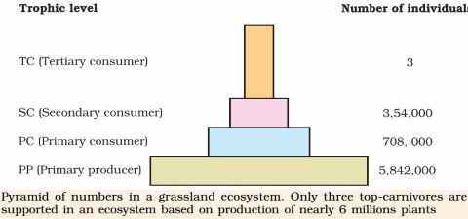
There are three of pyramid of numbers:
- Upright pyramid of number
- Partly upright pyramid of number or( spindle- shapped number pyramid).
- Inverted pyramid of number.
Upright Pyramid of Number
This type of pyramid number is found in the aquatic and grassland ecosystem, in these ecosystems there are numerous autotrophs which support lesser herbivores which in turn support smaller number of carnivores and hence this pyramid is upright because of with each higher trophic level, the number of individual decreases.

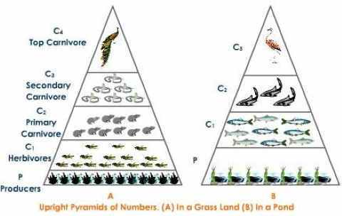

For example :- the grasses occupy the lowest trophic level (base) because of their abundance. The next higher trophic level is primary consumer – herbivore (ex. – grasshopper). The individual number of grasshopper is less than that of grass. The next energy level is primary carnivore (ex. – rat). The number of rats are less than grasshopper, because, they feed on grasshopper. The next higher trophic level is secondary carnivore (ex. – snakes). They feed on rats. The next higher trophic level is the top carnivore. (ex.- hawk).

Partly Upright pyramid of Number
It is seen in the forest ecosystem where the number of producers are lesser in number and support a greater number of herbivores and which in turn support a fewer number of carnivores.
Inverted Pyramid of Number
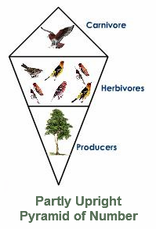
This type of ecological pyramid is seen in parasitic food chain where one primary producer supports numerous parasites which support more hyperparasites.
