What are the main factors that led to the significant characteristics of the traditional house ?
There is always a social- physical duality controlling the spatial arrangement and hierarchy.

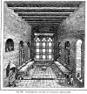

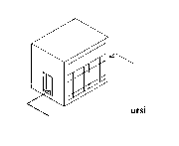
Ursi: most probably from russi, russian. The most important room of the house, as at the same time you may see, but not been seen as much as in a tarma, ivan or talar. Its separated from the tarma by a window-wall from colored glasses, without door. Those were the masterpieces of Baghdadi carpentry.
Talar, a usable open room behind the tarma. The difference to the iwan is, that it can't be entered directly from the rooms

beside it. I's separated from the tarma by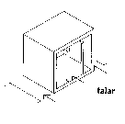 additional pillars.
Iwan (or Liwan), a room behind the tarma or adjacent tot the inner courtyard, that is on one side open.

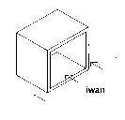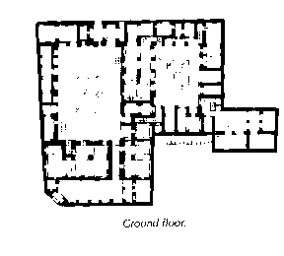

Hosh, the central courtyard, often with a fountain in the middle.
sirdab, the cellar, that did not only serve as store, but as cooling hall and for the provision of cool air through the badger-sirdab-system.
neem, a cellar that is only half buried. Mostly with one window.

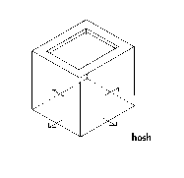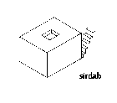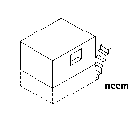

During the hot summer nights the roof was and is used in Baghdad for sleeping. The high value of privacy demanded, that no house was higher than the others, so that nobody was able to look down on his neighbors roof
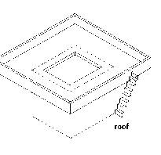
- With clay-construction not only the art and climatologically advantages disappeared, but further architectural uses of natural conditions, especially the use of the northwest-trade-wind, that blows all through the summer, as natural and sustainable acclimatization-engine.
- The system badger - sirdab was a cheap, environmentally friendly and energy saving solution to create an acceptable climate inside Baghdadi houses. Not an easy endeavor with outside temperatures of over 50°C during summer.
- The badgers caught the wind and led it through the cool cellar into the house.
- Not presented is here a second system, where the wind is not led into the cellar by pressure, but is sucking the hot air out of the living rooms, whereby replacing it by cooler air sucked in through the cellar.
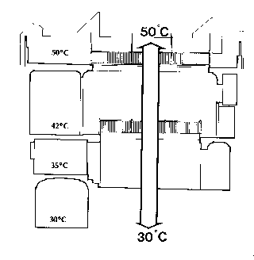
The sketch shows the large differences in temperature that may be produced using the naturally given conditions of the traditional house. More than those 20° are even nowadays, in the times of air-conditioning, considered as unhealthy. Those conditions turn the house dwellers into Bedouins', using different places during day and night as during winter (south side, mainly closed rooms) and summer (north side, cellar and roof)

