Determined the CEC
It is most commonly determined by saturating the soil with buffered cations (e.g., sodium acetate) and measuring the amount of sodium exchanged. Cation exchange capacity is a characteristic of the soil, not the cations, because it is measured as the total positive charge per mass of soil that can be exchanged. Soil with higher clay and organic matters are characterized by higher CEC. Cation exchange capacities range from 2-7 meq/100 gr for sandy soils, 9-27 7 meq/100 gr for silt loams, and 5-60 7 meq/100 gr for clay soils.
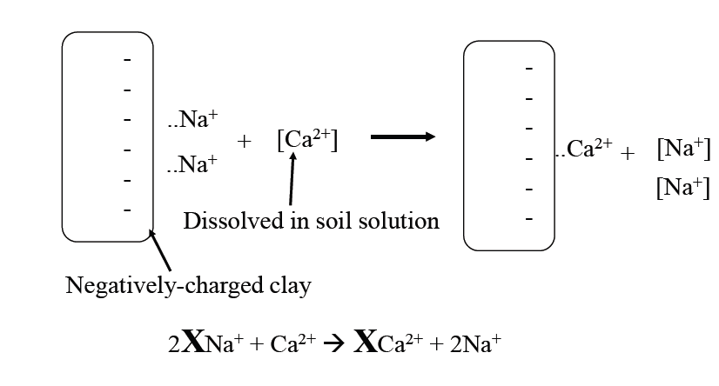
- 1 meq = 1 mmole
- Molecular weight MW
Example// cation exchange capacities
Using solution of sodium acetate as an exchange medium, a sandy soil was found to have a CEC of 0.14 meq/100gr. Additional analyses using Atomic adsorption spectrophotometry showed that 40% of the sites contained sodium. 50% of the sites contained calcium, and 10% of the sites exchange with chromium (III). Determine the concentrations of the three exchanged species in mg/Kg.
Solution // The mass concentration of each cation may be determined by first converting its concentration to moles/gr of soil, followed by conversion to its mass equivalent based on its molecular weight,
For sodium
(0.4)*$\left(\frac{0.14 meq}{100 gr}\right)=$0.00056 meq/gr soil
$\left(\frac{0.00056 meq}{100 gr}\right)*(\frac{1mmole}{1 meq}$)=5.6*10⁻⁴ mmole/ gr soil
$\left(\frac{0.00056 mmole}{ gr soil}\right)*\left(\frac{23mg {Na}^{+}}{mmole}\right)*\frac{1000 g}{Kg}=12.9 \frac{mg }{Kg}{Na}^{+}$
For calcium
(0.5)*$\left(\frac{0.14 meq}{100 gr}\right)=$0.0007 meq/gr soil
$\left(\frac{0.0007 meq}{100 gr}\right)*(\frac{1mmole}{2 meq}$)=3.5*10⁻⁴ mmole/ gr soil
$\left(\frac{0.0007 mmole}{ gr soil}\right)*\left(\frac{40.1 mg {Ca}^{2+}}{mmole}\right)*\frac{1000 g}{Kg}=14 \frac{mg }{Kg}{Ca}^{2+}$
For chromium (III)(${Cr}^{3+})$
For sodium
(0.1)*$\left(\frac{0.14 meq}{100 gr}\right)=$0.00014 meq/gr soil
$\left(\frac{0.00014 meq}{ gr}\right)*(\frac{1mmole}{3 meq}$)=4.67*10⁻⁵ mmole/ gr soil
$\left(\frac{4.67*{10}^{-5} mmole}{ gr soil}\right)*\left(\frac{52 mg {Cr}^{3+}}{mmole}\right)*\frac{1000 g}{Kg}=2.43 \frac{mg }{Kg}{Cr}^{3+}$

