What is pH
Soil pH refers to a soil’s acidity or alkalinity and is the measure of hydrogen ions (H⁺) in the soil. A high amount of H⁺ corresponds to a low pH value and vice versa. The pH scale ranges from approximately 0 to 14 with 7 being neutral, below 7 acidic, and above 7 alkaline (basic). Soil pH can affect CEC and AEC by altering the surface charge of colloids. A higher concentration of H⁺ (lower pH) will neutralize the negative charge on colloids, thereby decreasing CEC and increasing AEC. The opposite occurs when pH increases

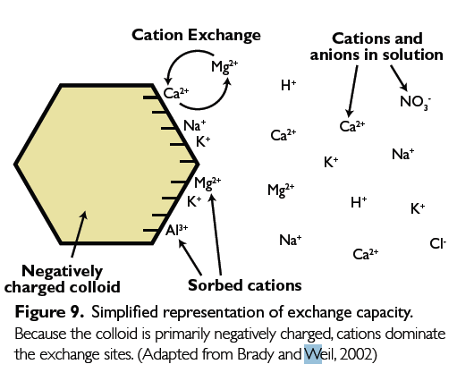
How is pH measured
Soil pH was determined in accordance with method 9045 developed by the office of solid waste, EPA. 20 ml of distilled water was added to 20 g of soil in a 50-ml beaker(1:1). The suspension was continuously stirred for 5 min. Thereafter, the soil suspension was stand for about 15 minutes. The suspension was filtered to obtain an aqueous phase ready for pH measurement.

