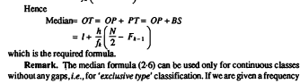

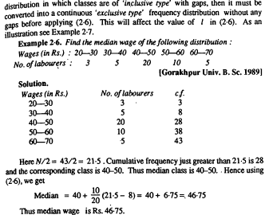

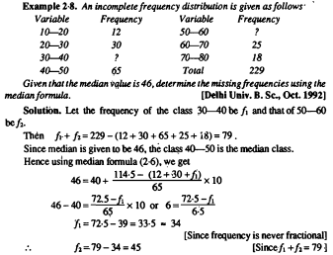

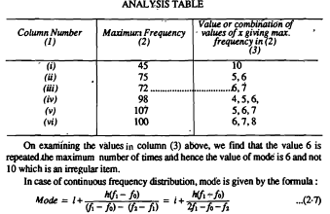

Mode is the value which occurs most frequently in a set of observastions and around which the other items of the set cluster densely.
In other words, mode is the value of the variable which is predominant in the series.
المنوال هو القيمة التي تكرراكثر من غيرها في مجموعة من المشاهدات وتتركز حولها مجموعة المشاهدات بكثافة.
Thtis in the case of discrete frequency distribution mode is the value of corresponding to maximum frequency. For example in the following frequency distribution:
the value of X corresponding 10 the maximum frequency, viz., 25 is 4. Hence mode is 4
