Graphic Representation of a Frequency Distribution
It is often useful to represent a frequency distribution by means of a diagram غالبا ما يكون مفيدا لتمثيل التوزيع التكراري عن طريق رسم تخطيطي
- which makes the unwieldy data intelligible and conveys to the eye the general run of the observations.
يجعل البيانات غير القابلة للفهم مفهومة وتوصل للعين فكره عامه عن المشاهدات
- Diagrammatic representation also facilitates the comparison of two or more frequency distributions.
التمثيل البيني ييسر أيضا المقارنه بين اثنين أو أكثر
We consider below some important types of graphic representation.
Histogram
In drawing the histogram of a given continuous frequency distribution we first mark off along the $x$-axis all the class intervals on a suitable scale. On each class interval erect rectangles with heights proportional to the frequency of the corresponding class interval so that the area of the rectangle is prortional to the frequency of the class.
If, however, the classes are of unequal width then the height of the rectangle will be proponional to the ratio of the frequencies to the width of the classes.
The diagram of continuous rectangles so obtained is called histrogram.
Remarks
1) To draw the histogram for an ungrouped frequency distribution of a variable we shall have to assume that the frequency corresponding to the variate value $x$ is spread over the interval $x-\frac{h}{2}$ to $x+\frac{h}{2}$, where $h$ the jump from one value to the next.
2. If the grouped frequency distribution is not continuous, first it is to be converted into continuous disiribution and then the histrogam is drawn.
3. Although the height of each rectangle is proportional to the frequency of the corresponding class, the height of a fraction of the rectangle is not proportional to the frequency of the corresponding fraction of the class, so that histogram cannot be directly used to read frequency over a fraction of a class interval.
4. The histogram of the distribution of marks of 250 students in
TABLE 1 is obtained as follows.
Since the grouped frequency distribution is not continuous, we frrst convert it into a continuous distribution as follows:
The upper and lower class limits of the new aclusive type classes
are known as class boundaries.
If $d$ is the gap between the upper limit of any class and the lower limit of the succeeding class, the class boundaries for any class are then given by :
$$Upper class boundary = Upper class limit + \frac{d}{2}$$
$$Lower class boundary = Lower class limit - \frac{d}{2}$$
In our example the $upper class limit of the firstclass=19$ and the $second lower class limit of the second class=20$ , then
$d=20-19=1$ , so $\frac{d}{2}=\frac{1}{2}$, thus
TABLE 2 Histogram for Frequency Distribution
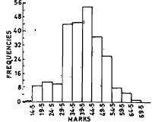
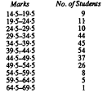

Frequency Polygon
For an ungrouped distribution, the frequency polygon is obtained by plotting points with abscissa as the variate values and the ordinate as the corresponding frequencies and joining the plotted points by means of straight lines. For a grouped frequency distribution, the abscissa of points are mid-values of the class intervals.$(mid-value={(U+L)}/2$),
For equal class intervals the frequency polygon can be obtained by joining the middle points of the upper sides of the adjacent rectangles of the histogram by means of straight lines. If the class intervals are of
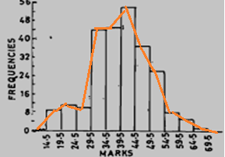
small width the polygon can be approximated by a smooth curve. The frequency curve can be obtained by drawing a smooth freehand curve through the vertices of the frequency polygon.

mid-values of the class intervals
17
22
27
32
37
42
47
52
57
62
67

