Lecture _3_

ANCIENT EGYPTIAN ARCHITECTURE
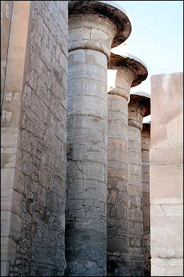
In ancient Egypt trees were scarce so wood was not widely used as a building material. Mud, clay, rock and reed were the only materials that were in abundance. The ancient Egyptian first lived in reed houses and later switched to unbaked mud brick, which was used even on palaces. Around 2,700 B.C. they developed a method of constructing buildings from stone and within half a century they were building pyramids, and within a century and half they built the Great Pyramid of Cheops.
"How and why their unexcelled techniques for building in stone were so quickly perfected still puzzles historians," the historian Daniel Boorstin wrote. "How did they quarry huge blocks of limestone, transport them for miles, then raise, place and fit them with jeweler’s precision? All without the aid of a capstan, a pulley, [beast of burden] or even a wheeled vehicle!" [Source: Daniel Boorstin
Egyptian architecture most likely had its roots in wood or clay. An indication of this is the practice of "battered walls." This means that they slant upwards from a broad base. These slanting walls are topped by horizontal molding on which leaf and stem patterns are often carved or painted. These patterns are reminders of a time when walls were built of matting stiffened with long reds or tree branches and covered with clay. Such walls can only stand vertically if they are low: higher walls are built at a slant. Walls made of stone don't need to slant, but the practice of slanting continued after stone came into use.
Large houses, temples and tombs all had similar plans---with a main court, hall and private rooms---that was also found in Greek architecture. The Egyptians and Assyrians used enamel bricks to decorate their buildings. The Greeks and Romans were masters of using enamels to make jewelry.
One reason Egypt was able to build such large temples and pyramids was that it was relatively untroubled by wars and could devote its manpower to construction projects rather than the military. For the most part only temples and tombs have survived because other buildings were built of materials such as wood and mud brick which have dissolved with time.

- Today our lecture concerns with the following axis:

The first point is the multiplicity of building materials in Egyptian architecture
Secondly we study the extent of technological development in Egyptian architecture
The third point is the multiplicity of productions in Egyptian architecture as evidence of intellectual and cultural development
The fourth point is that evolution can measure social development in ancient Egypt by studying the history of architecture
Finally, the strength of architectural variables in Egyptian architecture can be measured through mathematical relations.

Ancient Egyptian Temple Architecture
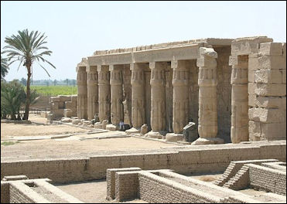
Temples from the Middle Kingdom onward were in large rectangular spaces enclosed by high walls with entrances flanked by two large pylons (sloping towers), with a door between them. After passing through the pylons, one entered a large courtyard with colonnades on two or three sides. This is where people gathered. Beyond the courtyard was a large hypostyle hall (a forest of columns that supported a roof). Beyond this a was sanctuary in which a statue of the deity was placed on a boat or in a shrine. Only the pharaoh and high level priests were allowed to enter this area.

Large temples, like the one at Karnak, had a series of courtyards, each with pylons, leading from the entrance, and multiple sanctuaries. These temples were regarded as embodiments of ancient Egyptian cosmology and symbols of renewal, a concept in which Egyptian civilization was largely based. The ceiling of a temple was viewed as the heavens; the floor, the fertile marsh from which life emerged. The pylons at the entrance were shaped like the hieroglyphic for “horizon," and the whole structure, like the horizon, was seen as the nexus of heaven and earth, divine and mortal, order and chaos. The polarities and contradictions of the world remained in harmony and balance as long as certain rites were carried out by the Pharaoh.
Some Egyptian columns were built with ridges to imitate bundled reeds. There were ones with closed papyrus capitals and ones with open papyrus capitals.
One reason Egypt was able to build such large temples and pyramids was that it was relatively untroubled by wars and could devote its manpower to construction projects rather than the military.

Mortuary of Amenhotep III
Mortuary of Amenhotep III (excavation at the Colossi of Memnon) was once the largest and most impressive temple complex in the world. Known as “The House of Millions of Years," it embraced gates, colonnades, courts filed with reliefs and inscriptions, and halls with columns more than 15 meters high. In its day it was filled with colorful royal banners hanging from cedar poles on red granite pedestals. Amenhotep III called the complex “a fortress of eternity” and said it was built “out of god white sandstone---worked with gold throughout. Its floors were purified with silver, all of its doorways were of electrum”---an alloy of gold and silver. Over the centuries, though, earthquakes, floods and looting, much of it by 19th century Europeans, have reduced the temple to buried ruins.
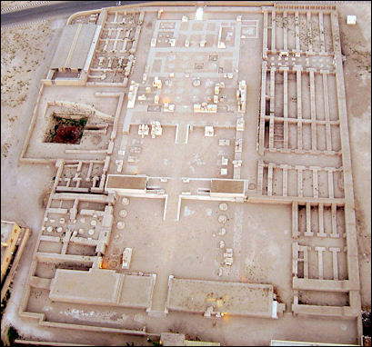

Merenptah's Mortuary Temple

Larger than Vatican City and vaster than the massive Karnak and Luxor temples, the Mortuary Temple of Amenhotep III was the length of seven football fields and stretched from the colossi to sacred altars pointing towards the Valley of the Kings. During Amenhotep III's rule the Nile flowed just a few hundred meters away from the temple. The Colossi of Memnon once stood in front of it. The massive front gate, or pylon, was once brightly painted in blues, red," greens, yellows and whites.
The Mortuary Temple of Amenhotep III has been excavated since 1999 by a team led by Baghdad-born, Armenian archeologist Hourig Sourouzian. The is some sense of urgency to the project as archeologists are worried about salty runoff and irrigation water groundwater and seepage from the Nile damaging the sculptures that are underground. The restoration plan calls for much of the temples to be reconstructed but that will take many years---even decades---to complete. Just piecing statues and columns back together take a lot of time. Sections are being completed and opened bit by bit.

Hatshepsut's Temple
Hatshepsut's Temple (near Valley of the Kings) was built in 1480 B.C. by Queen Hatshepsut, arguably the most powerful female ruler of ancient Egypt. Dedicated to Amun and several other deities and reached by a long ramp, it is comprised of three terraces of colonnades, connected by massive ramps, and a small chamber tunneled deep into the rock. The last set of colonnades is set into the face of a towering red sandstone cliff on the eastern face of a Thebean mountain.
The Temple of Hatshepsut begins with the large first courtyard in front to the temple. A ramp sided by pillars leads to a second courtyard. At the back of this is a colonnade with walls and small enclosures with engravings and reliefs of episodes from the queen's life and images of gods.
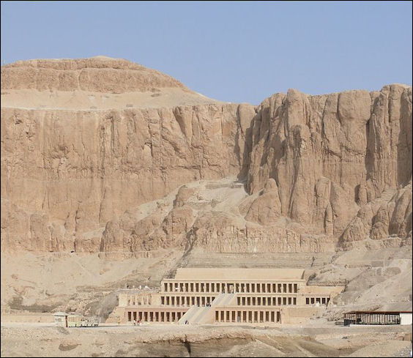

Mortuary Temple of Hatshepsut

Queen Hatshepsut planted botanical gardens and had incense burned on the terraces. During her funeral she was carried up the ramps to funerary chamber inside the temple. The temple was desecrated and vandalized by her successor. In the 7th century the Copts used the temple as a monastery.
The rear wall of the second courtyard consists of the Birth Colonnade on one side of the ramp and the Punt Colonnade on the other. The Birth Colonnade is a small sheltered area of the terrace that describes the preparation for and birth of Queen Hatshepsut. Particularly interesting is the scene of birds being captured in nets. Many of the victims of the 1997 attack were attacked in this area.

Luxor Temple
Luxor Temple (across the street from the Nile, next to the town of Luxor) was dedicated to the Amum, the god of fertility and growth, his wife Mut and their son Khonsu. Probably built on the site of an earlier temple, Luxor temple was started and extensively built by 2,623 slaves under Amenhotep III and completed a century later by Ramses II. Other pharaohs, Alexander the Great and the Romans also contributed to the effort. The Arabs even built a mosque inside one of the courtyards.
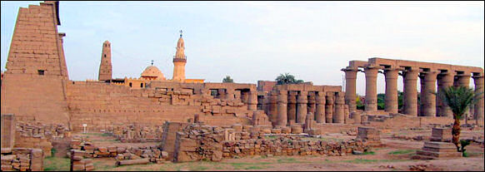

Luxor Temple

Luxor Temples is 260 meters long consists of four major structures connected to one another in a long row. They are (beginning at the entrance): 1) the courtyard of Ramses II; 2) the colonnade of Amenhotep III; 3) the courtyard of Amenhotep III; and 4) hypostyle hall and sacarium of Amenhotep III.
In ancient times the entire complex was surrounded by a massive wall. Unlike Greek temples which were meant to be viewed by everyone, Egyptian temples were not supposed to be seen by ordinary people. Every year a sacred procession commemorating the marriage between Amum and Mut moved across the Nile by boat from Karnak to Luxor Temple.
Luxor Temple was restored in the mid-1990s. The $2.2 million job included dismantling 22 columns and installing a system to halt the rise of underground water. Luxor Temple doesn't have a Light and Sound Show but it is open until 10:00pm. It is worth making a visit at night when temperatures are cool and the statues, reliefs and walls are illuminated with floodlights.

Entrance to Luxor Temple
Before the entrance is a long stone dromos “a walkway and precession route sided by sphinxes with the face of Ramses II. At one time a dromos and processional avenue connected Luxor with Karnak. There some 1,400 sphinxes spread along the two-mile route..
The façade of the entrance gate consists of a pylon (massive gate), two 15-meter-high granite seated statues of Ramses II, and once had two 25-meter obelisks (only one of which remains, the other was taken to Paris in 1833 and now sits in the Place de Concorde).
Ramses II erected a massive 65-meter-high pylon at the entrance of the temple. The front is decorated with scenes from Ramses II's military campaigns against the Hittites. At one time four statutes sat in front of the pylon. One representing Queen Nefertari was never finished. A ruined one to the right is of her's and Ramses’ daughter Merit-Amon.
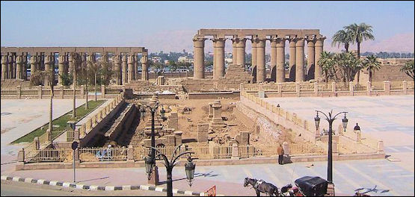

Courtyards at Luxor Temple

Courtyards at Luxor Temple
The Courtyard of Ramses II (beyond the entrance of Luxor Temple) is surrounded by a double row of thick stubby columns with bud papyrus capitals. On the inter columns on the south side of the courtyard are Orisis-like statutes of Ramses II. The columns were arranged in two closely-packed concentric squares to hold up the (now missing) heavy roof and to keep the entire temple from collapsing under its own weight.
The courtyard was built as a parallelogram instead of a rectangle so it would be oriented toward the Nile. At the northwest of the courtyard you can see the sacred boats built by Thutmosis II and dedicated to the triad of Amon, Mut and Khonsu. In the southwest corner a relief shows a procession of bulls being led to a sacrifice by bulls. The Colonnade of Amenhotep III (after the courtyard of Ramses II of Luxor Temple) is a 52-meter-long hall with 14 massive pillars, arranged in two parallel rows of seven.
The Courtyard of Amenhotep III (after the courtyard of Colonnade of Amenhotep III) is a second courtyard surrounded on three sides by double rows of columns with closed papyrus capitals. The Sacrarium of Amenhotep III (after the Courtyard of Amenhotep III of Luxor Temple) consists of a hypostyle hall with 32 pillars, a sanctuary for the sacred boat and a kiosk built by Alexander the Great. In the middle of the "maximum security labyrinth" of symmetrically arranged chapels and chambers, is four columned room with a holy shrine, which only the pharaohs and the highest priests were allowed to enter. The climatic rituals of the 15-day Opet festival occurred here. In the rear chambers are a number of engravings of a fertility god with a large erect penis.

Temple of Karnak
The Temple of Karnak (2 miles north of Luxor) ranks with the Pyramids as most amazing site in Egypt and by some estimates is the largest religious structure ever created. Over two millennia it was enlarged and enriched by consecutive pharaohs until it covered 247 acres of land on the Nile's east bank. At its height it stretched over an area of one mile by a half a mile---about half the size Manhattan---and was like a city, containing its own administrative offices, palaces, treasuries bakeries, breweries, granaries and schools. "Karnak" is the Arabic word for fort. It used to be called Ipetesut—“most esteemed of places."
There are three main areas at Karnak are: 1) the Sanctuary of Amon; 2) the Sanctuary of Mut, 3) Sanctuary for Montu. Each is separated by a rough brick boundary and each has a main temple in the middle of the enclosure. Next to the main temples were sacred lakes where ceremonies were held. Unlike most other temples in Egypt, Karnak has two axes: one following the sun from east to west; and the other following the Nile from north to south. The largest structure contains the largest columns in the world.

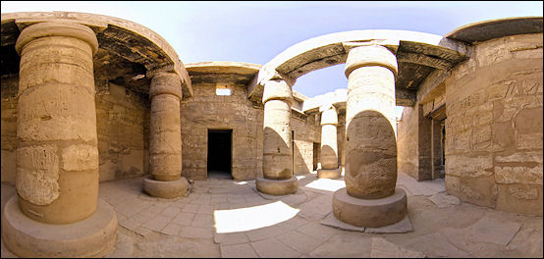

Temple of Karnak

Most of the structures at Karnak are part of the Sanctuary of Amon, which covers an area of about 60 hectares and is dedicated to Amon, the god of fertility and growth. To the south is the Sanctuary of Mut, which covers an area of about 9 hectares and is dedicated to Mut, the wife of Amon. Mut is symbolically portrayed in the form a vulture. To the north is a small Sanctuary for Montu, which covers an area of about 2½ hectares and is dedicated to Montu, the God of War.
The Temple Complex opens at 6:00am or 6:30pm. It is a good idea to arrive early and look around the grounds before it gets too hot and too many people arrive. When it does get hot you can seek refuge in the hypostyle hall, where there is ample shade even during the midday sun.
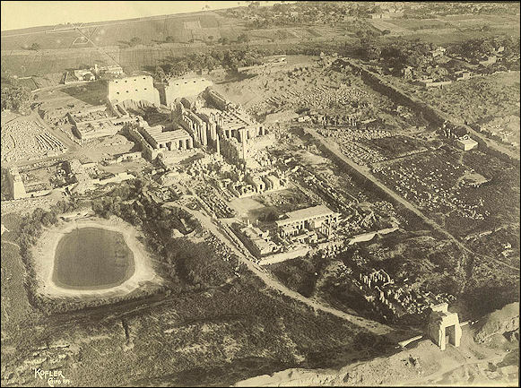

ariel view of Karnak

History of the Temple of Karnak
Karnak was built to mark the birthplace of Amun, the greatest of all Egyptian gods. It was probably built on a pre-existing sacred mound. It was built with money that the pharaohs earned in taxes and booty brought back from military victories.
Work was carried out on Karnak for 2,000 years beginning in the 12th dynasty (around 2000 B.C.) of the Middle Kingdom when an early temple was established and successive pharaohs added their own shrines and gates. Construction of buildings continued through the Middle and New Kingdom periods, with most of the work done between the XVIII Dynasty and the end of the Ramses era. In the XVIX Dynasty, 81,322 people, including priests and peasants, worked on the temple of Amon. Construction of the main hypostyle hall began in 1375 B.C. under Amenhotep III, and was continued under Seti I, his son Ramses II and was finally completed under Ramses IV.
Karnak was built from sandstone. Because it was easier to build a new temple from stones from an old temple than it was to quarry new stones, not much remains of the oldest temples because their stones were used to make newer structures. Over time the dimensions and buildings of each sanctuary changed according to the wishes of each successive pharaohs.
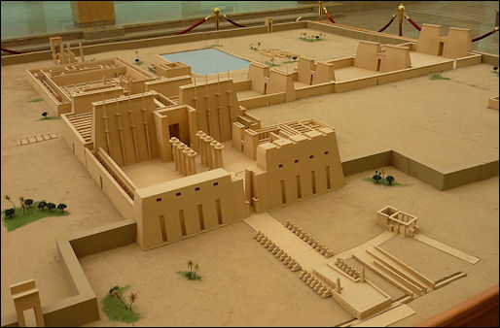
Supported by revenues from royal land endowments, Karnak became an economic power. Under Ramses III the “domain of Amun” covered 900 square miles of agricultural land, vineyards and marshlands, in addition to quarries and mines. Like many other monuments in Egypt, Karnak was covered by sand up until a century ago. When French soldiers first laid eyes on it in 1799, one lieutenant in Napoleon's army wrote: “Without an order being given the men formed their ranks and presented arms, to the accompaniment of drums and the bands." Exposure to the elements and the absorption of ground water has caused the columns to slowly deteriorate. The groundwater problem was caused by the Aswan Dam which has raised the level of the Nile and, along with it, the water table under Karnak.

Karnak model

Parts of Karnak Temple
The Temple of Amon is a long series of structures divided by six large walls and pylons (massive gates). Between these walls are large halls and courtyards, some with obelisks. The "Propylaea of the South" is an extension that includes the seventh, eight, ninth and tenth pylons.
Visitors enter the Temple of Amon on the Avenue of the Criosphinxes, which consists of a walkway sided by a parallel row of sphinx statues with ram heads. The rams represent Amon. Beneath the rams heads are small statues of Ramses II. The Avenue of the Cryophinxes, leads to the first and largest pylon. Largely unadorned and built during the Roman-Greco Ptolemy era, the avenue is 113 meters wide and 15 meters thick.
The Ethiopian Courtyard (the first courtyard after the entrance to Karnak) dates back to the IX Dynasty. On the north side is an enclosed wall fronted by columns with closed papyrus capitals. In front of these are sphinxes commissioned by Ramses II. A giant column with an open papyrus capital is all that remains of the a massive pavilion of Ethiopian king Taharka. The pavilion was 21 meters high, had a wooden ceiling and was built to house sacred boats.
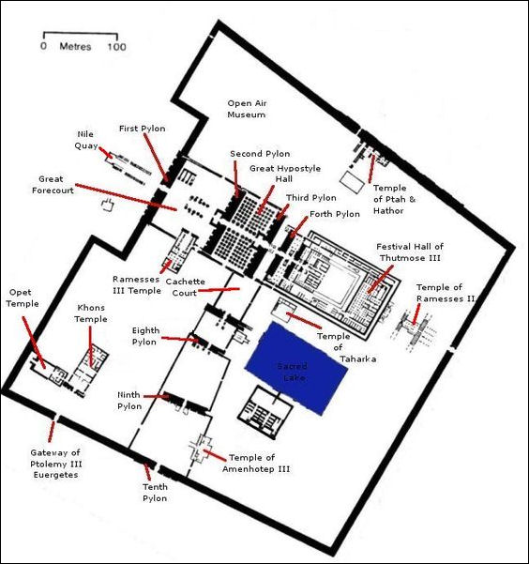
In front of the columns to the right is the Temple of Ramses III. On three sides of the interior of the temples are pillars fronted by statues of Ramses III with his arms crossedm holding a crook like the God Orisis. On the left side is the Temple of Seti I, dedicated to the chapels of the Thebes Triad: Amon, Mut and Khonsu. The white chapel of Semostris I and the alabaster chapel of Amenhotop I were rebuilt in the 1940s.

Temple of Amun

The Second Pylon (far side of the Ethiopian Courtyard) was originally decorated with two massive winged pyramids. Today there is a fallen statue of Ramses II. The large 15-meter-high statue is the Colossus of Pinedjem, a Pharaoh from XXI Dynasty. There is a small statue of a priest between his legs. Sometimes this statue is described as being Ramses II and his favorite wife Nefertari.

Hypostyle Hall of Karnak
The Hypostyle Hall of Karnak (between the Second and Third Pylons) is a massive hall, with 134 massive columns, that measures 102 meters by 53 meters and covers 56,000 square feet and was once covered by a roof. Running down the center of the hall are 12 gargantuan open-papyrus-shaped columns that soar 70 feet into the air. These columns are the tallest stone columns in the world. They were raised in 1270 B.C. It is said that there is enough room on the top of each of these columns to throw a party with 50 people. The hall itself is large enough to accommodate Notre Dame cathedral.
On both sides of the papyrus columns are 122 smaller but still massive closed-papyrus columns that rise up 42 feet. The temple and the column are so massive and overwhelming many tourists that stand transfixed with their mouths agape as they try to take it all in. The climactic scene of the movie version of Agatha Christie's Death on the Nile was shot here as well as a chase scene from one of the Roger Moore James Bond movies.
It worthwhile spending some time in the hall to see how light and shade affect the columns as the sun moves across the sky. It is also worthwhile to get a guidebook of hieroglyphics and sit in the shade and try to decipher the texts written on the columns. Paintings remain on the undersides of the lintels that link the top of the columns. Look for a pillar with the carving of a scarab, the Egyptian symbol of fertility. Women who walk around this pillar seven times are expected to give birth shortly afterwards.
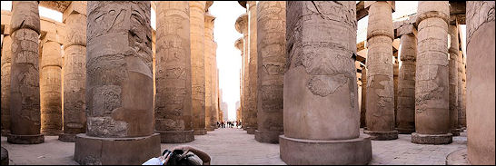

Karnak

The temple originally had a roof, and the columns were once plastered and painted with heroic scenes from the pharaohs lives. But mostly what remains now are some carved hieroglyphics and symbols, embellished by graffiti from 19th century British and Egyptian soldiers and 20th century tourists.
One of the remaining wall inscriptions reads: "His Majesty exults at the beginning of battle, he delights to enter it; his heart is gratified at the sight of blood. He lops off the heads of his dissidents...His majesty slays them at one stroke---he leaves them no heir, and whoever escapes his hand is brought prisoner to Egypt." Another set of inscriptions describe the festival of Opet. The victories of Shoshenq I, a Libyan referred to in the Bible as King Shishak, are immortalized on a relief at Karnak.

Karnak Obelisks
After the Third Pylon visitors come to the obelisk of Thumosis I. It is 23 meters tall and weighs 143 tons. Other obelisks were located here but they are now gone. After the Forth Pylon is the obelisk of Hatsheput. It is 30 meters high and weighs 200 tons. Queen Hatsheput reportedly spared no expenses and poured in "as many bushels of gold as sacks of wheat" to get the obelisk completed.
There were once six large obelisks and two smaller ones in this area. Among these are the Lateran Obelisk, now in Rome. The great obelisk at the Temple of Amun-Re at Karnak is nearly 100 feet high and weighs about 323 tons---about the same as a 747 jumbo jet. The Red Chapel of Queen Hatashepsut (1505-1484 B.C.) is Karnak's largest chapel at 100 square meters. Comprised of huge black granite and red quartzite slabs, it stood for only 20 years before it dismantled by her son-in-law and used for another structure. In 1996, it was reconstructed.
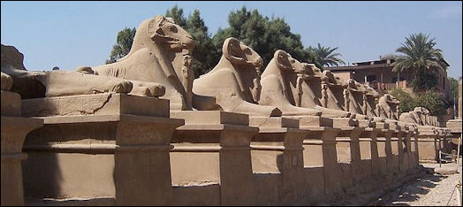
Karnak rams

After the Fifth and Sixth Pylon at Karnak
After the Fifth and Sixth Pylon is the Sanctuary of the Sacred Boats, the Festival Hall (also known as the "Temple of Millions of Years"), the large ceremonial Hall of Tuthmosis III and the Temple of Tuthmosis III. All of these buildings were covered by a large roof. Further on are the Temple of Ramses II and the Portal of the East. To the north of Portal of the East are the Osiris Chapels.
The Fifth Pylon was raised by Tuthmosis II and the Seventh Pylon was raised by Tuthmosis III. The Festival Hall is a hypostyle hall painted red to imitate wood. It included a row of 32 pillars. Some have paintings from the A.D. 6th century that are in fairly good condition. They were made by Christian monks. In the Sanctuary of the Sacred Boats are reliefs that still contain centuries-old pigments. In 1996, archaeologists began reconstructing the chapel of Thutmosis IV using a crane from a bridge project to lay the 35-ton ceiling slabs.
Sacred Lake (outside the main hall) was used for purification and was regarded as the dominion of Amon. Measuring 120 meters by 77 meters, it is surrounded by buildings, storehouses, and priest's homes. In ancient times there was an aviary for aquatic birds. Sacred ducks and geese lived in the lake whcih also provided fresh water for purification rituals. Priests purified themselves in the morning in the waters before going about their duties.
Today the Sacred Lake surrounded by restaurants and souvenir stands. Nearby is a large granite scarab dedicated to the Khepr by Amonosis and offering storehouses. To the east of the Sacred Lake is a row is a viewing stand, used to watch the Light and Sound Show at night. From here there are good views of the entire Karnak Complex.
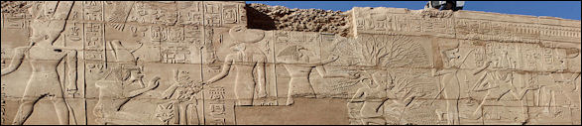

Karnak rams

Propylaea of the South (extending from the south of main temple) is in the process of being restored. It includes the seventh, eight, ninth and tenth pylons and several colossal statues. Large portions have completed. Judging from the numbers of pieces laying around a lot of work still needs to be done.
Next to the main hall are rows and rows of piled stones. These are remnants from a temple built by Akhemtan. In the 1960s a journalist photographed 30,000 decorated blocks and with the aid of a computer attempted to piece them together like a jigsaw puzzle. The Portal of the South, Temple of Khonsu and Pylon of the Temple of Opet are located on a rise with good views of the Propylaea of the South.
The Sanctuary of Mut (one kilometer south of the main temple) includes the Portal of Ptolemy II Philadelphia, Temple of Mut, Great Sacred Lake, Temple of Ramses III and Temple Amonosis III. Sanctuary for Montu (north of main temple) embraces the Temple of Montu, Temple of Maat, Portal of the North, and a Ptolemaic Temple.

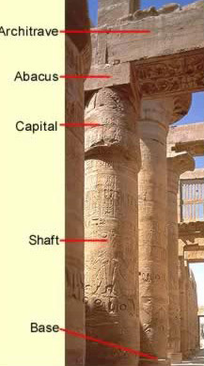
The Columns of Ancient Egypt
When we think of Egyptian temples, one of the principle architectural elements that comes to mind is the column. In fact, it is difficult to imagine a temple such as Karnak without thinking of its columned halls, and what many visitors will take away with them is visions of pylons, obelisks, statues and columns. Column shafts were often decorated with colorful depictions in painted, carved relief, and remain some of the most interesting architectural elements in Egyptian structures.
Most people who have any familiarity with ancient Egypt will immediately recognize the form of Lotus and Papyrus style columns, but actually not less than about 30 different column forms have been isolated from temples of the various periods. Most of the time, the column shafts were copied in stone of supports made from plants, resembling either a trunk or a bundle of stems of smaller diameter. Also, the shape of the capital, the top of the column, had a plant theme as well, and at the transition of the capital to the shaft, five bands might be found representing the lashing which held together the bundle of stems of which the earliest columns were made. Above the capital, a low abacus usually connected the column to the architraves placed above it. However, there are exceptions to all of this. At least prior to the Graeco-Roman Period, we also find columns with tent pole and the goddess Hathor and other god or goddess motifs.

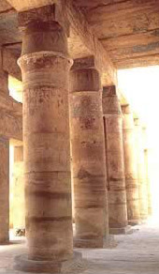
Actually, the type of column was usually, but not always, dictated by its placement within the temple, and therefore most temples actually employ more than one design. Most of the time, "Bud" style columns were used in the outer temple courts, particularly away from the central axis of the inner temple. "Open" style capitals were most often found in the temples' central areas. However, as time passed into the late antiquities period, there was considerably more variation in these themes. In the Graeco-Roman period, column styles became especially varied, and many Egyptian designs were exported to Greece and Rome, where they underwent further evolutionary changes.
In the very earliest of Egyptian history, columns were often made from one large monolithic block. However, in all later periods, columns were usually built up in sectional blocks that were then first shaped and then smoothed from the top down. They were then normally painted, and afterwards, were difficult to tell that they were not cut from a single piece of stone.

Major Types of Columns and/or Capitals
Plant Style Columns
- Fluted Column
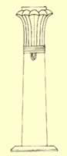
This early form of column first appears in the Step Pyramid enclosure of Djoser, but the form mostly died out by the New Kingdom. However, their use continued in Nubia. These columns resembled and represented bundled reeds or plant stems, but during later periods, sometimes took the form of a polygonal column shaft.
What is probably most interesting about fluted columns in Egypt is that they very probably represent the first columns made from stone in the world. While the fluted columns may have lost their popularity as an independent style many of the future columns incorporated design elements from them, in effect, simply incorporating a more complex capital.
- Palmiform Columns
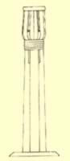
The Palmiform Columns were also one of the earliest styles of columns in Egyptian temple architecture. Examples of this type of column were found, for example, in the 5th Dynasty pyramid mortuary complex of Unas. However, after the 5th Dynasty, these types of columns are rare, but continued to occasionally be used. Mostly we find examples during later periods at the Taharga temple in Kawa in Upper Nubia, and in some temples dating to the Graeco-Roman Period. However, they may also be found in the Ramesseum. There, at the inner side of the court, are two rows of ten columns. The four middle columns in each row are Papyriform columns while the others are Palmiform. These columns obviously had a palm tree motif, but did not actually represent the tree itself, but rather eight palm fronds lashed to a pole.

- Lotiform Columns
Lotiform columns were perhaps used in non-secular buildings then in the temples. However, this is not to say that they were not also sometimes employed in religious architecture. The simple, lotus bud form of the column enjoyed widespread use in the Old and Middle Kingdom temples. Its use declined during the New Kingdom, but again found popularity during the Graeco-Roman Period. This column usually has ribbed shafts representing the the stems of the Lotus, and capitals in the form of a closed (bud) or open lotus flower. Just as a side note, Lotus plants specifically are not present in the earlier times of Egyptian antiquity. What we so often refer to as "Lotus" was in fact a type of water lily.
- Papyriform Columns
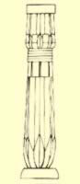
There are several variations in this type of column. Some have circular shafts representing a single plant, while others have ribbed shafts that represent a plant with multiple stems. The capitals could be closed (buds) or open in a wide, bell-shaped form. During the New Kingdom, the shafts of most papyriform columns taper upwards from bases decorated with triangular patterns representing stylized stem sheaths. The earliest examples we know of the circular shaft style columns can be found in Djoser's Step Pyramid enclosure at Saqqara. However, these are not free standing columns, but incorporated into other structures. Though the circular shaft form of the column seems to have been used throughout Egyptian history, they saw widespread use during the New Kingdom, along with both open and closed capital styles.

We first find the multi-stemmed form of this column employed during the 5th Dynasty, but it was also frequently used during the New Kingdom. 18th Dynasty columns are particularly fine, with considerable artistic detail. They became more stylized by the 19th Dynasty.
- Coniform Columns
This column style apparently quickly died out after their use in Djoser's Step Pyramid enclosure wall. It has not been found in later temples. The style is characterized by a fluted shaft surmounted by a capital representing the branches of a conifer tree.

- Tent Pole Columns
Though we probably know of other applications of this style from documentation, apparently the only surviving, known examples are found in the Festival Temple of Tuthmosis III at Karnak. It is possible that very early examples of the style were also constructed of brick. There is little doubt that this type of column made of stone was rare. The column is basically a representation in stone of the wooden "poles" used to support light structures such as tents, and sometimes shrines, kiosks or ships cabins. Why this tent pole design was used is perhaps somewhat of a mystery, though they certainly reflect back on the earliest of Egypt's structures and their wood counterparts. It is sometimes believed that the specific columns in Tuthmosis III temple were modeled after actual wooden poles of his military tent.

- Campaniform Columns
Considerable variety existed in this style of columns. They sometimes took the shape of a floral column or pillar. Some had circular, ribbed, or square shafts (pillars). They all had some form of flower shaped capital. Two of the best known of these are located in the Hall of Annals of Tuthmosis III at Karnak. At this temple, the structures take the shape of a pillar. They include two styles of columns, with one representing the heraldic plant of Lower (northern) Egypt, the Papyrus, and the other type representing the symbolic plant of Upper (southern) Egypt, the Lotus. They are positioned symbolically on the northern and southern sides of the hall. Such placement was not unusual, and we see many examples of columns positioned in the north and south of courtyards with northern and southern motifs. These specific types of columns are rare, but their more stylized forms appeared most frequently in the Graeco-Roman Period.
- Composite Columns
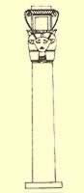
These columns were common during the Graeco-Roman Period. Composite Columns were probably an evolutionary extension of the campaniform columns with capitals decorations including floral designs of any number of real, or even imagined plants. Their variation could be endless, and they became so utterly stylized that the original floral motifs could hardly be recognized. In fact, this type of column continued to evolve in Greece and Rome, becoming very different than the Egyptian variety.

No Plant Style Columns
While natural plant columns were the most common in Egypt, other column and pillar types could represent deities or their attributes. Examples of these include:
- Hathoric Columns
This type of column never appeared prior to the Middle Kingdom, and probably originated in that period. They are usually instantly recognizable by their capital in the shape of the cow-headed goddess, Hathor. They often had a simple, round shaft. All considered, they were fairly common, and examples may be found in the Temple of Nefertari at Abu Simbel and within the hypostyle hall of the Ptolemaic (Greek) temple at Dendera. The Dendera columns are probably the best known, where all twenty-four columns have the head of this goddess on all four sides. We also know of several other temples with Hathor columns, including the temple of Nekhebet at el Kab. Sistrum columns are also associated with Hathor, but represent in the capitals and shafts the handles and rattles of the sistrum.
- Osiride Pillars

All examples of this type of pillar are engaged, meaning that they are part of another architectural element. They appear to also have originated in the Middle Kingdom, and and take the form of a statue of the god Osiris on the pillar's front surface.

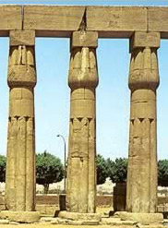 | 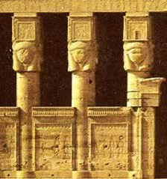
Lotiform Columns | Hathor Columns at Dendera
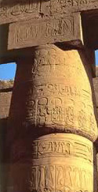 | 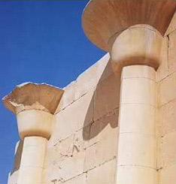
A Closed (bud) Style Capital | An example of Open Capital engaged Columns
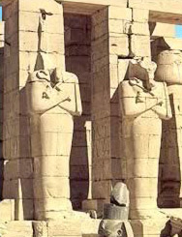 | 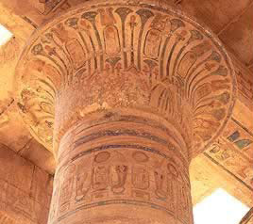
Osiride Pillars, normally identifiable by the crossed arms | An Open Papyrus Column

- There are some questions which I would like to raise.

- What are the methods of inference and access to the strength of architectural variables in Egyptian architecture?
- What are the most important architectural variables that can be inferred in Egyptian architecture?
- In light of the diversity of production in Egyptian architecture, how types can be determined?
- How to define the style of Egyptian architect in light of the similarity of the types of production in Roman and Greek architecture?

