1. General Grammars:
A grammar is a set of rules which are used to construct a language (combine words to generate sentences).
Definition: A grammar is a quadruple (∑, V, S, P), where:
1. ∑ is a finite nonempty set called the terminal alphabet. The elements of ∑ are called the terminals.
2. V is a finite nonempty set disjoint from ∑. The elements of V are called the nonterminals or variables.
3. S $∈$ V is a distinguished nonterminal called the start symbol.
4. P is a finite set of productions (or rules) of the form
$$α→β$$
where $α$ $∈$ (∑UV )*V (∑UV )* and $β$ $∈$ (∑UV )*, i.e. $α$ is a string of terminals and nonterminals containing at least one nonterminal and $β$ is a string of terminals and nonterminals.
Example 1: Let G1 = ({0, 1}, {S, T,O, I}, S, P), where P contains the following productions:
S → OT
S → OI
T → SI
O→0
I → 1
The grammar G1 can be used to describe the set {0^{n}1^{n}|n $≥$1}.
Example 2: An article can be the word a or the:
A → a
A → the
• A noun can be the word dog, cat or rat:

N → dog, N → cat, N → rat
A noun phrase is an article followed by a noun:

P → AN
An verb can be the word loves, hates or eats:

V → loves, V → hates, V → eats
A sentence can be a noun phrase, followed by a verb, followed by another noun phrase:
S → PVP
Taken all together, a grammar G1 for a small subset of unpunctuated English:
S → PVP A → a
P → AN A → the
V → loves N → dog
V → hates N → cat
V → eats N → rat
Each production says how to modify strings by substitution
• x → y says, substring x may be replaced by y.
2. The Language of the Grammar:
If G(V, T, P, S) is a CFG, then the language of G is L(G) = {w in T* | S$\underset{⇒}{*}$_{G} w} i.e., the set of strings over T derivable from the start symbol. If G is a CFG, then L(G) a context-free language.

3. Derivation:
A derivation is a sequence of rewriting operations that starts with the string$σ$ = S and then repeats the following until $σ$ contains only terminals.
A left-most derivation($\overset{⇒}{lm}$) is one in which the left-most non-terminal is always chosen as the next non-terminal to expand(Always replace the left-most variable by one of its rule-bodies).
A right-most derivation($\overset{⇒}{rm}$) is one in which the right-most non-terminal is always chosen as the next non-terminal to expand(Always replace the rightmost variable by one of its rule-bodies).
E →E+T, E →T, T →id
Derivations for id + id:
LEFTMOST | RIGHTMOST
E ⇒E+T  ⇒ T+T  ⇒ id+T  ⇒ id+id | E ⇒ E+T  ⇒E+id  ⇒ T+id  ⇒ id+id

$⇒$*is the transitive closure of ⇒. If $α⇒$*β holds, then $α$ can be derived to β. The sequence $α⇒$ · · · 𝛾· · · ⇒β is called the derivation of $α$ to β. In the same sense ⇒*LM is the transitive closure of ⇒LM.
This transitive closure can also be expressed as tree. Whenever a production is applied on a nonterminal, its node expands in the tree. Every symbol on the right-hand-side of the production becomes a child of this node. The advantage is that the order in which productions are applied does not matter and always result in the same tree. Such a tree is called a derivation tree.
Example 3: Recall the CFG for equal 0’s and 1’s:
S → 0S1S | 1S0S | є
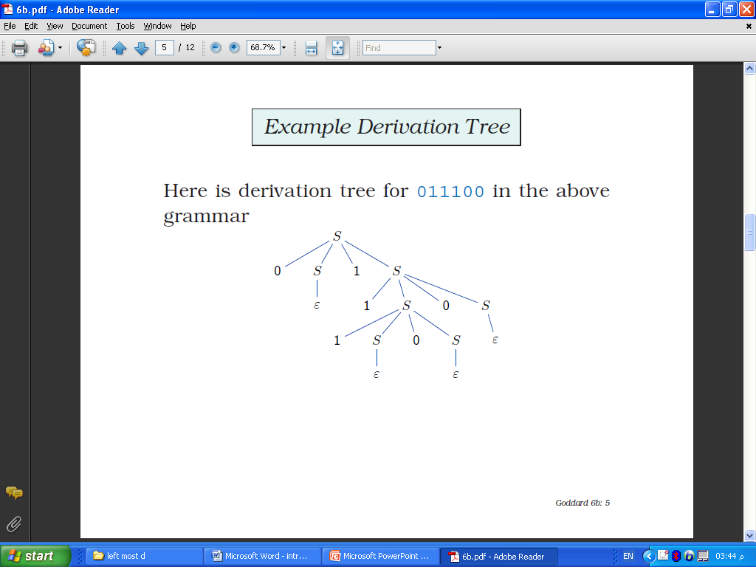
The derivation for 011100
S ⇒0S1S ⇒ 01S ⇒011S0S ⇒0111S0S0S
⇒01110S0S ⇒ 011100S ⇒011100
Here is derivation tree for 011100

Example 4: S$\overset{⇒}{rm}$aABe$\overset{⇒}{rm}$ aAde$\overset{⇒}{rm}$ aAbcde$\overset{⇒}{rm}$ abbcde

The grammar: S → aABe, A → Abc | b, B → d
Sentential Forms: For a grammar G, with start symbol S, any string a such that
S⇒* a is called a sentential form.
Let G = (V, T, P, S) be a CFG, and α $∈$ (V U T)*. If S$\underset{⇒}{*}$α then α is a sentential form.
A sentential form that can be obtained by a rightmost derivation from the start symbol is a right-sentential form of the grammar (and similarly with leftmost derivations)
If S$\overset{⇒}{lm}$α then α is a left-sentential form, and if S$\overset{⇒}{rm}$α then α is a right-sentential form.
Note: L(G) is those sentential forms that are in T*.

Example 5: Recall G1:
E → I | E + E | E * E | (E)
I → a | b | Ia | Ib | I0 | I1

1− Then E * (I + E) is a sentential form since
E ⇒E * E ⇒ E * (E) ⇒ E * (E + E) $⇒$ E*(I + E)
This derivation is neither leftmost, nor right-most.
2− a * E left-sentential form, since

E ⇒ E * E ⇒ I * E ⇒a * E
3− E * (E + E) is a right-sentential form since
E ⇒ E *E ⇒ E * (E) ⇒E * (E + E)
4. Parse Trees.:
Graphical representations of derivations. The leaves of a parse tree for a fully filled out tree is a sentence. Every derivation can be represented by a parse tree. The tree shows the symbols of a terminal string are grouped into substrings, each of which belongs to the language of one of the variables of the grammar.
In a derivation tree, the Root is the Start variable, all Internal nodes are labeled with Variables, while all Leaves are labeled with Terminals. The children of an internal node are labeled from left to right with the right-hand side of the production used.

Example 6:
S → aSbS | bSaS | є
Leftmost Derivation for aabb:
S ⇒ aSbS ⇒ aaSbSbS⇒aabSbS ⇒ aabbS⇒aabb
Rightmost Derivation:
S ⇒aSbS ⇒aSb ⇒aaSbSb ⇒aaSbb ⇒aabb
c) The parse tree is:

Homework:
Grammar is:
S →TW, T → Uc, U → aUcc | V, V → V b | є, W → Wd | є
Find the following:
a) Leftmost Derivation for string(abbcccd):
b) Rightmost Derivation(abbcccd):
c) The parse tree

Exercise 1:
Consider the following grammar G:
S → XY
X → aX |bX | a
Y → Y a | Y b | a
(a) Give a leftmost derivation of abaabb.
(b) Build the derivation tree for the derivation in part (1).
(c) What is L(G)?

