



Dr. Mohammed Al-dujaili

Department of Non-Metallic Materials Engineering

Faculty of Materials Engineering

University of Babylon

2014-2015

Lecture 2

Stage: forth

Subject: Industrial Engineering

1. **Concept of Plant Layout**

A plant layout study is an engineering study used to analyze different physical configurations for an manufacturing plant. It is also known as Facilities Planning and Layout.

Accordingly, A factory (previously manufactory) or manufacturing plant is an industrial site, usually consisting of buildings and machinery, or more commonly a complex having several buildings, where workers manufacture goods or operate machines processing one product into another.

Factories arose with the introduction of machinery during the Industrial Revolution when the capital and space requirements became too great for cottage industry or workshops. Early factories that contained small amounts of machinery, such as one or two spinning mules, and fewer than a dozen workers have been called glorified workshops. Consequently, Most modern factories have large warehouses or warehouse-like facilities that contain heavy equipment used for assembly line production. Large factories tend to be located with access to multiple modes of transportation, with some having rail, highway and water loading and unloading facilities.

However, factories may either make discrete products or some type of material continuously produced such as chemicals, pulp and paper, or refined oil products. Factories manufacturing chemicals are often called plants and may have most of their equipment, consisting of tanks, pressure vessels, chemical reactors and pumps and piping located outdoors and are operated by personnel in control rooms. Oil refineries are similar to chemical plants in that most equipment is outdoors.



**Define Plant Layouts**

**Plant Layout Design** gives manufacturing planners and facility planners advanced, efficient tools for factory resource layout. The included catalog of parametric resources such as conveyors, shelving, tables, and containers can leverage existing 2D factory drawings and be snapped to the 2D drawings to quickly realize the 3D layout. Advanced positioning makes it very easy to move, snap, and align these resources.

Plant Layout Design gives planners a realistic environment for defining and validating shop floor layouts, delivering them to the shop floor for construction, and sharing them with other stakeholders for enriching and validating process plans

**Plant Layout Design**

Designs processing plants and facilities for a wide range of environmental, recycling and mining project applications. Based on the results of treatability and process feasibility studies, ART prepares a detailed process design including Process Flow Diagram (PFD) with Mass Balance and Piping and Instrumentation Diagram(-s) (P&ID). Based on the PFD and P&ID drawings, equipment selection is made. Based on the process design, Plant Layout, Equipment, and Plan & Elevation Drawings are developed using Computer Aided Design (CAD).

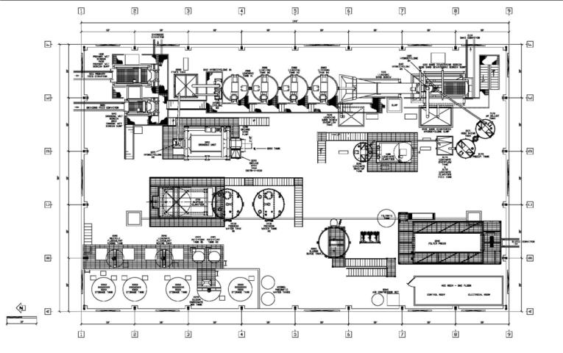

Plant Layout

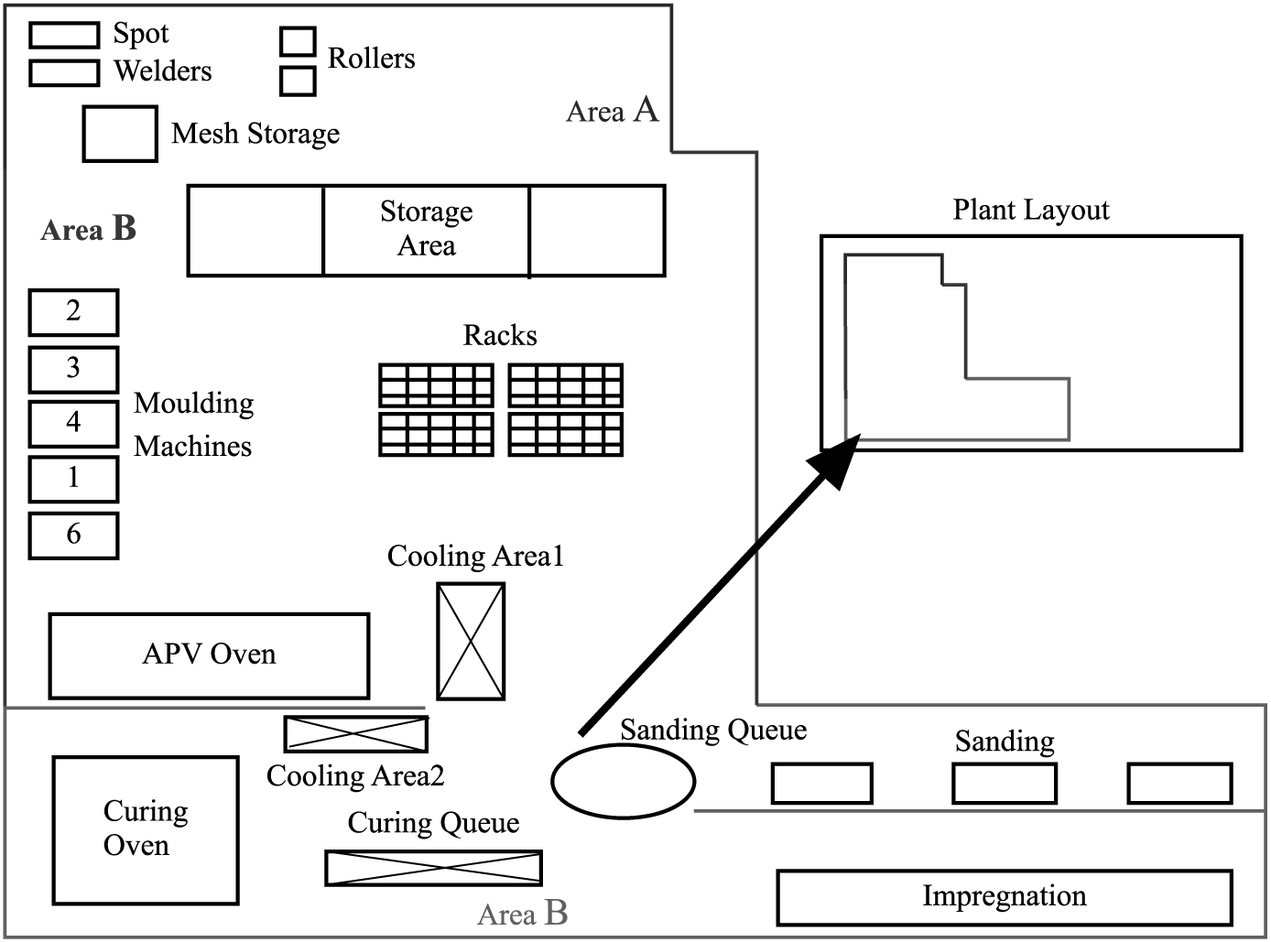

Process Design - P&ID

**Key Features and Benefits:**

* Groundbreaking user experience
* Fast and efficient layout definition
* Collaborative plant design and early discovery of layout problems
* Access to layout data throughout the extended enterprise
* Leveraging of intellectual property

**Plant Layout and Material Handling**

The production efficiency of a manufacturing unit depends on how well various machines, flow paths, storage facilities, and employee amenities are located in the plant. A systematically designed plant can ensure the smooth and rapid movement of material, from the raw material stage to the end product stage. Plant layout encompasses new layout as well as improvement in the existing layout. In modern manufacturing facilities, efficient layout is complemented by world class material handling equipment to drive the overall efficiency.

On the other hand, some of the issues that warrant careful layout planning and utilizing material handling equipments are improper material flow paths resulting in production idle time, production bottlenecks due to improper facility layout and planning, increased material handling costs due to increased number of "touches" across different operations, inability to scale up operations due to poorly designed infrastructure and material flow patterns, and reduced employee morale due to non availability of adequate amenities across the facility.

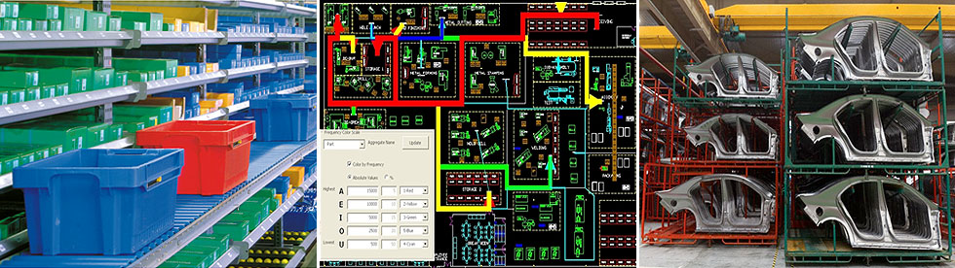

**Post-Production Analysis**

The pre-production part approval process (PPAP) is a new requirement being flowed down by many industrial customers to their component and process service suppliers. The Automotive Industry Action Group (AIAG) originated this requirement in the automobile industry in their original QS-9000, the automotive version of the ISO-9000 quality system. While the QS-9000 system is now obsolete, replaced by the new ISO/TS 16949, the requirement for doing a PPAP remains. Other industries have grasped these concepts and this requirement is growing ever larger spanning many industries not previously concerned with such formalities. For that reason, many suppliers being suddenly required to comply with these new requirements are often baffled by the vast array of paperwork they suddenly have to confront. In truth the PPAP is not as dizzying as it might seem and in many ways offers substantial benefits to the company facing the preparation of one. In view of that, A PPAP is simply a series of analyses of various aspects of a production manufacturing process. Prior to beginning production, the supplier needs to prove out his processes and procedures, on actual production tooling. The PPAP is simply a way of reporting the results of this process testing to the customer so they know the supplier has the ability to fulfil the production at the quality level required by the customer. It also demonstrates the recovery techniques to be used in the event non-complying materials are discovered during the production run. This allows the supplier to approach a zero defect quality level in his shipments.



Estimate the manufacturing costs

**Reduce the Cost of Components**

- Understand the Process Constraints and Cost Drivers

- Redesign Components to Eliminate Processing Steps

- Choose the Appropriate Economic Scale for the Part Process

Standardize Components and Processes-

- Adhere to “Black Box” Component Procurement

**Steps cost Calculation**

Mixed costs have both a fixed portion and a variable portion. There are a handful of methods used by managers to break mixed costs in the two manageable components--fixed costs and variable costs. The process of breaking mixed costs into fixed and variable portions allow us to use the costs to predict and plan for the future since we have a good insight on how these costs behave at various activity levels. We often call the process of separating mixed costs into fixed and variable components, cost estimation.

The four methods of cost estimation with regression and as follows

-Account analysis

-Scatter graphs

-High-low method

-Linear regression

**The Goal of Cost Estimation**

The ultimate goal of cost estimation is to determine the amount of fixed and variable costs so that a cost equation can be used to predict future costs. You should remember the concept of functions from your business calculus class. The function that represents the equation of a line will appear in the format of:

 y = m x + b

where y = total cost

          m = the slope of the line, i.e., the unit variable cost

          x = the number of units of activity

          b = the y-intercept, i.e., the total fixed costs

**Account Analysis**

One method of estimating fixed and variable costs requires considerable subjective judgment. This is likely the approach you have taken to identify cost behavior so far in your study of managerial accounting by looking at a cost and guessing its most likely type of cost behavior. It is most often used by accountants or managers who are familiar with the costs within an account. Account analysis is the only method you can use to estimate costs when only one data point is known. The account analysis approach requires four steps:

**Step 1:** Look through the costs that are included in a particular account and classify each amount as variable or fixed based on judgment.

**Step 2:** Total the variable costs. Determine variable costs per unit by dividing the total of all the variable costs you identified by the number of units produced (or sold). This will give you the cost per unit.

|  |  |  |  |  |
| --- | --- | --- | --- | --- |
|  | |  |  | | --- | --- | | Total Variable Costs | = Variable cost per unit | | # of Units Produced | |
|  |

**Step 3:** Total the fixed costs.

**Step 4:** Plug your answers to steps 2 and 3 into the cost formula by replacing the slope (m) with variable cost per unit and the y-intercept (b) with total fixed costs in the following format:

                                                            y = m x + b

**Scatter Graph Approach**

Creating a scatter graph is another method of estimating fixed and variable costs. It provides a good visual picture of the costs at different activity levels. However, it is often hard to visualize the line through the data points especially if the data is varied. This approach requires multiple data points and requires five steps:

**Step 1:** Draw a graph with the total cost on the y-axis and the activity (units) on the x-axis.Plot the total cost points for each activity points.

**Step 2:** Visualize and draw a straight line through the points.

**Step 3:** Determine variable costs per unit by identifying the slope thorough a measure of rise over run.

|  |  |
| --- | --- |
| Rise | = Variable cost per unit |
| Run |
|  |  |

**Step 4:** Identify where the line crosses the y-axis. This is the total fixed cost.

**Step 5:** Plug your answers to steps 3 and 4 into the cost formula by replacing the slope (m) with variable cost per unit and the y-intercept (b) with total fixed costs in the following format:

                            y = m x + b

**High-Low Method**

The high-low method uses the highest and lowest activity levels over a period of time to estimate the portion of a mixed cost that is variable and the portion that is fixed. Like the account analysis and scatter graph method, the amounts determined for fixed and variable costs are only estimates. Because it uses only the high and low activity levels to calculate the variable & fixed costs, it may be misleading if the high and low activity levels are not representative of the normal activity. For example, if most data points lie in the range of 60 to 90 percent for a particular accounting test, and one student scored a 20, the use of the low point might distort the actual expectation of costs in the future. The high-low method is most accurate when the high and low levels of activity are representation of the majority of the other points. The steps below guide you through the high-low method:

**Step 1:** Determine which set of data represents the total cost and which represents the activity. Find the lowest and highest activity points.

**Step 2:** Determine variable costs per unit by using the mathematical formula for a slope where you take divide the change in cost by the change in activity:

|  |  |
| --- | --- |
| Y2 -Y1 | = Variable cost per unit |
| X2 - X1 |

Where X2 is the high activity level

          X1 is the low activity level

          Y2 is the total cost at the high activity level selected

          Y1 is the total cost at the low activity level selected

**Step 3:** Plug your answer to steps 2 along with either the high or the low point into the cost formula by replacing the slope (VC) with variable cost per unit, the high activity total cost for the y variable, and the high activity for the x variable. Then solve for fixed costs (FC).

**Step 4:** Plug your answers to steps 2 and 3 into the cost formula by replacing the slope (VC) with variable cost per unit and the y-intercept (FC) with total fixed costs in the following format:

                            y = VC x + FC

**High Low Example:**

Information concerning  units sold and total costs for Bridges, Inc. for five months of 2009 appears below:

|  |  |  |
| --- | --- | --- |
|  | Units | Costs |
| January | 1,200 | $74,150 |
| February | 1,150 | 71,000 |
| March | 1,190 | 72,400 |
| April | 1,300 | 80,600 |
| May | 1,310 | 79,040 |

Use the high-low method to answer the following:

A.  How much are variable costs per unit?

B.  How much are total fixed costs?

C.  Write the cost equation in proper form:

**Solution:**

**Step 1:** Select the high and low data **activity** points. Because the *Units* column represents activity, select the high point: May, and the low point: February.

**Step 2:** Use the slope formula by subtracting the smallest from the largest activity on the denominator. Use the corresponding total costs for May and February and subtract the smallest from the largest cost on the numerator:

|  |  |  |  |  |
| --- | --- | --- | --- | --- |
| y2 - y1 | = | $79,040 - $71,000 | = | $50.25 per unit |
| x2 - x1 | 1,310 - 1,150 |

This is the variable cost per unit.

**Step 3:** Pick one point. They will both result in the same final answer. Substitute the total cost of one of the points for “y” in the equation: y = mx + b. Using the low point of February,  total costs are $71,000 total cost at 1,150 units. Substitute the variable cost from step 2 into the formula for “m.” Substitute the number of activity units for the low data point for “x”  You should now have the following equation:

71,000 = $50.25*1,150  + b

Solve for  total fixed costs which is the “b” variable, which gives you $13,212.50.

**Step 4:** Determine the cost formula to use in estimating the mixed costs at various levels in the following format by plugging in the variable cost per unit and total fixed cost by plugging the variable cost per unit and the total fixed costs into the cost equation as follows:

 y = $50.25x  + $13,213

The standard format is to express variable cost per unit using two decimal places and total fixed costs with no decimal places.

**A few words about variable cost per unit.**

Variable cost per unit is very literal meaning you determine 'cost per unit' using the literal interpretation:

In determining cost per unit, cost comes first so place it on the numerator. Per means to divide so draw the division sign under 'cost'. Unit comes last so it belongs on the denominator.

|  |  |
| --- | --- |
| Cost | = Variable cost per unit |
| Unit |

When you determine variable cost per unit, you must take the total cost and divide by number of units. In accounting, we often use the following as cost per unit amounts:

machine hours per unit

profit per sales dollar

cost per labor hour

miles per hour