**Changes in the O2-Hb dissociation curve:**

**Shift to the right:**

Occur when there is decreased affinity of Hb for O2 and unloading of O2 in the tissues is facilitated.

**Factors causing right shift:**

**Increases in PCO2 and decreases in pH:** When metabolic activity of the tissues increase, production of CO2 increases. An increase in tissue PCO2 causes an increase H+ and a decrease pH. This mechanism ensures that O2 delivery to the tissues can meet O2 demand (e.g. in exercising skeletal muscle).

Bohr effect states that an increased H+ concentration causes a right shift of the O2-Hb dissociation curve which causes Hb to unload O2 more readily in the tissues.

**Increases in temperature**. Increases in temperature also cause right shift, and facilitate unloading of oxygen in the tissues.

**Increases in 2, 3 diphosphoglycerate (2,3-DPG) concentration.**

2,3,-DPG: Is a byproduct of anaerobic glycolysis, present in high concentration in red blood cells because of their content of 2,3-DPG mutase, it diminishes the affinity of hemoglobin for O2, 2,3-DPG binds to β-chains of deoxyhemoglobin and reduces their affinity for O2. This decrease in affinity causes right shift and facilitates unloading of oxygen in the tissues. 2,3-DPG production increases under hypoxic conditions as in high altitude which causes hypoxemia, which stimulates production of 2,3-DPG in red cells. This facilitates O2 delivery to the tissues as adaptive mechanism.

**Importance:** Hypoxic condition that last longer than a few hours…

**Disadvantage:** The excess DPG also makes it more difficult for the hemoglobin to combines with O2 in the lungs.

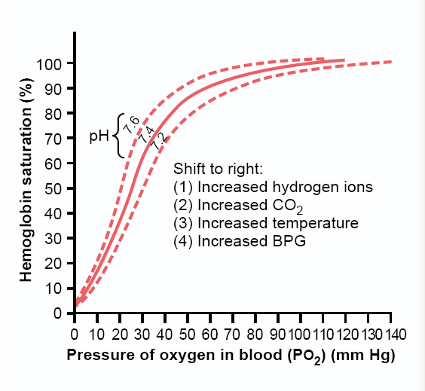

**Figure shows shift to the right**

**Shift to the left:**

This occurs when the affinity of Hb for oxygen increases. When the affinity is increased unloading of O2 in tissue is more difficult

**1.Decrease in PCO2 and increases in pH:**

When tissue metabolism decrease. CO2 production and H+ conc. decreases. Thus, when O2 demand decreases, O2 unloading to tissue decreases.

**2.Decreases in temperature:**

When tissue metabolism decreases, less heat is produced and less O2 is unloaded to the tissues.

**3.Decrease in 2,3-DPG concentration:**

This reflects decreased tissue metabolism, causing a left shift of the curve and less oxygen to be unloaded in the tissues.

**Effect of Carbon Monoxide (CO)**

CO combines Hb at the same point as does O2, and can displace O2 from hemoglobin.CO binds with about 250 times as much as O2. PCO greater than 40 mmHg can be lethal.In the presence of CO (low concentration), the affinity of hemoglobin for O2 is enhanced

**Carbon Dioxide Transport**

**Method Percentage**

Dissolved in Plasma 7 - 10 %

Chemically Bound to Hemoglobin in RBC’s 20 - 30 %

As Bicarbonate Ion in Plasma 60 -70 %

**Haldane effect**

For any given PCO2, the blood will hold more CO2 when the PO2 has been diminished. It reflects the tendency for an increase in PO2 to diminish the affinity of hemoglobin for CO2.

**Carbon dioxide transport:**

Carbon dioxidetransported from the body cells back to the lungs as:

**1.** **Dissolved in the plasma (10%)**

About 10% of the total CO2 in the blood is transported dissolved.

Solubility of CO2= 0.03mlCO2/100ml blood/mmHg.

Dissolved CO2 in arterial blood = 40mmHg x0.03mlCO2/100ml blood/mmHg= 1.2ml/100ml blood.

**2.** **Carbamino-hemoglobin** (**30%)**

CO2 binds to terminal aminogroups on proteins (eg. Hb and plasma proteins such as albumin). When CO2 is bound to Hb, it is called carbaminohemoglobin, which accounts for about 30% of the total CO2.

**3.** - **Bicarbonate (HCO3) ( 60%)**

Most of the carbon dioxide carried in the blood is in chemically modified form, HCO3 which accounts for 60% of the total CO2. The reaction is catalayzed by an enzyme called carbonic anhydrase (CA) in red cells. In the tissues, CO2 generated from aerobic metabolism is converted to HCO3 and transported to the lungs. In the lungs, HCO3 is reconverted to CO2 and expired.

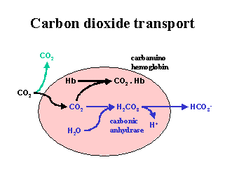

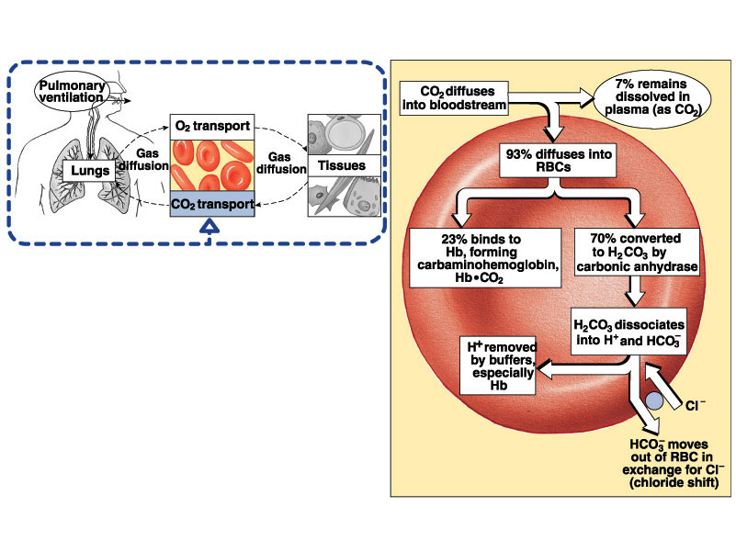

Figure :CO2 Transport and Cl- Movement

In the tissues, CO2 is produced from aerobic metabolism, CO2 then diffuses into RBC (derived by partial pressure gradient for CO2). Carbonic anhydrase found in high concentration in RBC catalyzes the hydration of CO2 to form H2CO3. In the RBC, H2CO3 dissociates into H+ and HCO3-. The H+ remains in RBC where it will be buffered. HCO3 is transported into the plasma in exchange for Cl-.

H+ is buffered in RBC by deoxyhemoglobin and is carried in venous blood in this form. By the time blood reaches the venous end of the capillaries Hb is conveniently in its deoxygenated form (i.e. it has released its O2 to the tissues). There is a useful reciprocal relationship between the buffering of H+ by deoxyhemoglobin and the Bohr effect. Thus the H+ generated from the tissue CO2 causes hemoglobin to release O2 more readily to the tissues. In turn, deoxgenation of Hb makes it better buffer for H+.

The HCO3- produced is exchanged for Cl- (to maintain change balance). The chloride-bicarbonate (Cl- - HCO3-) exchange is called Cl- shift (chloride shift).

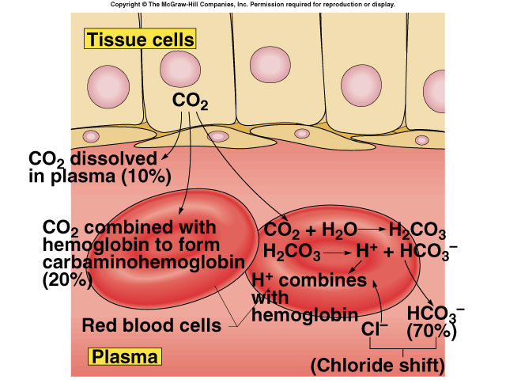

Transport of CO2 from tissues

In the lungs, the reaction is reversed (as shown in figure). When RBC enters pulmonary capillaries, O2 diffuses into cell and combines with Hb, which releases CO2 (Haldane effect).

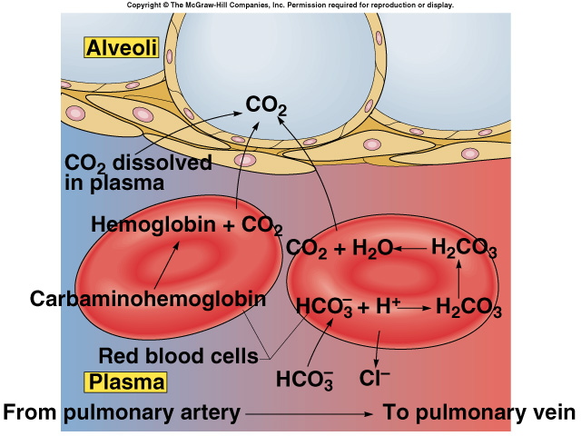

Figure: Transport of CO2 to the alveoli