Lec: 1 microbial genetics Ass. Prof.Dr. Lamees Abdul-Razzaq
Genetics: Is the study of the inheritance or heredity of living things
Genome:- is a complete set of genetic material (genes) in a cell. For example, an ovum or a sperm contains a genome. The genetic material of living things is predominantly DNA. However, the genetic material of some viruses such as HIV and Ebola is RNA.
Gene:- can be defined as a sequence of DNA which codes for the synthesis of one polypeptide.

Genetic code
The genetic code is a set of rules defining how the four-letter code of DNA is translated into the 20-letter code of amino acids, which are the building blocks of proteins. The genetic code is a set of three-letter combinations of nucleotides called codons, each of which corresponds to a specific amino acid or stop signal.
There are 64 possible permutations, or combinations, of three-letter nucleotide sequences that can be made from the four nucleotides. Of these 64 codons, 61 represent amino acids, and three are stop signals. Although each codon is specific for only one amino acid (or one stop signal), the genetic code is described as degenerate, or redundant, because a single amino acid may be coded for by more than one codon. It is also important to note that the genetic code does not overlap, meaning that each nucleotide is part of only one codon-a single nucleotide cannot be part of two adjacent codons. Furthermore, the genetic code is nearly universal, with only rare variations reported. For instance, mitochondria have an alternative genetic code with slight variations.

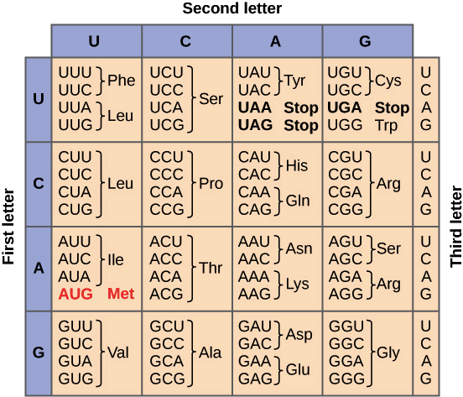

Mutation :is a change in the base sequence of DNA. An organism that has undergone mutation is called a mutant. The parent organism with a normal genotype is called the wild type or prototroph.
CAUSES OF MUTATIONS:-
A mutation can be spontaneous or induced. A spontaneous mutation is a random change in the base sequence caused by errors in replication or natural background radiation. This type of mutation occurs one in every 105 to 1010 replications. An induced mutation is caused by purposeful exposure to mutagens.
Mutagen = agent in environment that brings about DNA mutation. Usually chemically or physically interact with DNA to cause change. Once mistake is fixed into the DNA the change is permanent.

CATEGORIES OF MUTATIONS
Point mutation (base substitution or substitution mutation) is a change that involves only one base pair. This type of mutation may or may not cause a change in the amino acid sequence of a polypeptide.
  - There are three types of point mutations:
    - Silent Mutation:
      - A silent mutation causes no change in the activity of the protein.
      - A silent mutation is usually the result of a substitution occurring in the third location of the mRNA codon
        - Because the genetic code is degenerate (most amino acids are coded for by several alternative codons), the resulting new codon may still code for the same amino acid.
    - Missense Mutation:
      - A missense mutation is a nucleotide substitution that changes a codon so that it codes for a different amino acid in the protein.
      - This usually results in a change of the activity of the protein. The change may be harmful or beneficial to the protein.
    - Nonsense Mutation:
      - A nonsense mutation is the same as a missense mutation except the resulting codon codes for a STOP signal.
      - The result is a premature termination of translation.
      - The protein is shorter than usual and does not contain all the amino acids that it should. Therefore, this protein is most likely nonfunctional.
There are two types of point mutation: transition and transversion.
Transition is a replacement of a purine (adenine or guanine) by another purine, or a pyrimidine (cytosine or thymine) by another pyrimidine.
A-T <========= ===> G-C or C-G <=========> T-A
Transversion is a substitution of a purine (adenine or guanine) by a pyrimidine (cytosine or thymine) or vice versa in a DNA molecule.
A-T <============= > C-G or C-G <=============> A-T
A back-mutation refers to a type of mutation in which a gene undergoes a reverse mutation to its original base composition.

Frameshift Mutations
- Another type of mutation is a frameshift mutation which is caused by the insertion or a deletion of a base pair.
- An inserted or deleted nucleotide alters the triplet grouping of nucleotides into codons and shifts the reading frame so that all nucleotides downstream from the mutation will be improperly grouped.
Addition mutation: It is a type of mutation in which a base sequence has been added or duplicated.
Deletion mutation: It is a type of mutation in which a base sequence has been eliminated from the DNA sequence.
Addition and deletion may also be considered a point mutation if only one base pair is involved.

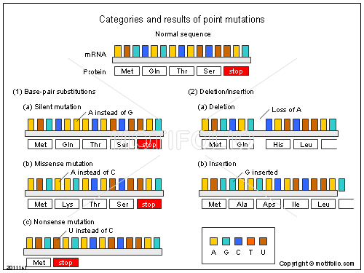

Microbial genetic elements:

Plasmids
- Plasmids are genetic elements that can also provide a mechanism for genetic change.
- Plasmids, are small, circular pieces of DNA that exist and replicate separately from the bacterial chromosome.
- We have already seen the importance of the F plasmid for conjugation, but other plasmids of equal importance can also be found in bacteria.
- One such plasmid is the R plasmid.
- Resistance or R plasmids carry genes that confer resistance to certain antibiotic

Transposons
- Transposons (Transposable Genetic Elements) are pieces of DNA that can move from one location on the chromosome another, from plasmid to chromosome or vice versa or from one plasmid to another.
Genetic Recombination:
Genetic recombination refers to the exchange between two DNA molecules. It results in new combinations of genes on the chromosome.

Genetic Transfer
- Genetic transfer is the mechanism by which DNA is transferred from a donor to a recipient.
- Once donor DNA is inside the recipient, crossing over can occur.
  - The result is a recombinant cell that has a genome different from either the donor or the recipient.
- In bacteria genetic transfer can happen three ways:
  - Transformation
  - Transduction
  - Conjugation

Transformation
- After death or cell lyses, some bacteria release their DNA into the environment.
- Other bacteria, generally of the same species, can come into contact with these fragments, take them up and incorporate them into their DNA by recombination.
  - This method of transfer is the process of transformation.
- Any DNA that is not integrated into the chromosome will be degraded.
- The genetically transformed cell is called a recombinant cell because it has a different genetic makeup than the donor and the recipient.
  - All of the descendants of the recombinant cell will be identical to it.
  - In this way, recombination can give rise to genetic diversity in the population.
