physiology GIT))

المرحلة الثانية

المحاضرة الثانية

**Regulate GIT function:**

this can be done by two pathways**1**-neural pathway **2**-Humoral pathway

**1-neural pathway:**

all the activities of GIT are involuntary controlled by (ANS); except ingestion (intake of food),mastication and defecation

Neural control can be divided into:

**A-Intrinsic nerve supply**

The GIT has an enteric nervous system or ( local brain) which control movement and secretion of GIT .It lies entirely in the wall of the gut, beginning in the esophagus and extending all the way to the anus. The parasympathetic and sympathetic nervous signal to GIT from the brain and spinal cord alter the degree of activity of this enteric nervous system. The enteric nervous system is composed of two layer of neurons and connecting fibers, **a**-the outer layer called the myenteric plexus(Auerbach’s) which control mainly the GIT movement including strength and frequency and GIT tone **b**- the inner layer called the submucousal plexus or (Meissner's plexus) which is controls secretion of submucosal gland .

**B-Extrinsic nerve supply**; include

**The Parasympathetic innervations:** divided into cranial and sacral division. The cranial is mediated through the vagus nerves which innervate esophagus, stomach. pancreas, and first half of the large intestine, and little enervation to small intestine. The sacral originate in S2, 3, 4 sacral segments of the spinal cord. and pass through the pelvic nerves to distal half of the large intestine. These fibers function in the defecation reflex. Stimulation of parasympathetic nerve fibers releases acetylcholine and causes increase activity of the enteric nervous system which enhances the activity of GIT.

**The sympathetic innervations**: sympathetic out flow from lower thoracic and upper lumbar (T5-L2)it has inhibitory function. Four sympathetic ganglia serve the GIT:

Celiac. superior mesenteric, inferior mesenteric, and hypogastric. synapse on ganglia in the myenteric and submucosal plexuses which directly innervate smooth muscle, endocrine or secretary cells.50 % of the sympathetic nerve fibers are afferent and 50% are efferent.

**Nervous Control of Gastrointestinal Blood Flow**:-

Stimulation of the parasympathetic nerves going to the stomach and lower colon increases local blood flow at the same time that it increases glandular secretion. The effects of stimulation are not direct that glandular secretion lead to increase blood flow.

Sympathetic stimulation, by contrast, cause intense vasoconstriction of the arterioles with greatly decreased blood flow. After a few minutes of this vasoconstriction, the flow often returns almost to normal by means of a mechanism called “auto regulatory escape.” That is, the local metabolic vasodilator mechanisms that are elicited by ischemia override the sympathetic vasoconstriction returning toward the necessary nutrient blood flow to the gastrointestinal glands and muscle .

sympathetic vasoconstriction in the gut allows shut-off of gastrointestinal and other splanchnic blood flow for short periods of time during heavy exercise, when increased flow is needed by the skeletal muscle and heart. Also, in circulatory shock ,when all the body’s vital tissues are in danger of cellular death for lack of blood flow—especially the brain and the heart—sympathetic stimulation can decrease splanchnic blood flow to very little for many hours.

Sympathetic stimulation also causes strong vasoconstriction of the large-volume intestinal and mesenteric veins. This decreases thereby displacing large amounts of blood into other parts of the circulation. In hemorrhagic shock or other states of low blood volume, this mechanism can provide as much as 200 to 400 milliliters of extra blood to sustain the general circulation

**2-Humoral pathway:**

Include hormones called GIT hormones which are secreted from certain area of GIT and released into portal circulation to influence the function of other parts in GIT to regulate movement and secretion of the digestive enzyme example gastrin cholecystokinin -pancreozyme (CCK-PZ), secretin, vasoactive intestinal poly peptide (VIP),substance P (neurotensin) this can be classified into 3 groups :

**1-Gastrin family**: function mainly on stomach to increase gastric secretion .

**2-secretin family**: influence the secretion and movement of the small intestine ,(CCK-PZ) which is of the secretin family act mainly on the secretion of gall bladder and pancreas .

**3-small poly peptides**: are really neurotransmitters which may have local function on certain area of GIT example villikinin which regulate movement of the intestinal villi.

**Ingestion of food**

The amount of food that a person ingests is determined by intrinsic desire for food called hunger .The type of food that a person preferentially seeks is determined by appetite.

Chewing and swallowing are the first steps in processing of ingested food.

**1- Chewing (Mastication**):

Chewing has three functions:

**A**- It mixes food with saliva, lubricating it to facilitate swallowing

**B** - it reduce the size of food which facilitates swallowing.

**C**- It mixes carbohydrates with salivary amylase to begin carbohydrate digestion.

It include as both voluntary and involuntary components, involuntary component involves reflexes initiated by the presence of a bolus food in the mouth. Sensory information is relayed from mechanoreceptors in the mouth to the brain stem. While voluntary chewing occur at any time. The teeth is designed for chewing. The incisor providing a strong cutting action, and the molars for grinding action. Most of the muscles of chewing are innervated by motor branch of the 5Th cranial nerve, and the chewing process is controlled by nuclei in the brain stem. Stimulation of specific reticular areas in the brain stem taste centers will cause rhythmical chewing movements

.Also, stimulation of areas in the hypothalamus, amygdala, and even the cerebral cortex near the sensory areas for taste and smell can often cause chewing. Chewing process is caused by chewing reflex. The presence of a bolus of food in the mouth causes reflex inhibition of muscles or mastication which allows the lower jaw to drop. The drop in turn initiates a stretch reflex of the jaw muscles ( the masseter, medial pterygoid, and temporalis muscles) that lead to *rebound contraction,* This automatically raises the jaw to cause closure of theTeeth,but it also compresses the bolus against the lining of the mouth and push the food to come in contact with buccal receptors, which inhibit the jaw muscles again allowing the jaw to drop and rebond another time; this is repeated again and again.

**2- Swallowing: (deglutition ):**

Swallowing is initiated voluntarily In the mouth but thereafter it is under involuntary

or reflex control. Swallowing center is located in the medulla. Sensory information ( food in the mouth detected by somatosensory receptors located near pharynx), this afferent information is carried to medullary swallowing center via vagus and gloss pharyngeal nerves. The information is coordinated in medulla, motor (efferent) to striated muscle of the pharynx and upper esophagus.

There are 3 phases involved in the swallowing:

**A- Oral phase:** it is initiated when the tongue forces a bolus of food back toward the pharynx, which contains high density of receptors, which initiate the involuntary swallowing reflex in medulla

**B- Pharyngeal phase**: The purpose of this phase to propel the food bolus from the mouth through the pharynx to esophagus in the following step:

**1-** The soft palate is pulled upward, creating a narrow passage for food to move into the pharynx, so food cannot reflux into nasopharynx.

**2-** Epiglottis move to cover opening of larynx to prevent food from entering the trachea.

**3-** Upper esophageal sphincter relaxes allowing food to pass from pharynx to esophagus.

**4**-Aperistaltic wave of contraction is initiated in pharynx and propel food through the open sphincter. The breathing is inhibited during the pharyngeal phase of swallowing:

**C- Esophageal phase:** it is controlled by swallowing reflex. in this phase, food propelled through the esophagus to the stomach the esophageal secretions are entirely mucous provide lubrication for swallowing. Once the bolus has passed through the upper esohagus sphincter in pharyngeal phase. The reflex closes the sphincter. so food cannot reflux into pharynx. Primary peristaltic wave coordinated by swallowing reflex, travels down the esophagus propelling the food along the secondary wave which is mediated by the enteric nervous system, begins at site of distension and travels down ward. (Figure 3)

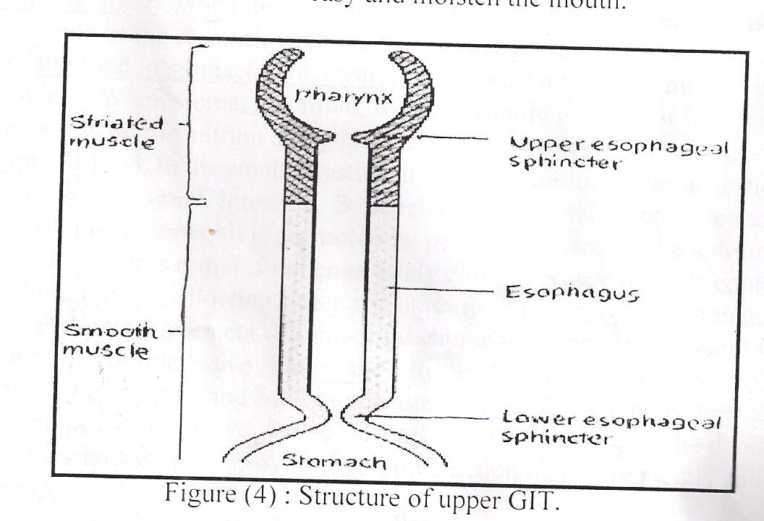

esophagus

stomach

pharynx

Smooth muscle

Striated muscle

lower esophageal sphincter

Upper esophageal sphincter

(Figure 3):structure of upper GIT

**Disorders of Swallowing**

Damage to the 5th, 9th, or 10th cerebral nerve , swallowing center and brain stem can cause paralysis swallowing mechanism .

As well as deep anesthesia ,cause blocked the reflex mechanism of swallowing, in this case large quantities of vomiting materials come from the stomach into the pharynx; then, instead of swallowing the materials again, they suck them into the trachea. As a result, such patients choke to death on their own vomitus.

**Disorders of esophagus**

Achalasia or Megaesophagus is a condition in which the lower esophageal sphincter fails to relax during swallowing. As a result of damaging in the neural network of the myenteric plexus,lead to lost its ability to transmit a signal to cause “receptive relaxation” of the gastroe sophageal sphincter the food fails to pass from the esophagus into the stomach Antispasmotic drugs (drugs that relax smooth muscle) can be helpful.