Lec 2 + 3 :

Infections of the pharynx:

Acute Viral Pharyngitis
Etiology, symptoms: Acute viral pharyngitis, which is often caused by influenza or parainfluenza viruses, typically presents clinically with sudden onset of fever, sore throat, and headache. There may also be coughing and catarrhal symptoms (e.g., rhinitis, sinusitis).
Concomitant cervical adenopathy may also be present.

Diagnosis: The pharyngeal mucosa appears red and coated on mirror examination. If a bacterial etiology is suspected, a rapid streptococcal test can be performed

Treatment is supportive and consists mainly of analgesic agents. Cold compresses to the neck can also help to relieve pain. The patient should drink copious amounts of warm liquid to ease complaints

Chronic Pharyngitis
Etiology: Chronic pharyngitis is often a result of longterm exposure to various noxious agents (nicotine, alcohol, chemicals, gaseous irritants). It can also occur as a result of chronic mouth breathing due to nasal airway obstruction (e.g., deviated septum) or as an accompanying feature of chronic sinusitis.

Symptoms: The main clinical manifestations are a drythroat sensation with frequent throat clearing and the drainage of a viscous mucus. Some patients have a dry cough and a foreign-body sensation in the pharynx.

Diagnosis: The history will often direct attention to possible noxious agents. On mirror examination, the pharyngeal mucosa appears red and “grainy” due to the hyperplasia of lymphatic tissue on the posterior pharyngeal wall (hypertrophic form: The pharyngeal mucosa may also have a smooth, shiny appearance in some cases (atrophic form). A thorough nasal examination should be performed to exclude nasal airway obstruction as the cause of chronic pharyngitis, giving particular attention to possible septal deviation or turbinate hyperplasia.

The middle meatus should also be examined endoscopically (Anatomy of the Ostiomeatal Unit

Treatment: Any agents causing the pharyngitis should be avoided. Also, an herbal product such as sage or chamomile can be used in a steam inhalation to moisten the airways. In patients with nasal airway obstruction due to septal deviation or turbinate hyperplasia, a
surgical procedure can be performed to improve complaints

Tonsillitis
Tonsillitis, or infection of the tonsils is commonly seen in ENT and in general practice. Common bacterial pathogens are B haemolytic streptococcus, pneumococcus and haemophilus influenzae. Sometimes this occurs following an initial viral infection. Treatment consists of appropriate antibiotics (e.g. penicillin), regular simple analgesia, oral fluids and bed rest.
Signs of acute tonsillitis
- Sore throat
- Enlargement of the tonsils
- Exudate on the tonsils
- Difficulty in swallowing
- Pyrexia
- Malaise
- Bad breath
- Ear ache.
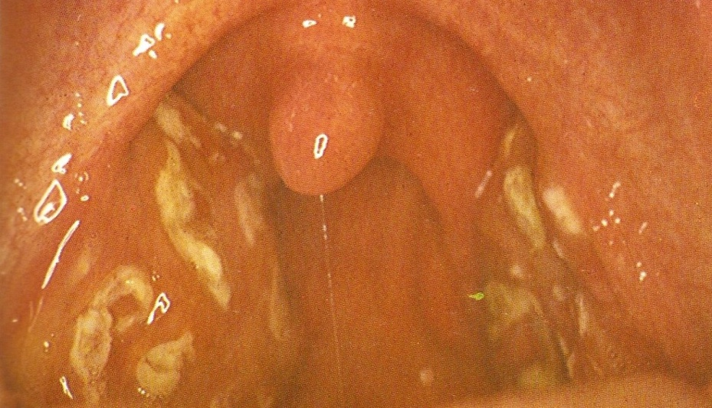

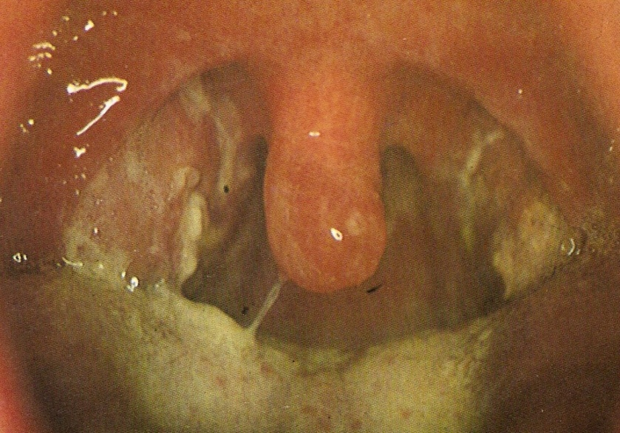

Complications of tonsillitis
Airway obstruction: This is very rare, but may occur in tonsillitis due to glandular fever. The patient may experience severe snoring and acute sleep apnoea. This may require rapid intervention e.g. insertion of nasopharyngeal airway or intubation.
Quinsy (paratonsillar abscess): This appears as a swelling of the soft palate and tissues lateral to the tonsil, with displacement of the uvula towards the opposite side. The patient is usually toxic with fetor, trismus and drooling. Needle aspiration or incision and drainage is required, along with antibiotics which are usually administered intravenously..
Parapharyngeal abscess: This is a serious complication of tonsillitis and usually presents as a diffuse swelling in the neck. Admission is required and surgical drainage is often necessary via a neck incision. The patient will usually have an ultrasound scan first, to confirm the site and position of the abscess.
Management
Patients with complicated tonsillitis, and those who are unable to take enough fluid orally, will need to be admitted to hospital for rehydration, analgesia, and intravenous antibiotics. Ampicillin should be avoided if there is any question of glandular fever, because of the florid skin rash which will occur.

Treatment: The standard treatment for streptococcal
tonsillitis is a 10–14-day course of penicillin V. This
regimen should be continued for at least 7 days to
avoid late complications (see below). Macrolides or
oral cephalosporins can be used in patients allergic to
penicillin. Analgesics are also administered for pain

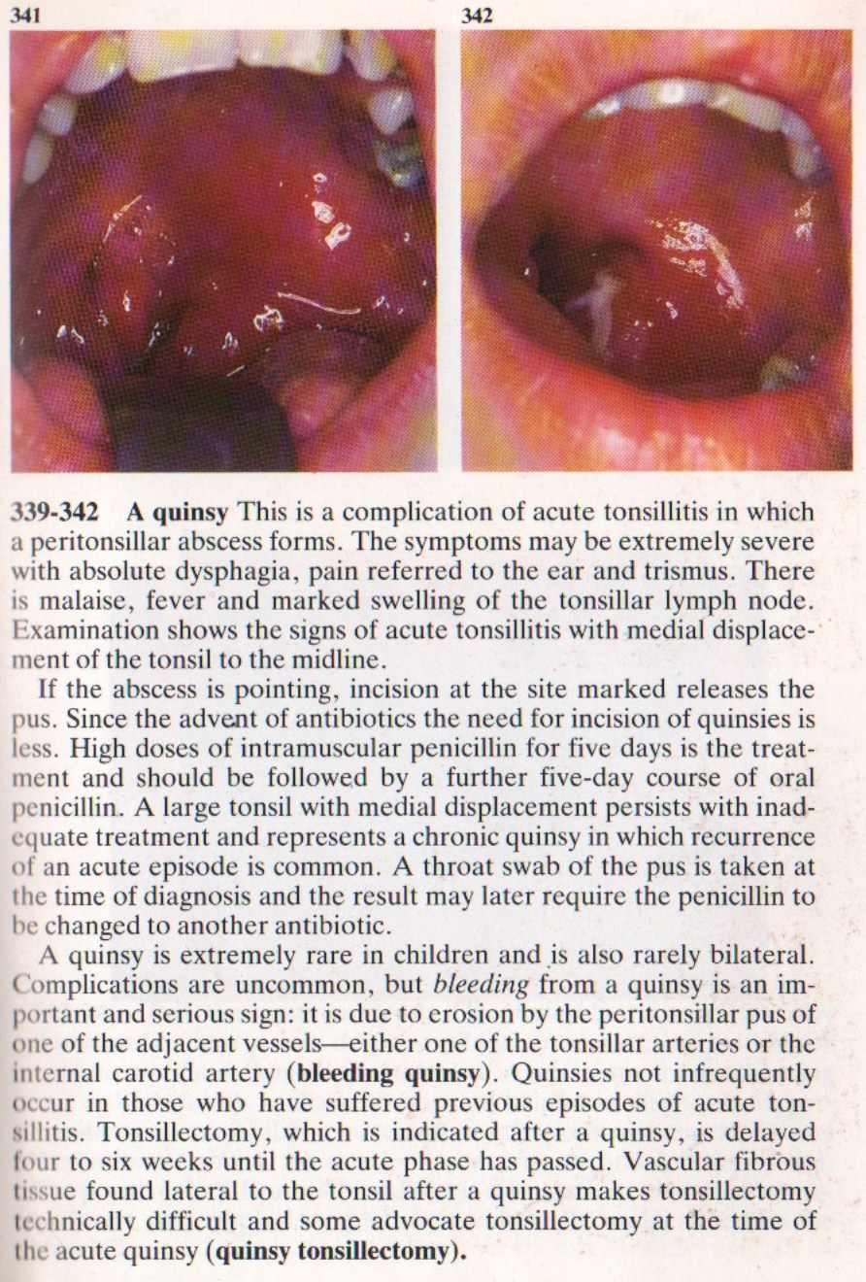

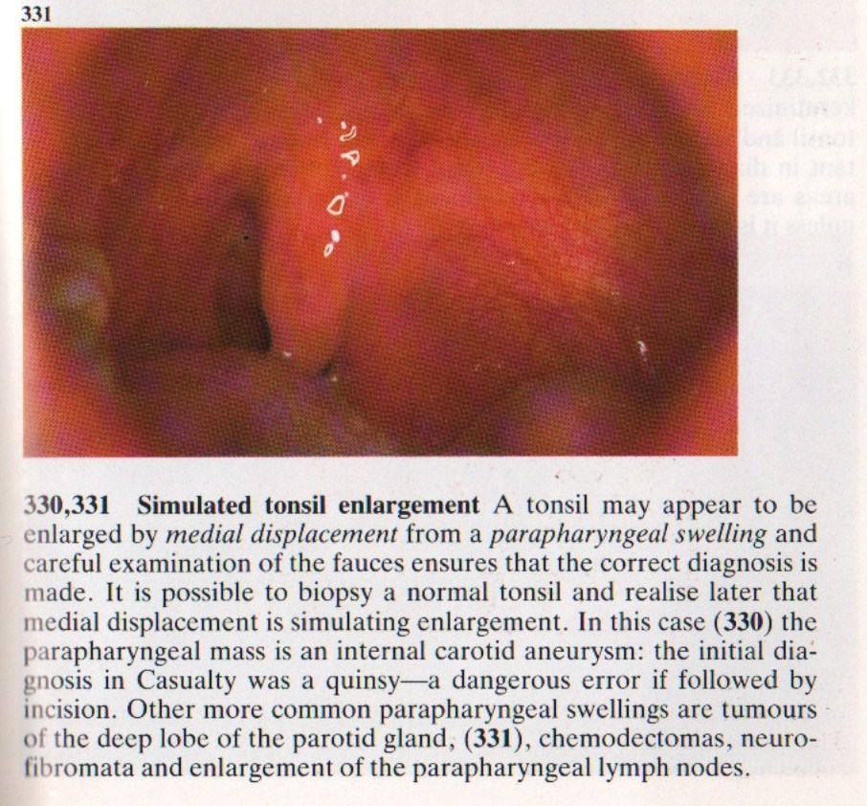

Diphtheria :

Epidemiology: Diphtheria was controlled for a time by active immunization, but lately its incidence has been rising due to low vaccination numbers, especially in immigrants from Eastern Europe, and secular fluctuations in the virulence of the toxin. All instances of the disease must be reported to health officials.

Causative organism: The causative organism is Corynebacterium diphtheriae, which is transmitted by droplet inhalation or skin-to-skin contact. The incubation period
is 1–5 days.

Pathogenesis: The bacterium produces a special endotoxin that causes epithelial cell necrosis and ulcerations.

Clinical manifestations: Two main forms are distinguished based on their clinical presentation:
• Local, benign pharyngeal diphtheria
• Primary toxic, malignant diphtheria
The disease begins with moderate fever and mild swallowing difficulties. The clinical picture becomes fully developed in approximately 24 hours, characterized by severe malaise, headache, and nausea.

Diagnosis: Mirror examination of the pharynx reveals typical grayish-yellow pseudomembranes that are firmly adherent to the tonsils and may spread to the palate and pharynx. The underlying tissue bleeds when the coatings are removed. A slightly sweet breath smell is also characteristic. The diagnosis is confirmed by the overall clinical impression, combined with smear findings.

Treatment: First, the patient should be isolated. Whenever diphtheria is suspected, even before it is confirmed by smear results, diphtheria antitoxin (200– 1000 IU/kg body weight) should be administered by intravenous or intramuscular injection. Allergy to the antitoxin should be excluded (with a skin test) before it is administered. Penicillin G should also be administered.

Discharge from the hospital is contingent upon test results: three smears taken at 1-week intervals must all be negative. Two percent of patients continue to carry the bacterium and should undergo tonsillectomy.

Complications: Dangerous complications, which occur mainly in association with the primary toxic malignant form, are toxic myocarditis (which may terminate fatally in 10–14 days) and interstitial nephritis. The more severe the diphtheria, the earlier these complications may arise. Electrocardiography and urinalysis follow-ups should be continued for at least 6weeks after the onset of the disease.

Glandular fever
Glandular Fever is also known as infectious mononucleosis or Epstein-Barr virus infection. It is common in teenagers and young adults. Patients with glandular fever may present a similar picture to patients with acute bacterial tonsillitis, but with a slightly longer history of symptoms. Diagnosis relies upon a positive monospot or Paul-Bunnell blood test, but early in the course of the disease this test can still show up negative.
Signs and symptoms
- Sore throat
- Pyrexia
- Cervical lymphadenopathy
- White slough on tonsils
- Petechial haemorrhages on the palate
- Marked widespread lymphadenopathy
- Hepatosplenomegaly.
Treatment
This is a self limiting condition for which there is no cure as such. Treatment is largely supportive with painkillers, although patients may appreciate a short course of corticosteroids to decrease swelling. IV fluids may be necessary if they cannot drink enough.
Complications
Patients should be advised to refrain from contact sports for six weeks because of the risk of a ruptured spleen. This can lead to life threatening internal bleeding.

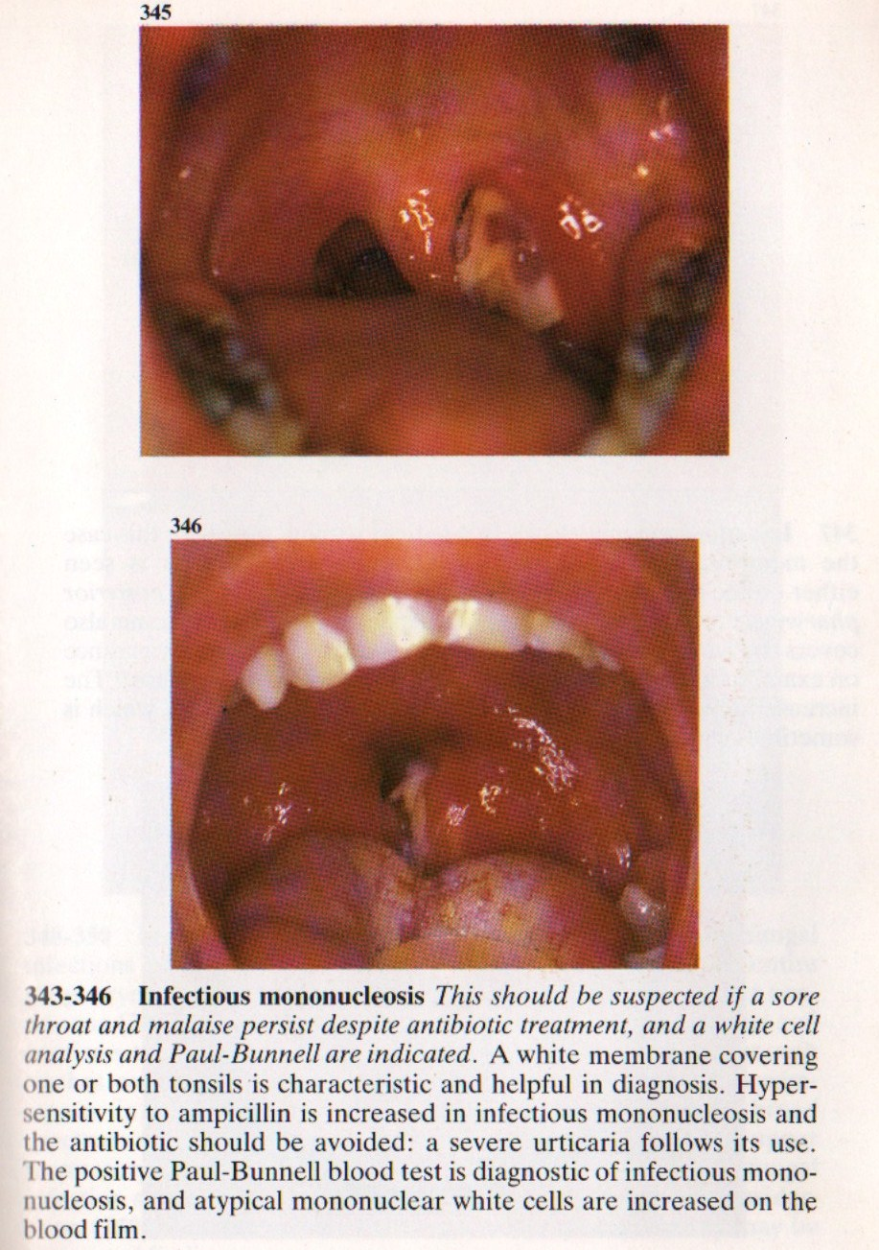

Tonsillectomy
This is one of the most commonly performed operations. Patients usually stay in hospital for one night, so that bleeding may be recognized and treated appropriately. Tonsils are removed by dissection under general anaesthetic. Haemostasis is achieved with diathermy or ties.

Tonsillectomy is very painful and regular simple analgesia is always required afterwards. Patients should be advised that referred pain to the ear is common. Until the tonsillar fossae are completely healed, eating is very uncomfortable. The traditional jelly and ice cream has now been replaced with crisps, biscuits, and toast, since chewing and swallowing after tonsillectomy is very important for recovery and in helping to prevent infection.
In the immediate postoperative period the tonsillar fossae become coated with a white exudate, which can be mistaken as a sign of infection.

Indications for tonsillectomy
- Absolute indications for surgery
- Suspected malignancy
- Children with OSA (obstructive sleep apnoea)
- As part of another procedure such as UPP for snoring.
- Relative indications for surgery
- Recurrent acute tonsillitis
- 3 attacks per year for 3 years or
- 5 attacks in any one year
- More than one quinsy.
Big tonsils which are asymptomatic need not be removed.

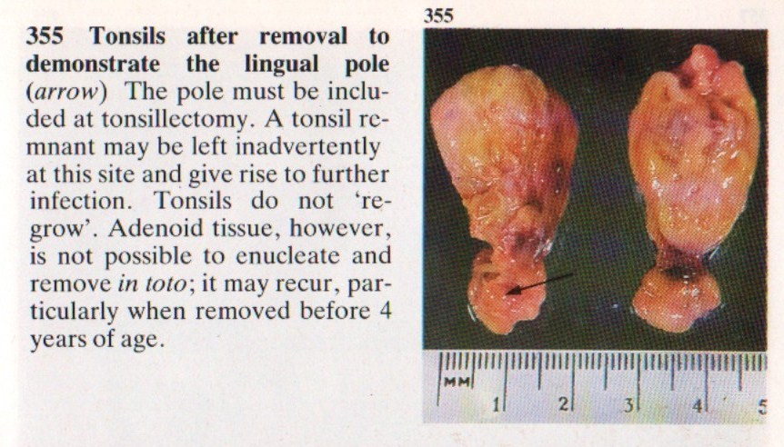

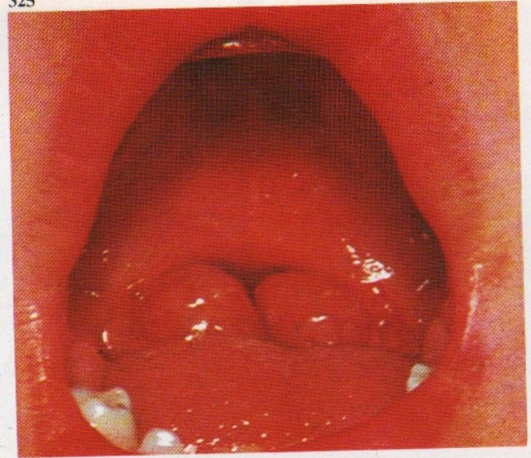

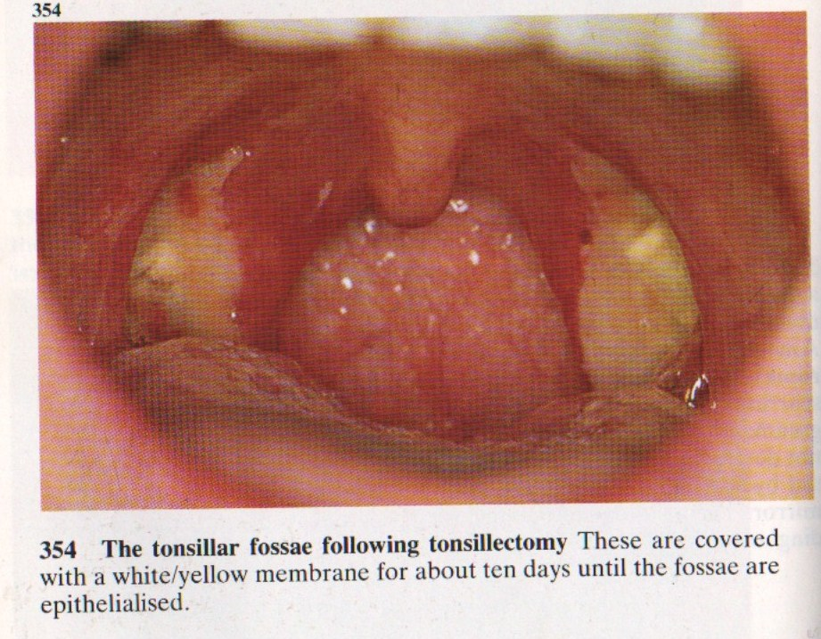

Complications
Postoperative haemorrhage is a serious complication for between 5-15% of patients after a tonsillectomy.
A reactive haemorrhage can occur in the first few hours after the operation, this will frequently necessitate a return trip to the operating theatre.
A secondary haemorrhage can occur any time within two weeks of the operation.

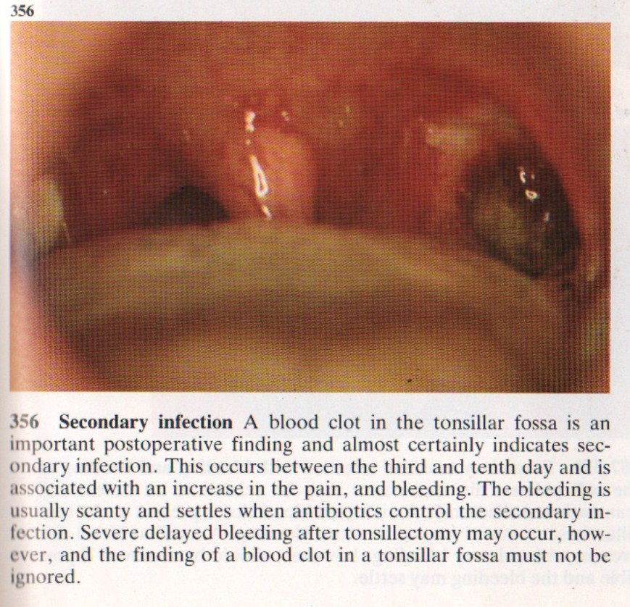

Adenoidal enlargement
The adenoid is a collection of loose lymphoid tissue found in the space at the back of the nose. The Eustachian tubes open immediately lateral to the adenoids. Enlargement of the adenoids is very common, especially in children. It may happen as a result of repeated upper respiratory tract infections which occur in children due to their poorly developed immune systems.
Signs and symptoms
- Nasal obstruction
- Nasal quality to the voice
- Mouth breathing which may interfere with eating
- A Runny nose
- Snoring
- Obstructive sleep apnoea syndrome (OSAS)
- Blockage of the eustachian tube.
A diagnosis of adenoidal enlargement is usually suspected from the history. Using a mirror or an endoscopic nasal examination will confirm the diagnosis.
The glue ear which arises as a result of poor eustachian tube function may cause hearing impairment. Adenoiditis or infection of the adenoid, may allow ascending infections to reach the middle ear via the eustachian tube.
Treatment
An adenoidectomy is performed under a general anaesthetic. The adenoids are usually removed using suction diathermy or curettage.
Complications
Haemorrhage (primary, reactionary, and secondary): These are serious complications of an adenoidectomy, but this is less common than with a tonsillectomy. The procedure is frequently carried out safely as a day case.
Nasal regurgitation: The soft palate acts as a flap valve and separates the nasal and the oral cavity. If the adenoid is removed in patients who have even a minor palatal abnormality, it can have major effects on speech and swallowing. Palatal incompetence can occur in these patients resulting in nasal regurgitation of liquids and nasal escape during speech. Assessment of the palate should form part of the routine ENT examination before such an operation, in order to avoid this complication.

