Lec 1 :

Anatomy, Physiology and Immunology
of the Pharynx :

The pharynx is a tubular, fibromuscular space extending from the skull base to the inlet of the esophagus (upper esophageal sphincter). Anatomically and clinically, the pharynx consists of a nasal part (nasopharynx), an oral part (oropharynx), and a laryngeal part (hypopharynx). The entire pharynx is bounded externally by several muscle systems, which perform diverse functions and are continuous distally with the muscles of the esophageal wall.
The primary function of the pharynx and esophagus is to coordinate the act of swallowing, which is regulated by a complex interaction of various cranial nerves and peripheral muscular and connective-tissue structures located in the oral cavity, pharynx, and esophagus. The pharynx also contains the tonsillar ring, a series of lymphoepithelial organs that are important in the immune response to infection. Finally, portions of the pharynx function as a variable resonance chamber for modulating vocal sounds.

Nasopharynx, Oropharynx,
and Hypopharynx

Anatomical Extent

Nasopharynx: This highest part of the pharynx extends from the bony skull base to an imaginary horizontal line at the level of the velum . It communicates with the nasal cavity via the choanae and with the middle ear via the orifice of the Eustachian tube. The nasopharynx is bounded superiorly by the floor of the sphenoid sinus and pharyngeal roof. Also in this region is the pharyngeal tonsil, which forms part of the tonsillar ring .Medial to the Eustachian tube orifice, the tubal cartilage forms a projecting lip called the torus tubarius. The concavity behind it is termed the pharyngeal recess (Rosenmuller fossa) . The nasopharynx is bounded posteriorly by the curve of the first cervical vertebra, with its overlying prevertebral cervical fascia and prevertebral musculature.

Oropharynx: The oral cavity communicates via the faucial isthmus with the oropharynx, which extends inferiorly from the lower boundary of the nasopharynx to the upper margin of the epiglottis . It is bounded anteriorly by the tongue base and lingual tonsil and posteriorly by the second and third cervical vertebrae with their prevertebral fascia. It is bounded laterally by the faucial pillars , which flank the palatine tonsils.

Hypopharynx: The lowest pharyngeal segment is the hypopharynx, which extends from the superior border of the epiglottis to the inferior border of the cricoid cartilage plate of the larynx , where it joins with the esophagus. Lying posterior to the hypopharynx
are the third through sixth cervical vertebrae. Its anterior wall is formed by the back of the larynx, which protrudes into the hypopharynx and forms two lateral mucosal pouches (piriform sinuses), which rejoin at the level of the esophageal inlet.

Mucosal Lining
The mucosa that lines the nasopharynx consists of several rows of ciliated epithelium. At the oropharynx this gives way to a stratified, nonkeratinized squamous epithelium, which also lines the hypopharynx. Pharyngeal Musculature The muscular boundaries of the pharynx are formed by the constrictor pharyngis muscle group. The highest of these muscles, the constrictor pharyngis superior, begins at the level of the nasopharynx just below the tough, fibrous pharyngobasilar fascia, which in turn is suspended from the bony skull base. Just below the superior constrictor muscle are the overlapping constrictor pharyngis medius and inferior muscles, the latter of which joins distally with the esophageal musculature
While most of the constrictor pharyngis muscle fibers run obliquely, the lowest portions of
anatomical weak spots in the pharyngeal wall . These weak spots are sites of predilection for the development of pulsion (Zenker) diverticula in the hypopharynx
Three additional pairs of external muscles are distributed to the pharyngeal wall and assist in controlling vertical movements of the pharynx: the stylopharyngeus, the salpingopharyngeus, and the palatopharyngeus

Neurovascular Supply
The pharynx receives its blood supply from the territory of the external carotid artery (branches of the facial artery, maxillary artery, ascending pharyngeal artery, lingual artery, and superior thyroid artery). The veins of the pharynx drain into the internal jugular vein.
The lymphatic drainage of the upper portions of the pharynx is through the retropharyngeal lymph nodes, while the lower portions drain to the parapharyngeal or deep cervical nodes.

Nerve supply: The muscles and mucosa of the pharynx receive their motor and sensory innervation from the pharyngeal plexus, which in turn receives fibers from the glossopharyngeal and vagus nerves. The plexus itself is located on the outer aspect of the constrictor pharyngis medius muscle.

Parapharyngeal Space
The parapharyngeal space encompasses an anatomicallywell- defined region with the shape of an inverted pyramid whose base is formed by the inferior surface of the petrous bone and whose apex is at the lesser horn of the hyoid bone. The parapharyngeal space is divided anatomically into two parts, the retropharyngeal space and the lateral pharyngeal space. The latter in turn is subdivided by the common connective-tissue sheath of the muscles
arising from the stylohyoid process (stylopharyngeal aponeurosis) into a prestyloid and a retrostyloid part.
The prestyloid part communicates with the parotid compartment. It contains the lateral and medial pterygoid muscles, lingual nerve, optic ganglion, and maxillary artery. Its lower part is directly adjacent to the tonsillar compartment. The retrostyloid part of the lateral pharyngeal space is traversed by neurovascular bundles made up of the internal carotid artery, internal jugular vein, and lower cranial nerves (IX–XII).
The retropharyngeal space contains smaller arterial and venous vessels and, most notably, the retropharyngeal lymph nodes that drain the nasopharynx.

Weak points in the wall of the hypopharynx
Three muscular weak points exist in the lower posterior wall of the hypopharynx. The first is the Killian triangle, located between the constrictor pharyngis inferior and the uppermost
fibers of the cricopharyngeus muscle. The second area of weakness is the Killian Jamieson region between the oblique and transverse fibers of the constrictor pharyngis.
The third is the Laimer triangle, which is bounded above by the cricopharyngeus and below by the uppermost fibers
of the esophageal musculature .The Killian triangle is a particularly common site for the formation of hypopharyngeal diverticula.

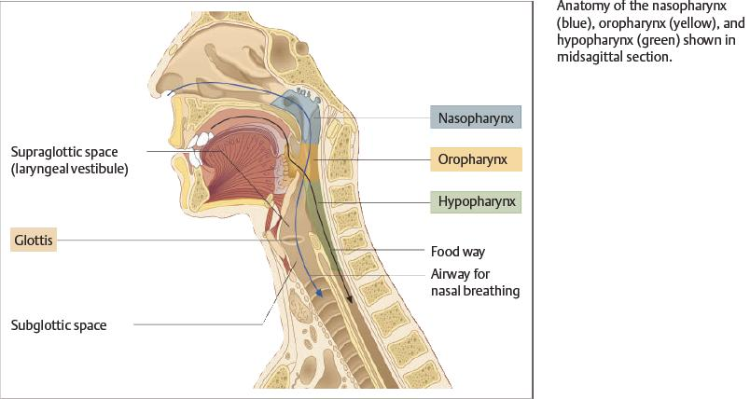

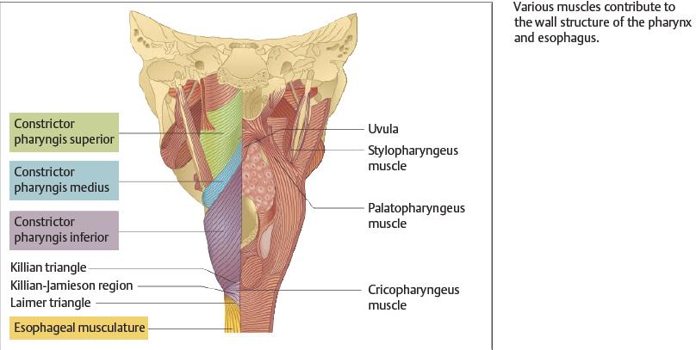

Physiology of Swallowing
Normal swallowing requires a coordinated interaction of various anatomic structures in the oral cavity, pharynx, larynx, and esophagus. From a functional standpoint, the voluntarily initiated oral phase of swallowing is distinguished from an “involuntary” pharyngeal phase and esophageal phase, which are controlled through reflex mechanisms .
During the oral phase of swallowing, food is broken down and moistened to form a bolus that is moved toward
the oropharynx. This is accomplished mainly by pressing the food against the hard palate with the tongue (➀).
The pharyngeal phase begins when the bolus comes into contact with receptors in the throat (especially on the tongue base), eliciting an involuntary swallowing
reflex (➁). The afferent impulses for this reflex travel through the glossopharyngeal and vagus nerves, while the efferent neurons that supply the pharyngeal muscles arise fromcranial nerves V3, VII, IX, X, and XII.
The extensive nerve supply highlights the complexity of swallowing as well as the potential vulnerability of this process. While the involuntary swallowing reflex is triggered during the pharyngeal phase, the velum is elevated to close off the nasopharynx ➂. The larynx is also sealed off by elevation of the epiglottis ➃. This is accompanied by a reflex adduction of the vocal cords ➄, allowing the food to pass through the piriform sinuses toward the esophagus while bypassing the larynx ➅.
The esophageal phase of swallowing begins with a primary peristaltic wave, which is reflexly initiated in response to movement of the bolus through the pharynx (cranial nerves IX, X) ➆. Secondary peristalsis is additionally triggered in the esophagus by the pressure of
the bolus against the esophageal wall ➇. Through the coordinated action of these mechanisms, the bolus is transported into the stomach within 7–10 seconds.

Structure and Function of the Tonsillar Ring Anatomy

The tonsillar ring (Waldeyer’s ring) is composed of a series of lymphoepithelial “organs” called the tonsils. This tissue is structurally similar to lymph nodes but lacks afferent lymphatic vessels.
The tonsils are named for their location, consisting of a pharyngeal tonsil, the paired palatine tonsils, and the unpaired lingual tonsil at the base of the tongue. Additionally,
smaller condensations of lymphoepithelial tissue are found in the pharyngeal recess.
and in the “lateral bands” (tubopharyngeal folds) on the posteriorwall of the oropharynx and nasopharynx.The epithelium of the tonsils also varies by location. While the pharyngeal tonsil is covered mainly by multiple rows of ciliated epithelium, the palatine and lingual
tonsils are covered by stratified, nonkeratinized squamous epithelium.

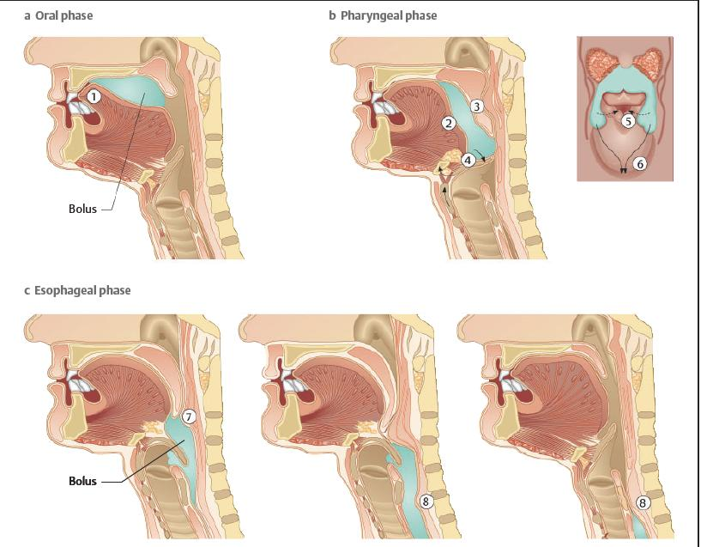

Structure of the Palatine Tonsil
The palatine tonsil has special immunologic importance among the tissues of the tonsillar ring owing to its distinctive morphology. Its surface is invaginated by crypts—fold-like tissue indentations that are lined by porous epithelium and substantially increase the surface area of the tonsil. This arrangement facilitates contact between inspired or ingested antigens and the subepithelial lymphatic tissue. 5 Pharynx and Esophagus 101 Probst-Grevers- Within the lymphatic tissue, primary follicles are formed during embryonic development and differentiate into secondary follicles after birth .the secondary follicles mainly contain B lymphocytes at various stages of differentiation, along with scattered T lymphocytes. Besides the lymph follicles, there are also extrafollicular areas with B and T lymphocytes that enter the lymphatic tissue through the postcapillary venules.

Functional Importance of the Tonsils
in the Immune System

The palatine tonsil in particular is considered to be an “immune organ” that plays a significant role in the defense against upper respiratory infections. By analogy with comparable lymphoepithelial tissue masses in the bronchi and intestinal tract, the lymphatic tissue in the tonsillar ring is also termed the mucosa-associated lymphatic tissue (MALT) of the upper respiratory tract. Accordingly, this tissue has the ability to mount specific immune reactions in response to various antigens. The activity of this lymphatic organ is especially pronounced during childhood, when immunologic challenges from the environment induce hyperplasia of the palatine tonsils . Following this “active phase” of immune initiation, which lasts until about 8–10 years of age, the lymphatic tonsillar tissue becomes less important as an immune organ, and there is a corresponding decline in the density of lymphocytes in all regions of the tonsils. While the tonsils become less important immunologically with ageing, the tonsillar tissue continues to perform immune functions even at an advanced age, although this should not alter the decision to remove the tonsils if a valid indication for tonsillectomy exists .While the tonsils are “learning” their immune function during childhood, extreme tonsillar hyperplasia (“kissing tonsils”) may develop, leading to functionally significant narrowing of the faucial isthmus, with eating difficulties and obstructed breathing. Especially when recumbent, these children may experience significant respiratory dysfunction, with periods of apnea. They also have an increased long-term risk of developing cor pulmonale. Consequently, there should be little hesitation in recommending tonsillectomy, even in small children.

