Lec 4:

Tumours of the pharynx:

-Tumours of the Nasopharynx :
Benign Tumors
Juvenile Angiofibroma
Epidemiology: Benign tumors of the nasopharynx are rare. The most common of these is juvenile angiofibroma, which accounts for less than 0.05% of all ear, nose, and throat (ENT) tumors and occurs exclusively in boys 10–18 years of age

Symptoms: Typical symptoms are obstructed nasal breathing, recurrent epistaxis, headache, impaired Eustachian tube ventilation with middle ear effusion, and conductive hearing loss due to obstruction of the eustachian tube orifice.

Diagnosis: The typical endoscopic appearance is that of a well-circumscribed, vascularized mass with superficial vascular markings, situated in the nasopharynx or posterior part of the nasal cavity. If there is clinical suspicion of an angiofibroma, a biopsy should not be performed due to the risk of heavy bleeding. The primary workup should include MRI or CT, which can accurately define tumor extension into surrounding structures . Digital subtraction angiography (DSA) is useful for identifying tumor-feeding vessels

Treatment: The treatment of choice is surgical removal of the tumor. Preoperative embolization of the feeding vessels (usually the maxillary artery) should be performed to reduce the intensity of intraoperative bleeding

Malignant Tumors:

Epidemiology: Carcinomas of squamous-cell origin account for the great majority of malignant nasopharyngeal tumors. A basic distinction is drawn between

squamous cell carcinomas and lymphoepithelial carcinomas
(Schmincke tumor).
Much less common tumors of this region are adenocarcinoma, adenoid cystic carcinoma, malignant melanoma, sarcoma, lymphoma, and plasmacytoma.

Etiology: The Epstein–Barr virus (EBV) appears to have a key role in the etiology of undifferentiated lymphoepithelial carcinoma.

Symptoms: Early symptoms of nasopharyngeal malignancies are unilateral conductive hearing loss with middle ear effusion. Any persistent middle ear effusion of long duration in an adult patient with no prior history of middle ear disease is suspicious for a tumor and should be investigated accordingly. Cervical lymph-node metastasis, usually involving the
nodes at the mandibular angle, is another common initial finding. Features of advanced disease include nasal airway obstruction, recurrent epistaxis, headaches, and cranial nerve palsies.

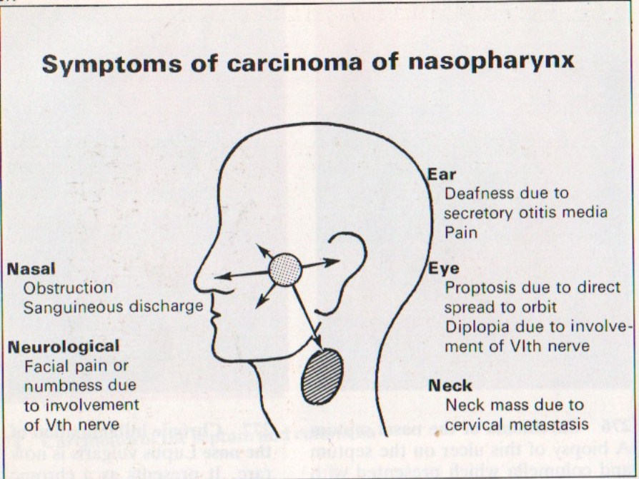

Diagnosis: The primary study is endoscopy of the nasopharynx Nasopharyngeal malignancies can have a variety of appearances ranging from a smooth, well-circumscribed tumor surface to mucosal ulcerations.
Some of these tumors are initially submucosal and are easily missed at endoscopy.

Otomicroscopy reveals unilateral tympanic membrane retraction and a middle ear effusion as a result of impaired eustachian tube ventilation. Given the EBV association of many nasopharyngeal cancers, the

EBV antibody titer should be determined (this shows an elevated IgA, contrasting with the elevated IgM/IgG that is found in infectious mononucleosis). MRI or CT is useful for defining tumor extent

Treatment: The treatment of choice for most nasopharyngeal carcinomas is primary high-voltage radiotherapy, because most of these tumors are very radiosensitive and the unfavorable tumor location and rapid invasion of the skull base preclude curative surgery in
many cases.

-Tumours of the oropharynx :

Tonsillar tumours
Benign tumours are very rare. But tonsillar stones (tonsiliths) with surrounding ulceration, mucus retention cysts, herpes simplex or giant aphthous ulcers, may mimic the more common malignant tumours of the tonsil. These tumours are becoming increasingly common, and unusually, are now being found in younger patients and in non-smokers.

Squamous cell carcinoma (SCC)
This is the commonest tumour of the tonsil. It tends to occur in middle-aged and elderly people, but in recent years tonsillar SCC has become more frequent in patients under the age of 40. Many of these patients are also unusual candidates for SCC because they are non-smokers and non-drinkers.
Signs and symptoms
- Pain in the throat
- Referred otalgia
- Ulcer on the tonsil
- Lump in the neck.
As the tumour grows it may affect the patient's ability to swallow and it may lead to an alteration in the voice—this is known as ‘hot potato speech’.
Diagnosis is usually confirmed with a biopsy taken at the time of the staging panendoscopy. Fine needle aspiration of any neck mass is also necessary. Imaging usually entails CT and/or a MRI scan. It is important to exclude any bronchogenic synchronous tumour with a chest X-ray and/or a chest CT scan and bronchoscopy where necessary.
Treatment
Decisions about treatment should be made in a multidisciplinary clinic, taking into account the size and stage of the primary tumour, the presence of nodal metastasize, the patient's general medical status and the patient's wishes.

Treatment options include:
- Radiotherapy alone
- Chemoradiotherapy
- Trans oral laser surgery
- En-bloc surgical excision—this removes the primary and the affected nodes from the neck. It will often be necessary to reconstruct the surgical defect to allow for adequate speech and swallowing afterwards. This will often take the form of free tissue transfer such as a radial forearm free flap.
Lymphoma
This is the second most common tonsil tumour.
Signs and symptoms
- Enlargement of one of the tonsils
- Lymphadenopathy in the neck—may be large
- Mucosal ulceration—less common than in SCC.

Investigations
- Fine needle aspiration cytology may suggest lymphoma, but it rarely confirms the diagnosis. It is often necessary to perform an excision biopsy of one of the nodes.
- Staging is necessary with CT scanning of the neck chest, abdomen, and pelvis. Further surgical intervention is not required other than to secure a threatened airway.
Treatment
Usually consists of chemotherapy and/or radiotherapy.
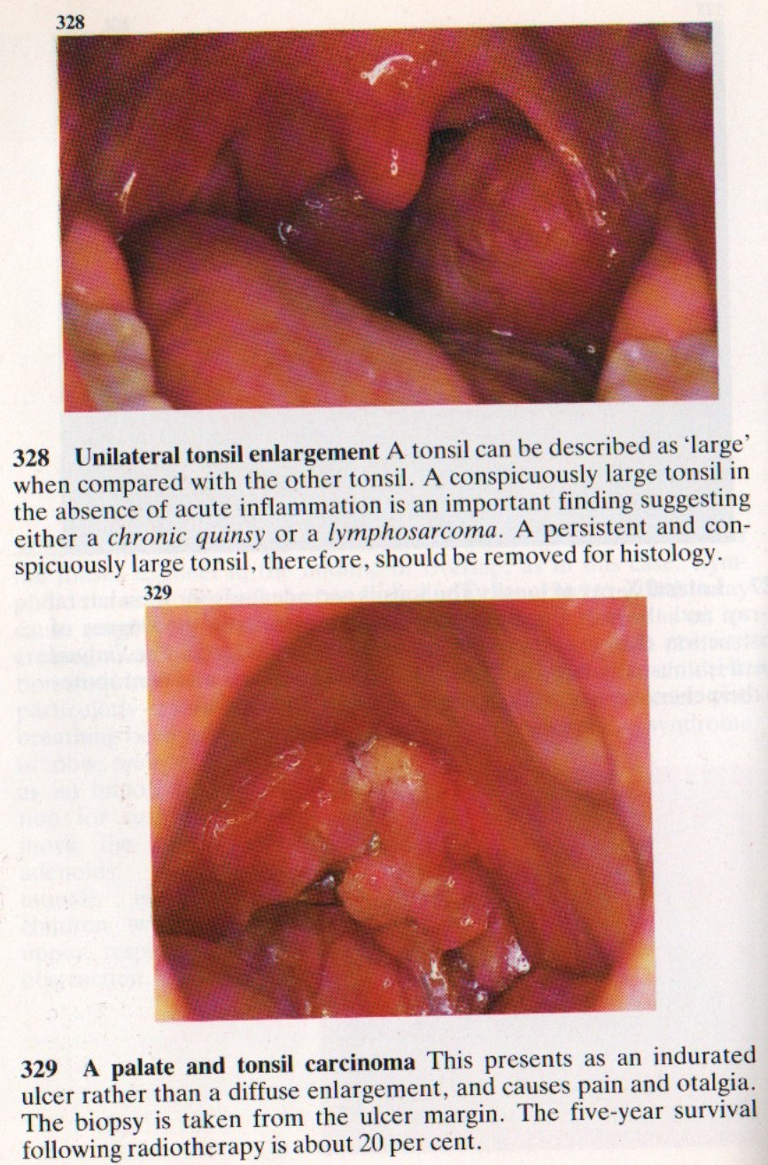

-Tumors of Hypopharynx:
Benign Tumors
Benign tumors of the hypopharynx are considered a rarity. They may present clinically with dysphagia, regurgitation, or retrosternal pain. The diagnosis is established with an incisional biopsy taken endoscopically under general endotracheal anesthesia. Treatment consists of surgical removal, depending on the tumor size.

Plummer-Vinson syndrome : It is a pre malignant .Most common in nonsmoking Scandinavian women characterized by iron deficiency anemia , dysphagia associated with postcricoid web and angular cheilitis . There is increased incidence of oral leukoplakia and s.c.c ( 10% ). Treatment with iron will improve the anemia but will not reverse the mucosal changes .

Malignant Tumors

The hypopharynx is divided into 3 parts :
  - Postcricoid
  - Pyriform fossae
  - Posterior pharyngeal wall

Histologically, almost all of these tumors are squamous cell carcinomas. As with oral and oropharyngeal carcinomas, there is an etiologic link to chronic alcohol and nicotine abuse.

Symptoms: Most malignant tumors of the hypopharynx are diagnosed at an advanced stage because earlier lesions do not produce symptoms. Initial complaints tend to be nonspecific, depending on tumor size and location, and consist of dysphagia and a fetid breath odor. Later there may be pain radiating to the ear. Hoarseness and possible
dyspnea signify tumor extension to the larynx.

In many cases, cervical lymph-node metastasis is noted as the earliest sign of disease.

Diagnosis: Besides the mirror examination or indirect laryngoscopy, the diagnostic workup
should include endoscopic examination under general endotracheal anesthesia, as this is the best way to evaluate tumor extent. A biopsy can also be taken in the same sitting for histologic confirmation. Additionally, sectional imaging modalities can help to define the tumor size and check for involvement of adjacent structures while also evaluating the cervical lymphnode status

Treatment: Treatment depends on tumor size but usually consists of local surgical excision with a concomitant neck dissection Many malignant tumors of the hypopharynx have already spread to the larynx, making it necessary to perform a laryngectomy in the same sitting. The tissue defect is closed primarily whenever possible. This cannot be done with extensive hypopharyngeal resections due to the high risk of stricture formation, and larger defects should be reconstructed by means of a free jejunum transfer with microvascular anastomosis. Surgery should be followed by radiation to the tumor site
and lymphatics. Alternative treatments for advanced hypopharyngeal cancers are primary radiotherapy and combined radiation and chemotherapy.

