The radial part of the wavefunction, R_{(r)}

The mathematical forms of some of the wave functions for the H atom are listed in Table 1. Figure 1 shows plots of the radial parts of the wavefunction, R(r), against distance, r, from the nucleus for the 1s and 2s atomic orbitals of the hydrogen atom, and Figure 2 shows plots of R(r) against r for the 2p, 3p, 4p and 3d atomic orbitals;
the nucleus is at r = 0.
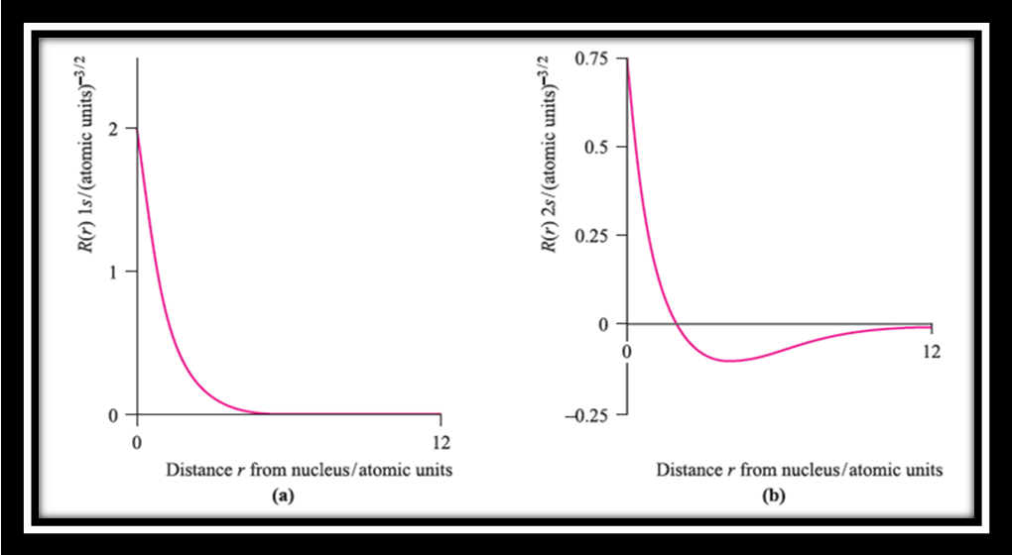
Fig. 1 Plots of the radial parts of the wavefunction, R(r), against distance, r, from the nucleus for (a) the 1s and (b) the 2s atomic orbitals of the hydrogen atom; the nucleus is at r = 0. The vertical scales for the two plots are different but the horizontal scales are the same.

From Table 1, we see that the radial parts of the wavefunctions decay exponentially as r increases, but the decay is slower for n = 2 than for n = 1. This means that the likelihood of the electron being further from the nucleus increases as n increases. This pattern continues for higher values of n. The exponential decay can be seen clearly in Figure 1a. Several points should be noted from the plots of the radial
parts of wavefunctions in Figures 1 and 2:
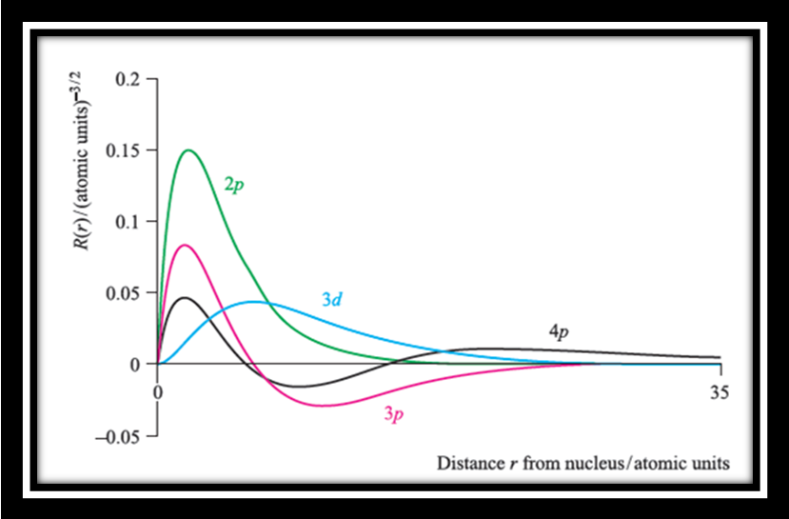
Fig. 2 Plots of radial parts of the wavefunction R(r) against r for the 2p, 3p, 4p and 3d atomic orbitals; the nucleus is at r = 0.

. s atomic orbitals have a finite value of R(r) at the nucleus;
. for all orbitals other than s, R_{(r)} = 0 at the nucleus;
. for the 1s orbital, R(r) is always positive; for the first
orbital of other types (i.e. 2p, 3d, 4f ), R(r) is positive everywhere except at the origin;
. for the second orbital of a given type (i.e. 2s, 3p, 4d, 5f ), R(r) may be positive or negative but the wavefunction has only one sign change; the point at which R(r) = 0 (not including the origin) is called a radial node;
. for the third orbital of a given type (i.e. 3s, 4p, 5d, 6f ),
R(r) has two sign changes, i.e. it possesses two radial nodes.

Table 1 Solutions of the Schrodinger equation for the hydrogen atom which define the 1s, 2s and 2p atomic orbitals. For these forms of the solutions, the distance r from the nucleus is measured in atomic units.
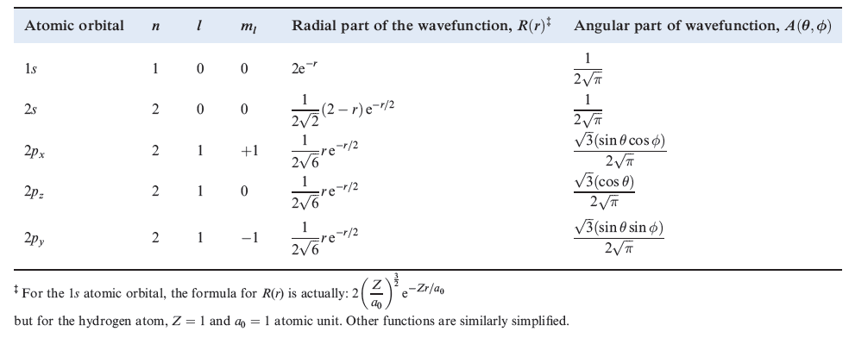
The radial distribution function, 4 π r² R (r)²
Let us now consider how we might represent atomic orbitals in three-dimensional space. We said earlier that a useful description of an electron in an atom is the probability of finding the electron in a given volume of space. The function Ψ²
is proportional to the probability density of the electron at a point in space. By considering values of Ψ² at points around the nucleus, we can define a surface boundary which encloses the volume of space in which the electron will spend, say, 95% of its time. This effectively gives us a physical representation of the atomic orbital, since Ψ² may be described in terms of the radial and angular components
R(r)² and A(θ, Φ)².
First consider the radial components. A useful way of depicting the probability density is to plot a radial distribution function and this allows us to envisage the
region in space in which the electron is found.

Radial distribution function = 4 π r² R (r)²
The radial distribution functions for the 1s, 2s and 3s atomic orbitals of hydrogen are shown in Figure 3, and Figure 4 shows those of the 3s, 3p and 3d orbitals. Each function is zero at the nucleus, following from the r² term and the fact
that at the nucleus r = 0. Since the function depends on R (r)², it is always positive in contrast to R(r), plots for which are shown in Figures 3 and 4. Each plot of
4 π r² R (r)² shows at least one maximum value for the function, corresponding to a distance from the nucleus at which the electron has the highest probability of being
found. Points at which 4 π r² R (r)² = 0 (ignoring r = 0) correspond to radial nodes where R (r) = 0.
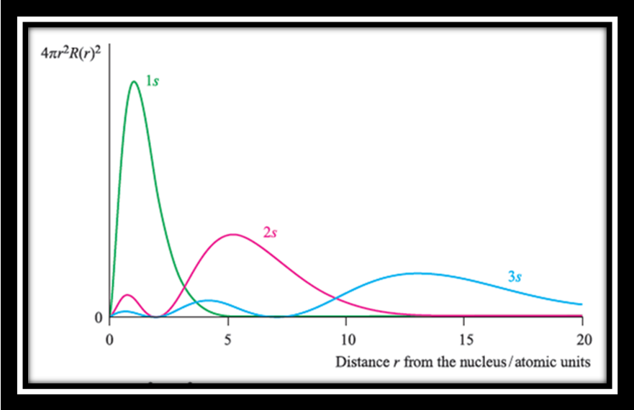
Fig. 3 Radial distribution functions, 4 π r² R (r)², for the 1s, 2s and 3s atomic orbitals of the hydrogen atom.

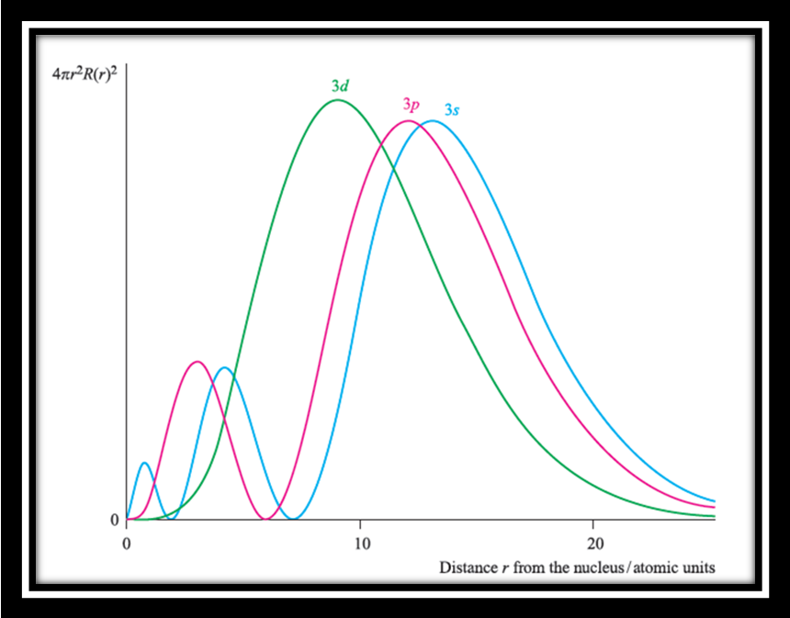
Fig. 4 Radial distribution functions, 4 π r² R (r)², for the 3s, 3p and 3d atomic orbitals of the hydrogen atom.

